NIRVANA FARMS
Information Memorandum – content draft v2
Forestry, carbon, farming and mānuka estate – Taranaki / Whanganui hill country · receivership sale by expressions of interest
Prepared by | Searle Forestry (Forestry Sales Limited, Licensed Agent REA Act 2008)
Draft | v2 – 13 October 2026 – content in the agreed IM order for the designer's layout
Status | Working draft for the Receivers' review. Items in red [TBC] are to be confirmed or supplied before release; stand records from the forest manager (Stand) are still awaited and will replace the ETS-derived planting years.
Vendors | Nirvana Farm Limited (In Receivership); and Andrew Grenfell and Kare Johnstone (McGrathNicol) as receivers of the Makowhai Trust titles
Also available | Magons (172 Puniwhakau Road, 777 ha) – owned by a third party and offered separately through Searle Forestry

How to use this draft
The document follows the agreed IM order: (1) executive summary of all the assets, (2) forestry summary including carbon and NZUs across the estate, (3) farming summary, (4) honey and mānuka summary, then (5) a property-by-property section grouped by location, each property with a key-characteristics table and a full-page map, and (6) appendices.
- Red [TBC] text marks facts not yet on file or not yet confirmed; the consolidated list is in Appendix B.
- Grey 'internal note' boxes are for the Searle team and the designer and are not IM copy.
- Charts are PNG files in IM/charts; property maps are PNG renders of the georeferenced sheets in IM/maps (GeoPDFs in Claude/map/geopdf).
- Areas are LINZ record-of-title areas unless stated. Land-cover areas are GIS-derived from the July 2026 appraisal mapping and are approximate. Altitude is from the LINZ 8 m DEM and land use capability from the LRIS NZLRI (2021) layer, both clipped to the titles.
- No valuation or appraisal figures are included.
Internal note – not for the IM: Branding: the designer's draft uses the Searle Agribusiness template; the agency agreements are with Forestry Sales Limited trading as Searle Forestry. This draft uses Searle Forestry details – confirm the brand before layout.

1 Executive summary
Nirvana Farms is a 13,800 hectare forestry, carbon, farming and mānuka estate across the hill country between Waverley, the Waitōtara Valley and Whangamomona in eastern Taranaki, with one outlying mānuka block near Ōpōtiki. It is offered for sale by the receivers of Nirvana Farm Limited and of the Makowhai Trust titles, as a whole or in parts, by expressions of interest.
The estate comprises 16 properties in 56 freehold and Crown-leasehold titles (13,832 ha), together with Nirvana Farm Limited's registered forestry rights over the planted areas of the Makowhai Trust land and over a further 362 ha at Soldiers Road. Staghaven (296 ha on Mangaehu Road) is included in the sale. About 2,597 ha of Pinus radiata was established across eight blocks between 2022 and 2024 and is registered in the New Zealand Emissions Trading Scheme (ETS), most of it under averaging accounting, with two permanent-forest accounting areas of older radiata. A further 9,190 ha is native bush and regenerating mānuka/kānuka, and roughly 2,141 ha is open hill-country grassland.
Two further holdings in the same eastern Taranaki country are owned by a third party, FR Waipuna Limited, and are not part of the receivership sale, but are available for purchase through Searle Forestry by separate negotiation: Magons, a 777 ha forestry property at 172 Puniwhakau Road, and the fourth Staghaven title (TNH4/170, 156 ha at 694 Mangaehu Road), which carries the Staghaven homestead. Both are shown separately in the portfolio table below and described in Section 5 for completeness.
An independent ground survey by Stand in April 2026 found 1,673 ha of the young crop adequately stocked (above 850 stems/ha) and programmed 406 ha of replanting and 417 ha of blanking for the 2026 season, restoring about 2,497 ha of adequately stocked crop. That programme has been completed: Forest360's post-planting quality-control sheets of 14 October 2026 record 613.2 ha of net stocked area blanked in 2026 across the six blocks mapped, checked with 186 quality-control plots, and an independent review by NZ Forestry Limited in October 2026 found the planting and blanking to industry standard. Release spraying (spot and aerial) is under way and is anticipated to be finished by November 2026. Completion certification, the reviews and the forest manager's stand records will be provided in the data room [TBC – Soldiers Road sheet, final review copy and stand records from Stand].
The carbon position is substantial: 2,740 ha of registered carbon accounting areas with a combined unit balance of about 149,552 NZUs per the MPI land status reports, including the permanent-forest areas at Longreach and Back Farm (about 102,000 NZUs between them). The NFL carbon account is controlled by NZGT as trustee, which will control the transfer of units at settlement; NZUs are to be transferred with the property [TBC – holding account balances and the treatment of the forward sale to the financier].
About 2,260 ha of Front Farm, the Eastern Block and one Puau Road Crown lease is subject to a grazing lease to Pukekahu Farms Limited expiring 31 December 2029; rent for the full term has been prepaid and the lease may be terminated by the landlord on five months' notice. The estate was assembled by Settlers Honey as a mānuka honey and carbon enterprise; the honey business itself and the former owner's private residence are not included, but the mānuka resource, the beekeeping rights reserved under the lease and the registered indigenous carbon areas pass with the land.
The estate is offered by expression of interest with international coverage so that the process can be tailored to purchasers' needs – whether for the whole estate, the planted forest blocks, the farming land, or the native and mānuka blocks separately. The sale is a receivership sale on an "as is, where is" basis.

Key facts
Vendors | Nirvana Farm Limited (In Receivership); and the receivers of the Makowhai Trust titles – Andrew Grenfell and Kare Johnstone, McGrathNicol
Estate type | Forestry and carbon estate with farming and mānuka honey land – young Pinus radiata, permanent and regenerating forest, native bush, mānuka/kānuka and open hill country
Properties | 16 properties in four locations: Waitōtara Valley / Ngamatapouri (9), Nukumaru / Waverley coast (3), eastern Taranaki (3, plus the Soldiers Road forestry right) and Toatoa, Ōpōtiki (1)
Tenure | Freehold (54 titles) and two Crown renewable leases (s82 Land Act 1948, Puau Road); two registered forestry rights held by Nirvana Farm Limited
Total titled area | 13,832 ha (6,045 ha Nirvana Farm Limited, 7,787 ha Makowhai Trust) plus a forestry right over 362 ha at Soldiers Road
Planted area | 2,597 ha Pinus radiata (2022–2024 plantings) including 176 ha under the Soldiers Road forestry right; 2,497 ha adequately stocked after the 2026 programme [TBC – stand records]
Native and mānuka | 4,673 ha native bush and 4,518 ha mānuka/kānuka and scrub
Open grassland | about 2,141 ha, of which about 3,190 ha of grassland and scrub is indicatively ETS-eligible (post-1989)
ETS | Registered by Nirvana Farm Limited (NZ-10251) and Makowhai Station (NZ-1181); 2,740 ha of carbon accounting areas, mostly averaging; two permanent-forest CAAs to 2060
NZU balance | CAA unit balance about 149,552 NZUs per MPI land status reports (NFL 79,294; Makowhai Station 70,258) [TBC – holding account balances from NZGT / JTL]
Leased area | About 2,260 ha to Pukekahu Farms Limited, five-year term to 31 December 2029, rent prepaid
Territorial authorities | South Taranaki District (12 properties), Stratford District (3 plus Soldiers Road) and Ōpōtiki District (1)
Regional councils | Taranaki Regional Council; Bay of Plenty Regional Council (Pakihi)
Zoning | Rural Zone under the Operative South Taranaki District Plan, the Stratford District Plan 2014 and the Operative Ōpōtiki District Plan 2021 [TBC – Whangamomona's Section 31 Block IV Town of Whangamomona may carry township zoning]
Legal access | Road frontage to all blocks except as noted; parts of Front Farm, the Eastern Block and Puau Road are worked through neighbouring properties [TBC – access details from Stand]
Rating valuations | Council capital values total $50,688,000 across the sale titles (land value $47,245,000); South Taranaki values as at 1 September 2024, Stratford 1 August 2023, Ōpōtiki 1 June 2025 – see Appendix C
Rates | About $151,395 per annum across the sale titles (district and regional, 2026/27 as shown by the councils' rating databases) [TBC – confirm against invoices]
Buildings and dwellings | Farm complex with dwelling at Front Farm (leased), a second leased dwelling on the Eastern Block / Front Farm land, the workers' dwelling at 228 Taumatatahi Road, Patricks House at 2606 Waitotara Valley Road, and woolsheds and sheds on Longreach, Back Farm, Whangamomona, Ernies and the Nukumaru blocks [TBC – building schedule from Stand / the receivers]
Also available | Owned by FR Waipuna Limited and offered by separate negotiation through Searle Forestry: Magons (777 ha, 172 Puniwhakau Road) and the Staghaven homestead title TNH4/170 (156 ha, 694 Mangaehu Road)
Sale method | Expressions of interest closing [TBC date and time], plus GST (if any)

Portfolio of assets
All assets in the offering, grouped by location. Areas are record-of-title hectares; planted and ETS figures are from Stand (April 2026) and the MPI land status reports (September 2026).
Receivership sale – Nirvana Farm Limited and the Makowhai Trust titles
Property | Location | Vendor / interest | Titles | Area (ha) | Radiata (ha) | ETS CAA ha / NZUs | Principal land use
Longreach | Waitōtara Valley and Ngamatapouri | Nirvana Farm Ltd (In Rec.) | 4 | 1,723 | 777 | 873 / 63,819 | Forestry (Pinus radiata) and carbon · permanent forest · native bush and mānuka · open hill grazing
Back Farm | Waitōtara Valley and Ngamatapouri | Makowhai Trust (receivers) | 8 | 2,104 | 785 | 952 / 64,769 | Forestry (Pinus radiata) and carbon · permanent forest · native bush and mānuka · open hill grazing
Front Farm | Waitōtara Valley and Ngamatapouri | Makowhai Trust (receivers) | 5 | 502 | 231 | 236 / 1,766 | Forestry (Pinus radiata) and carbon · grazing (leased to Pukekahu Farms) · farm buildings
Eastern Block | Waitōtara Valley and Ngamatapouri | Makowhai Trust (receivers) | 3 | 1,071 | 138 | 111 / 259 | Forestry (Pinus radiata) and carbon · native bush and mānuka · grazing (leased to Pukekahu Farms)
Home Block | Waitōtara Valley and Ngamatapouri | Makowhai Trust (receivers) | 2 | 1,165 | – | – | Native bush and mānuka (honey) · carbon (indigenous) · open hill grazing
Ernies | Waitōtara Valley and Ngamatapouri | Makowhai Trust (receivers) | 6 | 1,626 | – | 121 / 13,159 | Mānuka and native bush (honey) · carbon (indigenous) · open hill grazing
Karapara | Waitōtara Valley and Ngamatapouri | Makowhai Trust (receivers) | 3 | 1,318 | – | – | Native bush and mānuka (honey, conservation)
Workers House | Waitōtara Valley and Ngamatapouri | Nirvana Farm Ltd (In Rec.) | 2 | 2 | – | – | Dwelling
Patricks House | Waitōtara Valley and Ngamatapouri | Nirvana Farm Ltd (In Rec.) | 3 | 28 | – | – | Dwelling and small grazing block
Puau Road | Nukumaru and the Waverley coast | Nirvana Farm Ltd (In Rec.) | 4 | 1,872 | 52 | 46 / 139 | Native bush and mānuka (honey) · forestry (Pinus radiata) · grazing (part leased to Pukekahu Farms) · Crown leasehold
Moonys | Nukumaru and the Waverley coast | Nirvana Farm Ltd (In Rec.) | 4 | 644 | – | – | Mānuka, native bush and open hill grazing · older exotic cover
Ridge Road | Nukumaru and the Waverley coast | Nirvana Farm Ltd (In Rec.) | 3 | 283 | – | – | Mānuka scrub and open grazing
Whangamomona | Eastern Taranaki | Nirvana Farm Ltd (In Rec.) | 1 | 739 | 355 | 309 / 928 | Forestry (Pinus radiata) and carbon · native bush and mānuka
Staghaven | Eastern Taranaki | Nirvana Farm Ltd (In Rec.) | 3 | 296 | 83 | 82 / 4,654 | Forestry (Pinus radiata) and carbon · native bush · rolling pasture
Tims | Eastern Taranaki | Nirvana Farm Ltd (In Rec.) | 1 | 14 | – | – | Native bush and scrub
Soldiers Road (forestry right) | Eastern Taranaki | NFL forestry right – land excluded | 1 | 362 | 176 | 9.6 / 59 [TBC] | Forestry right only – Pinus radiata and carbon
Pakihi | Eastern Bay of Plenty | Nirvana Farm Ltd (In Rec.) | 4 | 446 | – | – | Mānuka and native bush (honey)
Total – receivership sale |  |  | 56 | 13,832 | 2,421 | 2,740 / 149,552

Internal note – not for the IM: The Soldiers Road forestry right sits outside the title total. The 56-title total includes Staghaven's three retained titles (295.6 ha), added to the sale on 21 September 2026.
Available separately – owned by FR Waipuna Limited (not part of the receivership sale)
Property | Location | Owner / basis | Titles | Area (ha) | Radiata (ha) | ETS CAA ha / NZUs | Principal land use
Magons | Eastern Taranaki – Puniwhakau Road | FR Waipuna Limited – separate negotiation through Searle Forestry | 7 | 777 | ~311 [TBC] | ~311 [TBC] | Forestry (Pinus radiata) and carbon · hill grazing – available separately
Staghaven – homestead title TNH4/170 | Eastern Taranaki – 694 Mangaehu Road | FR Waipuna Limited – separate negotiation through Searle Forestry | 1 | 156 | [TBC] | [TBC] | Homestead, farm buildings and hill country adjoining the Staghaven sale titles [TBC]
Total – available separately |  |  | 8 | 933

Internal note – not for the IM: LINZ records FR Waipuna Limited as registered owner of all seven Magons titles and of TNH4/170 (Section 1 SO 13102, 156.24 ha, Stratford rating unit 1204110202). Confirm with the owner the basis on which both are offered before the IM is released.

Investment highlights
- Scale – 13,832 ha in 56 titles with a further 362 ha under forestry right, offered as a whole or in parts.
- A young, ETS-registered radiata estate of about 2,597 ha, remediated in 2026 under an independent programme, with stand records and a third-party review to be provided [TBC].
- Registered carbon of 2,740 ha and a unit balance of roughly 149,552 NZUs, including two permanent-forest accounting areas to 2060.
- About 9,190 ha of native bush and mānuka/kānuka – an established mānuka honey resource with 163 ha of registered indigenous carbon and roughly 3,190 ha of further indicatively eligible land.
- Farming income and infrastructure – about 2,260 ha under a prepaid grazing lease, farm buildings and dwellings on the Waitōtara Valley blocks, and about 219 ha of further plantable open ground.
- Freehold tenure on 54 titles; two renewable Crown leases with 27 years to run; road frontage to most blocks.
- The option to add Magons (777 ha, about 311 ha of ETS-registered radiata) and the Staghaven homestead title (156 ha) from their third-party owner by separate negotiation, building an eastern Taranaki holding of more than 1,200 ha with Staghaven and Tims.

Estate overview – all holdings – property map
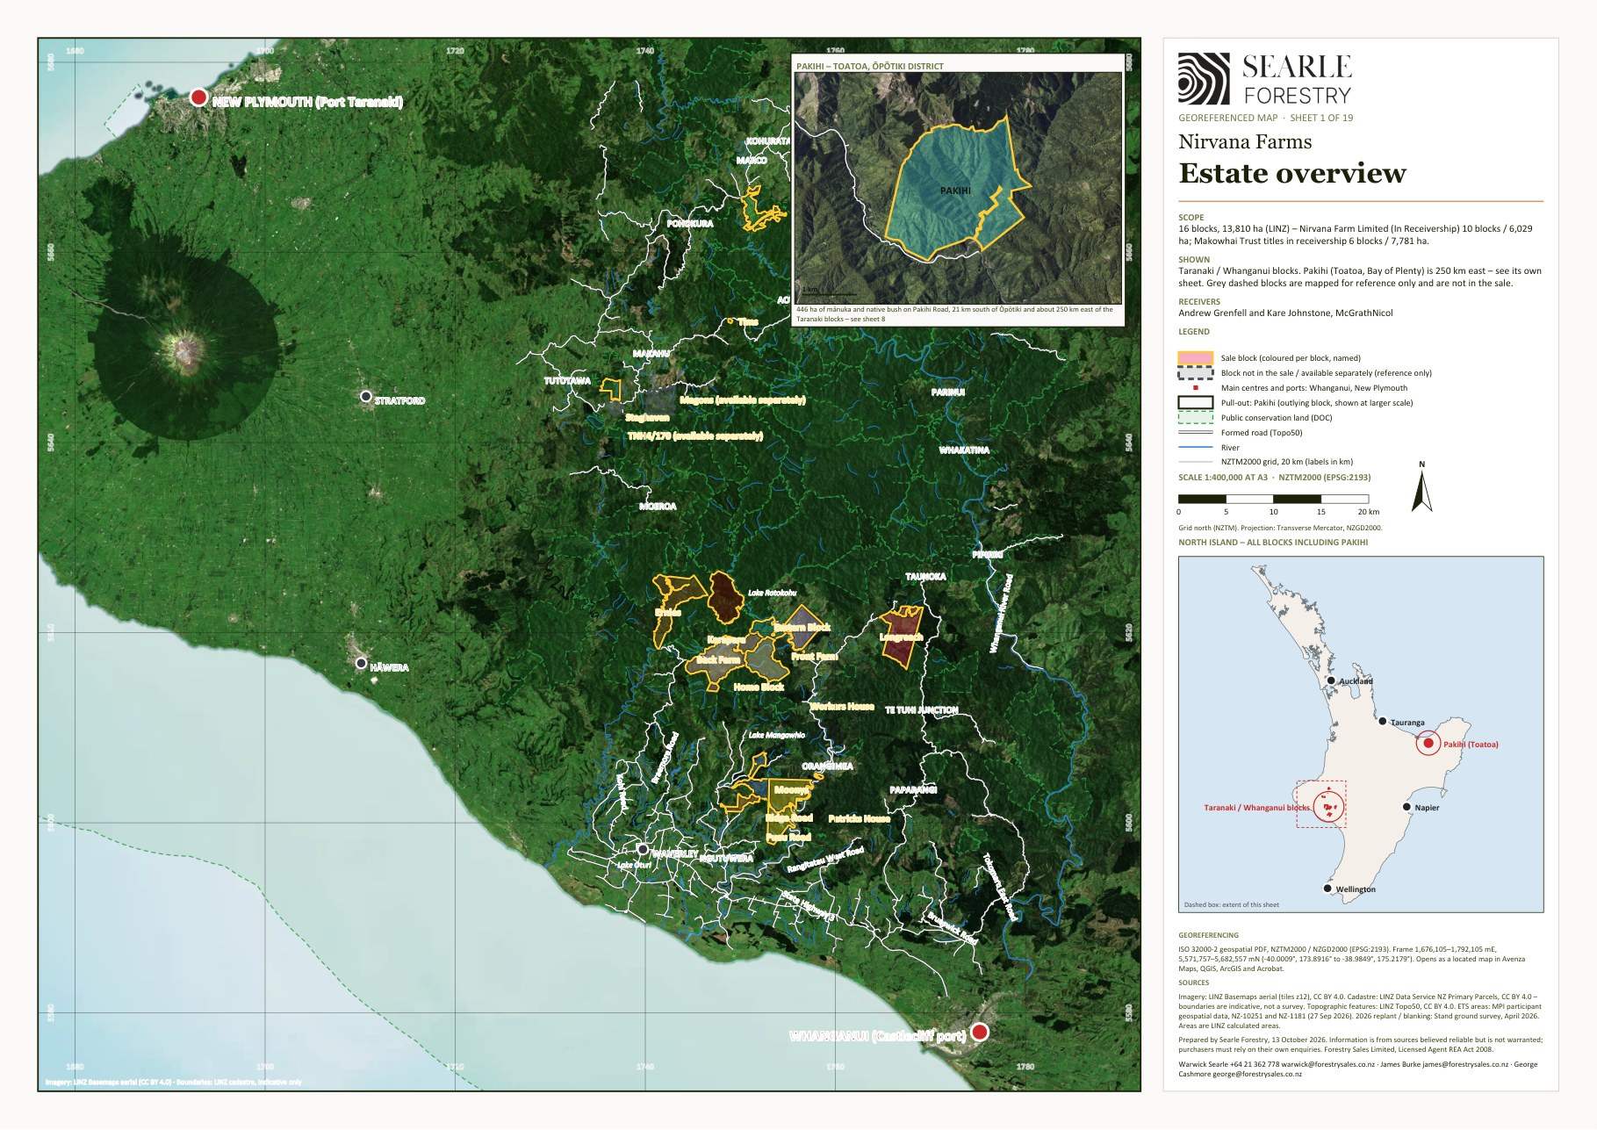
Georeferenced sheet from the Nirvana Farms map set (LINZ cadastre, LINZ aerial imagery, MPI ETS data, Stand 2026 programme). The designer may substitute a styled version; the GeoPDF sheets are supplied in the IM/maps folder and the data room.

2 Forestry summary
Eight blocks carry a Pinus radiata crop: Longreach, Back Farm, Front Farm and the Eastern Block in the Waitōtara Valley, Puau Road at Nukumaru, and Whangamomona, Staghaven and the Soldiers Road forestry right in eastern Taranaki. About 2,597 ha was planted between 2022 and 2024 at a target of 850 stems/ha (originally 1,100). Older exotic stands – the 1994–97 radiata in the permanent-forest accounting areas at Longreach and Back Farm, and the 2011 stands at Staghaven – add roughly 150 ha. Forest360 has supplied the post-planting quality-control sheets for the 2026 work (14 October 2026) and Stand is collating the GIS stand data and forest descriptions [TBC – expected late October 2026]; until they arrive, planting years are taken from the ETS carbon accounting area registrations.

2.1 Planted estate and the 2026 planting programme
Stand's ground survey of 23 April 2026 checked every planted block against Interpine's tree-detection report and programmed the 2026 replanting and blanking needed to bring the young crop back to the 850 stems/ha target. That programme has been carried out over the winter 2026 planting season. Forest360's post-planting quality-control sheets, dated 14 October 2026, map the net stocked area blanked in 2026 on each block and the locations of the quality-control plots measured across the blanked areas.
Block | Planted (ha) | Adequate Apr 2026 | 2026 programme (replant + blanking) | NSA blanked 2026 (Forest360, 14 Oct 2026) | QC plots | Adequate after 2026 | Further plantable | Planting years (ETS CAAs)
Longreach | 777 | 691 | 27 + 59 | 102.77 | 26 | 777 | – | 2024 (777 ha); permanent-forest CAA of 1995 and 1997 radiata (84 ha); 1995–2011 radiata (23 ha) and 1997–2007 indigenous (42 ha) under stock change
Back Farm | 785 | 500 | 50 + 235 | 223.65 | 57 | 785 | 3.5 | 2022 (188 ha) and 2023 (437 ha) under the NFL forestry right; 2022 (144 ha) by Makowhai Station; 1994 radiata (66 ha) and indigenous within permanent-forest CAA 69
Front Farm | 231 | 184 | 12 + 35 | 51.56 | 24 | 231 | 140.0 | 2023 (231 ha)
Eastern Block | 138 | 0 | 18 + 20 | 36.01 | 17 | 38 | 70.0 | 2023 (25 ha) and 2024 (86 ha) registered; about 138 ha planted 2023–24 including the failed stand 1.03
Puau Road | 52 | 26 | 17 + 8 | 21.37 | 10 | 52 | – | 2024 (52 ha)
Whangamomona | 355 | 139 | 194 + 22 | 177.86 | 52 | 355 | 5.5 | 2024 (355 ha)
Staghaven | 83 | 83 | 0 + 0 | none required | – | 83 | – | 2024 (83 ha); 2011 radiata (22 ha) under stock change; older exotic about 27 ha
Soldiers Road (forestry right) | 176 | 50 | 88 + 38 | [TBC] | [TBC] | 176 | – | 2023 (176 ha)
Total | 2,597 | 1,673 | 406 + 417 | 613.2 (six blocks) | 186 | 2,497 | 219.0

Source: Forest360 Ltd, Nirvana Farm Limited – Blanking NSA 2026 post-planting quality-control sheets (Back Farm, Eastern Block, Front Farm, Longreach, Puau Road and Whangamomona), dated 14 October 2026. The 2026 programme column is Stand's April 2026 survey; the blanked column is the 'Blanked Area' on each Forest360 sheet – the net stocked area replanted and blanked in 2026 – and the QC plots column is the number of quality-control plot locations shown on it: 613.2 ha and 186 plots across the six blocks. Differences between the programme and blanked areas reflect the final mark-up of the work areas on the ground. No sheet has been issued for Soldiers Road, where the 2026 work lies under NFL's forestry right [TBC – Soldiers Road sheet]; no 2026 work was required at Staghaven.
The blanked areas and plot locations are shown in yellow on the interactive map (maps.forestrysales.co.nz/nirvana) and are to be added to the property map sheets in Section 5 [TBC – map sheets]. In addition to Forest360's plots, the receivers commissioned NZ Forestry Limited (Cameron Eyre, Registered Member NZIF) to check the work independently; its October 2026 review found the planting and blanking to industry standard with good coverage throughout the areas inspected, and confirmed that pest control was clearly under way across the estate. Completion certification, both reviews and the forest manager's stand records are to be placed in the data room [TBC – final copy of the NZ Forestry review; stand records from Stand].
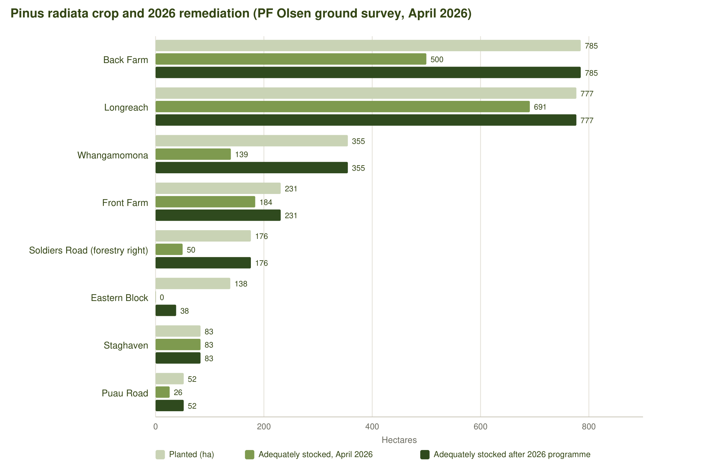
Figure 1 – Planted radiata by block: adequately stocked at April 2026, 2026 replanting and blanking, and the resulting adequately stocked area.
- Pest control: a culling programme was carried out before planting on Back Farm, the Eastern Block and Soldiers Road, and constant pest control (including aerial shooting) continues across the planted blocks to keep the pressure on deer, goats and pigs.
- Release spraying of the 2026 plantings is under way, by spot spraying and aerial releasing, and is anticipated to be finished by November 2026.
- About 219 ha of further plantable open ground has been identified on Front Farm (140 ha), the Eastern Block (70 ha), Whangamomona (5.5 ha) and Back Farm (3.5 ha).
- Planting records, completion certificates and the stand records will be supplied by the forest manager [TBC – Stand].

2.2 Emissions Trading Scheme and carbon
Two participants hold the registered forest land: Nirvana Farm Limited (NZ-10251, MPI holding P-054526) as landowner on its own titles and as forestry-right holder over the Makowhai Trust land and Soldiers Road, and Makowhai Station (NZ-1181, P-054188) as landowner on part of the Makowhai Trust titles. The MPI land status reports (NFL 28 September 2026; Makowhai Station August 2025) record 2,740 ha of carbon accounting areas with a combined unit balance of 149,552 NZUs. All of it is on land in the sale except four small Soldiers Road CAAs (9.6 ha, 59 NZUs) registered under the forestry right.
Block | CAAs | Registered ha | Unit balance (NZUs) | Accounting and age classes
Longreach | 38 | 873.2 | 63,819 | Stock change – indigenous 42 ha (5,272 NZUs); Stock change – pine 23 ha (6,800 NZUs); Permanent (PP89) 84 ha (49,574 NZUs); Averaging – 2024 724 ha (2,173 NZUs)
Back Farm | 42 | 952.5 | 64,769 | Averaging – 2022 144 ha (4,371 NZUs); Permanent (PP89) 183 ha (52,466 NZUs); Averaging – 2023 437 ha (2,862 NZUs); Averaging – 2022 188 ha (5,070 NZUs)
Front Farm | 6 | 235.8 | 1,766 | Averaging – 2023 34 ha (262 NZUs); Averaging – 2023 202 ha (1,504 NZUs)
Eastern Block | 15 | 111.2 | 259 | Averaging – 2023 25 ha; Averaging – 2024 86 ha (259 NZUs)
Puau Road | 5 | 46.1 | 139 | Averaging – 2024 46 ha (139 NZUs)
Whangamomona | 17 | 308.6 | 928 | Averaging – 2024 309 ha (928 NZUs)
Staghaven | 8 | 82.5 | 4,654 | Stock change – pine 22 ha (4,472 NZUs); Averaging – 2024 61 ha (182 NZUs)
Ernies | 2 | 120.9 | 13,159 | Stock change – indigenous 121 ha (13,159 NZUs)
Soldiers Road (FR) | 4 | 9.6 | 59 | Averaging – 2023 (forestry right over RT 153235; 160 ha CAA described in the right) [TBC]
Total | 137 | 2,740.2 | 149,552

By accounting category across the estate:
Category | CAAs | Registered ha | Unit balance (NZUs) | Notes
Averaging – 2022 | 17 | 332.4 | 9,441 | Back Farm (NFL forestry right and Makowhai Station) – first averaging allocation to 2026 reported
Averaging – 2023 | 34 | 697.8 | 4,628 | Back Farm, Front Farm, Eastern Block, Soldiers Road
Averaging – 2024 | 59 | 1,225.2 | 3,681 | Longreach, Whangamomona, Eastern Block, Staghaven, Puau Road – units accrue from the 2024 planting year
Permanent (PP89) | 2 | 267.4 | 102,040 | Longreach CAA 24 (84 ha, 1995/97 radiata, 49,574 NZUs) and Back Farm CAA 69 (183 ha, 1994 radiata and indigenous, 52,466 NZUs) – permanent forest to 2060
Stock change – pine | 12 | 44.7 | 11,272 | Longreach 1995–2011 and Staghaven 2011 radiata
Stock change – indigenous | 9 | 163.1 | 18,431 | Ernies (121 ha, 1991/1998 regenerating indigenous, 13,159 NZUs) and Longreach (42 ha)

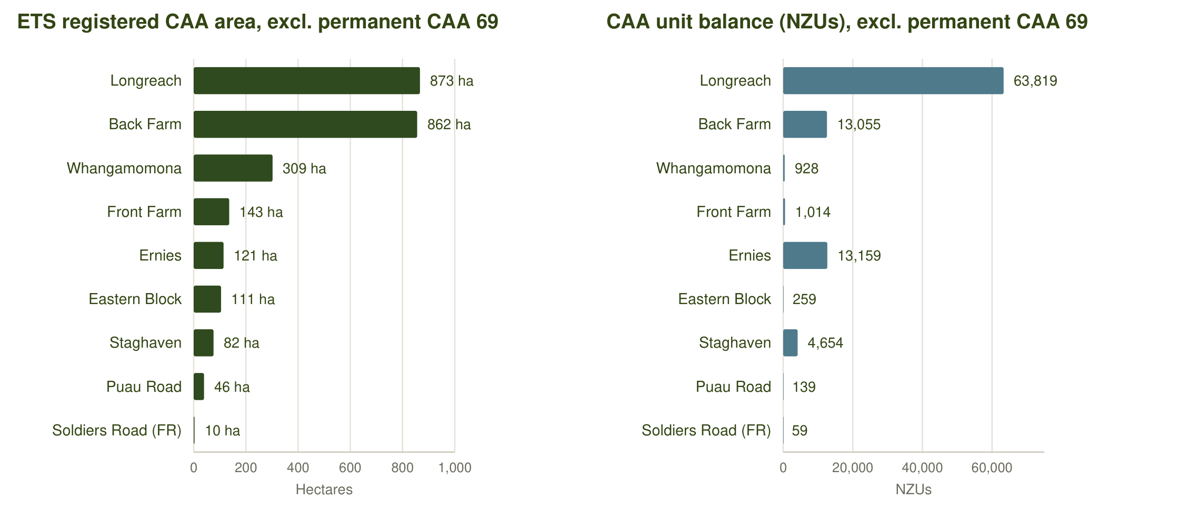
Figure 2 – Registered carbon accounting areas and unit balances by block and accounting category.
- Averaging accounting applies to the 2022–2024 plantings: units are earned to the average age (about year 16 for radiata) with no surrender on harvest, provided the forest is replanted.
- The two permanent-forest accounting areas (PP89, stock change to 28 May 2060) carry the bulk of the unit balance – about 102,000 NZUs – and cannot be clear-felled without surrender.
- Nirvana Farm Limited's carbon account is controlled by NZGT as trustee, which will control the transfer of units at settlement; some Makowhai Station units sit in a separate holding account and all NZUs are intended to be transferred ahead of settlement [TBC – holding balances and NZGT documentation].
- The 2024 CBRE report recorded that carbon units to year 14 (about 1.6 million units at roughly $33) had been pre-sold to the financier; the receivers advise that this contract is to be extinguished [TBC – agreed IM wording].
- Indicatively, about 3,190 ha of open grassland and regenerating scrub across the estate is post-1989 land that could be registered in the ETS, subject to MPI determination and the current rules for new exotic registrations.

2.3 Forestry rights and third-party interests
- Forestry Right 12717687.18 (7 June 2023) – granted by the Makowhai Trust to Nirvana Farm Limited over the planted areas of Back Farm, Front Farm and the Eastern Block (titles 451953, TNB4/1080–1082, TNE3/649, TNF3/564, 565, 567, 568 and TNH1/1356). Included in the sale; the mortgage of the right to Vitol will be discharged at settlement.
- Forestry Right 12717687.19 (7 June 2023) – granted by Land & Bee's Limited to Nirvana Farm Limited over RT 153235 (362 ha) at Soldiers Road, Tuwharenikau Road, covering about 176 ha of 2023 radiata. The right is included; the land is not. [TBC – term, rent and carbon provisions from the registered instrument.]
- Earlier forestry rights registered in 2018–2019 in favour of Longreach Carbon No 1–3 Limited (Longreach), Angiwhai Carbon No 1–6 Limited (Ernies), Makowhai Carbon No 1–7 Limited (Back Farm, Home Block and the Eastern Block), Staghaven Carbon Limited (Staghaven) and Whanga Carbon Limited (Whangamomona) remain on the titles [TBC – these are understood to be the former owner's carbon vehicles; confirm status and whether they are to be surrendered before settlement].
- Sustainable Forest Management permits under s67M of the Forests Act 1949 (indigenous timber, granted 2000–2002) are noted on several Makowhai Trust and Staghaven titles.
Internal note – not for the IM: The 2018–19 carbon-company forestry rights and the QEII covenants were picked up from the October 2026 guaranteed title searches; they are listed per property in Section 5 and need the receivers' confirmation before the IM is released.

3 Farming summary
About 2,141 ha of the estate is open grassland, almost all of it hill country. The farming land is concentrated on the Waitōtara Valley blocks – Front Farm, the Eastern Block, Back Farm, Longreach and Ernies – and on the Nukumaru blocks (Puau Road, Moonys and Ridge Road). Front Farm on Taumatatahi Road is the most developed farm, with the highest proportion of easy contour and the main farm buildings. Farming continues under a grazing lease and stock will be present on parts of the estate at settlement.
Block | Open grassland (ha) | Flat 0–7° | Rolling 8–20° | Medium hill 21–35° | Steep >35° | Leased | Improvements (CBRE 2024)
Longreach | 362 | 10 | 53 | 149 | 151 | No | [TBC – schedule]
Puau Road | 358 | 45 | 45 | 154 | 114 | Part – 948077 | [TBC – schedule]
Eastern Block | 302 | 18 | 64 | 140 | 80 | Yes – TNE3/649 | [TBC – schedule]
Back Farm | 264 | 19 | 40 | 120 | 85 | No | [TBC – schedule]
Front Farm | 227 | 46 | 86 | 72 | 23 | Yes – 451953 | [TBC – schedule]
Moonys | 159 | 25 | 27 | 69 | 38 | No | [TBC – schedule]
Ernies | 130 | 20 | 46 | 48 | 17 | No | [TBC – schedule]
Whangamomona | 84 | 4 | 15 | 38 | 28 | No | [TBC – schedule]
Home Block | 74 | 5 | 16 | 34 | 19 | No | [TBC – schedule]
Ridge Road | 71 | 22 | 23 | 20 | 6 | No | [TBC – schedule]
Staghaven | 65 | 0 | 20 | 45 | 0 | No | [TBC – schedule]
Karapara | 29 | 2 | 6 | 14 | 7 | No | [TBC – schedule]
Patricks House | 11 | 7 | 2 | 2 | 0 | No | [TBC – schedule]
Pakihi | 2 | 0 | 1 | 1 | 0 | No | [TBC – schedule]
Workers House | 2 | 2 | 0 | 0 | 0 | No | [TBC – schedule]
Total | 2,141 | 224 | 443 | 905 | 569

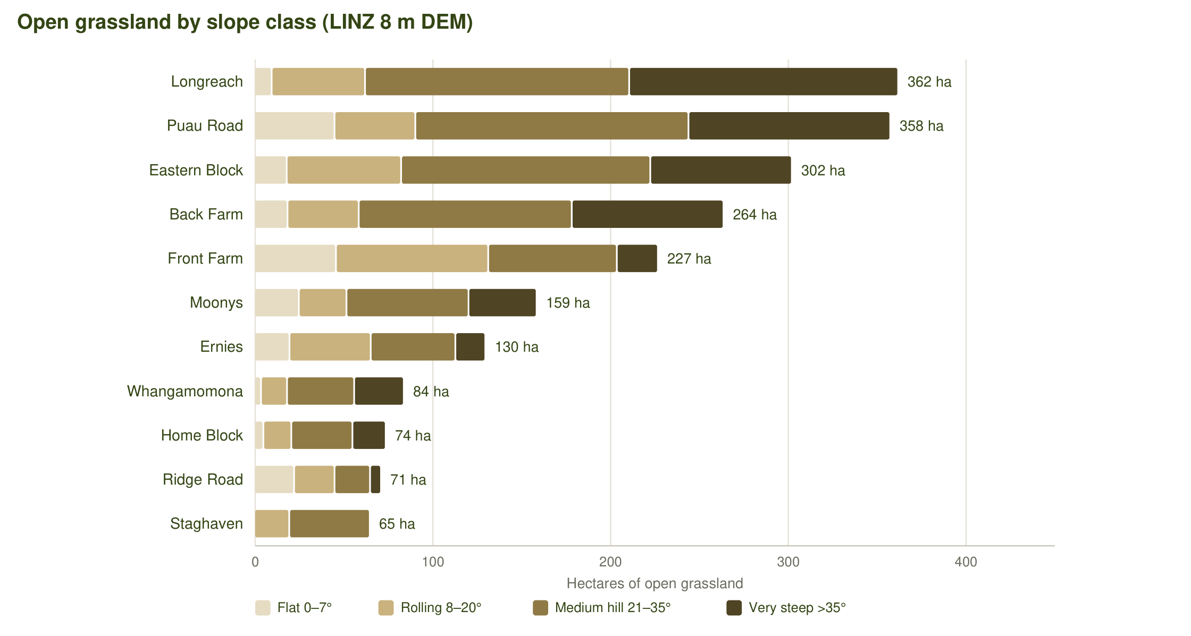
Figure 3 – Open grassland by slope class and block (July 2026 mapping, LINZ DEM).

3.1 Pukekahu Farms grazing lease
Tenant | Pukekahu Farms Limited (guarantors Paul William Kinder and Virginia Kinder-Matthews, Whanganui)
Landlord | Nirvana Farm Limited (55% of rent) and the trustees of the Makowhai Trust (45%)
Term | Five years from 1 January 2025, expiring 31 December 2029
Land | Record of Title 948077 (884.24 ha, Puau Road – Crown lease), 451953 (338.57 ha, Front Farm) and TNE3/649 (1,037.11 ha, Eastern Block) – that part shaded on the lease plans, about 2,200 ha
Rent | $105,000 plus GST per annum ($57,750 to NFL, $47,250 to the Makowhai Trust)
Prepayment | Rent for years 1 and 2 was paid in advance; rent for years 3–5 was prepaid at a discounted $250,000 plus GST. No rent is receivable by a purchaser for the balance of the term.
Permitted use | Grazing of sheep and cattle only; no pigs. Tenant may not cut scrub or trees, light fires or apply chemicals near scrub.
Rights reserved | Landlord retains exclusive beekeeping and honey rights, timber, access for forestry and ETS (Climate Change Response Act) purposes; the lease is subject to the registered forestry rights and confers no rights over existing forestry.
Termination | Landlord may terminate on five months' written notice, on refunding prepaid rent at $83,333.33 plus GST per annum pro rata plus $8,333.33 per month to 31 December 2029.
Dwellings | The tenant is to maintain the two dwellings on the leased land.

Because the rent has been prepaid, a purchaser receives no rental income for the balance of the term but inherits a tenant who maintains the pasture, fences and two dwellings. The landlord's right to terminate on five months' notice (with a pro-rata refund of prepaid rent) gives a purchaser the option of taking the land back for planting or farming. [TBC – the receivers' position on whether the lease is retained or terminated before settlement.]

3.2 Crown leases – Puau Road
Titles | 948076 (720.34 ha, Section 1B Block I Nukumaru SD) and 948077 (884.24 ha, Section 1 Block I Nukumaru SD) – Puau Road
Type | Renewable leases under section 82 of the Land Act 1948 (instruments RL 11709159.1 and .2)
Term | 33 years commencing 1 July 2020
Rent | [TBC – copy of lease in the data room]
Notes | Reassignment is expected to be straightforward (receivers' advice); 948077 is also within the Pukekahu Farms grazing lease. No pine has been planted on the leased titles.

3.3 Dwellings and farm improvements
The estate carries dwellings and farm buildings on the Waitōtara Valley blocks: the Front Farm complex on Taumatatahi Road (occupied by the lessee), a dwelling on the Eastern Block (leased), the workers' dwelling at 228 Taumatatahi Road, Patricks House at 2606 Waitotara Valley Road, and woolsheds, yards and sheds on Back Farm, Ernies, Karapara, the Home Block and Whangamomona. A schedule of buildings by block, with condition and occupancy, is to be supplied [TBC – Stand / receivers]. The former owner's private residence is not on the sale titles [TBC – confirm].
Block | Building outlines (LINZ aerial 2021–22) | Buildings and dwellings | Occupancy
Longreach | 6 (1619, 326, 135, 111… m²) | Six building outlines on the LINZ aerial layer, the largest about 1,600 m² (woolshed / implement shed) with a second shed of about 330 m² and smaller buildings; CBRE carried farm buildings on the block. [TBC – dwelling, condition and occupancy] | [TBC]
Back Farm | 5 (1016, 119, 88 m²) | Woolshed (about 1,000 m²) and yards near the Mataimoana Road entrance with four smaller sheds; Stand note about 3.5 ha of unplanted land around the woolshed. No dwelling recorded. [TBC] | [TBC]
Front Farm | 9 (916, 288, 234, 199… m²) | The main farm complex – nine building outlines including a woolshed / covered yards of about 900 m², a dwelling (about 230–290 m²) and farm sheds; occupied by the lessee (Pukekahu Farms), who maintains the dwellings under the lease. [TBC – number of dwellings, bedrooms, condition] | Lessee (Pukekahu Farms)
Eastern Block | none mapped | One of the two dwellings maintained by the tenant under the Pukekahu Farms lease is on the leased land here or on Front Farm; no building outlines are mapped on the LINZ aerial layer within the titles. [TBC – location and description of the leased dwelling] | Lessee (Pukekahu Farms)
Home Block | 1 (51 m²) | One small building outline (about 50 m²); no dwelling recorded. The former owner's residence is understood to be outside the sale titles. [TBC] | [TBC]
Ernies | 4 (133, 108, 45 m²) | Four building outlines (about 130, 110, 45 and 17 m²) – sheds and a possible cottage on Moewatea Road; CBRE carried farm improvements on the block. [TBC – description and occupancy] | [TBC]
Karapara | none mapped | No building outlines mapped within the titles; CBRE carried improvements (likely yards, fencing and tracks). [TBC] | –
Workers House | 1 (302 m²) | Workers' dwelling at 228 Taumatatahi Road – a single building outline of about 300 m² on 1.7 ha with power and a 1966 electricity agreement on the title. [TBC – bedrooms, condition and occupancy] | [TBC]
Patricks House | 2 (213, 50 m²) | House at 2606 Waitotara Valley Road (about 210 m²) with an outbuilding (about 50 m²); water-supply and power easements registered. A tenant is believed to occupy one of the estate dwellings. [TBC – description, condition and tenancy] | [TBC – tenant]
Puau Road | 1 ( m²) | One small shed (about 25 m²); no dwelling. [TBC] | [TBC]
Moonys | 3 (124, 72 m²) | Three small buildings (about 125, 70 and 20 m²) – sheds / hut; no dwelling recorded. [TBC] | [TBC]
Ridge Road | 5 (182, 54, 48 m²) | Five small buildings off Ridge Road, the largest about 180 m² – sheds; no dwelling recorded. [TBC] | [TBC]
Whangamomona | 7 (625, 163, 162, 79… m²) | Seven building outlines around the Whangamomona Road frontage, the largest about 625 m² (the old woolshed noted by Stand) with two buildings of about 160 m² that may be dwellings or cottages. [TBC – description, condition and occupancy; the block includes the 46 and 105 Whangamomona Road addresses] | [TBC]
Staghaven | 1 ( m²) | One small building (about 20 m²); the Staghaven homestead sits on TNH4/170, which has been sold separately and is not included. [TBC] | [TBC]
Pakihi | 4 (114, 54 m²) | Four small buildings (about 115, 55, 18 and 17 m²) – hut / sheds; no dwelling recorded. [TBC] | [TBC]

Internal note – not for the IM: Building footprints are from the LINZ NZ Building Outlines layer (Taranaki 0.25 m rural aerial photography 2021–22) clipped to the titles; they show what is on the ground but not its use or condition. The council rating records carry improvements value on the combined Waitōtara Valley unit, Longreach, Workers House, Patricks House, Ernies, Karapara, Ridge Road, Whangamomona and Staghaven (Appendix C).

3.4 Access, tracks and fencing
- Road frontage to every block except where noted; Front Farm's stands 1.01 and 5.01, the Eastern Block and Puau Road are worked through the neighbouring Dobson, Larson and Wood Country properties and those permissions need to be re-secured [TBC].
- About 80 km of internal track across the estate (Topo50), with the longest networks on Longreach (17 km), the Home Block (12 km), Karapara (11 km) and Back Farm (10 km); Stand budgeted minor track maintenance on Back Farm, Whangamomona and Puau Road.
- Boundary and internal fencing is variable across the hill country [TBC – fencing condition from Stand].

4 Honey and mānuka summary
The estate was assembled by Settlers Honey, one of the larger mānuka honey producers in Taranaki, and its native bush and regenerating mānuka/kānuka are its largest land cover: 4,673 ha of native forest and 4,518 ha of mānuka/kānuka and scrub, about two-thirds of the land area. The honey business – hives, plant and brand – is not part of the sale, but the mānuka resource, the exclusive beekeeping rights reserved to the landowner under the Pukekahu Farms lease, and the registered indigenous carbon pass with the land. A purchaser may run its own hives, license apiary sites to a honey operator, or manage the regenerating areas for carbon. [TBC – historical hive numbers, apiary sites and honey production by block from the receivers.]
Block | Native bush (ha) | Mānuka / kānuka (ha) | Combined (ha) | Share of block | Registered indigenous carbon | Indicatively ETS-eligible (ha)
Ernies | 546 | 950 | 1,496 | 92% | 121 ha, 13,159 NZUs (CAAs 56 and 66) | 688
Puau Road | 889 | 568 | 1,457 | 78% | – | 445
Karapara | 677 | 612 | 1,288 | 98% | – | 3
Home Block | 673 | 418 | 1,091 | 94% | 19 ha within CAA 69 | 260
Back Farm | 565 | 487 | 1,052 | 50% | 46 ha within CAA 69 | 281
Eastern Block | 399 | 325 | 724 | 68% | 24 ha within CAA 69 | 537
Longreach | 295 | 288 | 583 | 34% | 42 ha (stock change) | 506
Pakihi | 244 | 199 | 443 | 99% | – | 1
Moonys | 94 | 277 | 371 | 58% | – | 36
Whangamomona | 123 | 177 | 300 | 41% | – | 78
Ridge Road | 58 | 153 | 211 | 75% | – | 66
Staghaven | 88 | 12 | 100 | 34% | – | 26
Front Farm | 16 | 27 | 43 | 9% | – | 234
Patricks House | 0 | 17 | 17 | 60% | – | 28
Tims | 5 | 9 | 14 | 100% | – | –
Total | 4,673 | 4,518 | 9,190 | 66% | 163 ha, 18,431 NZUs | 3,190

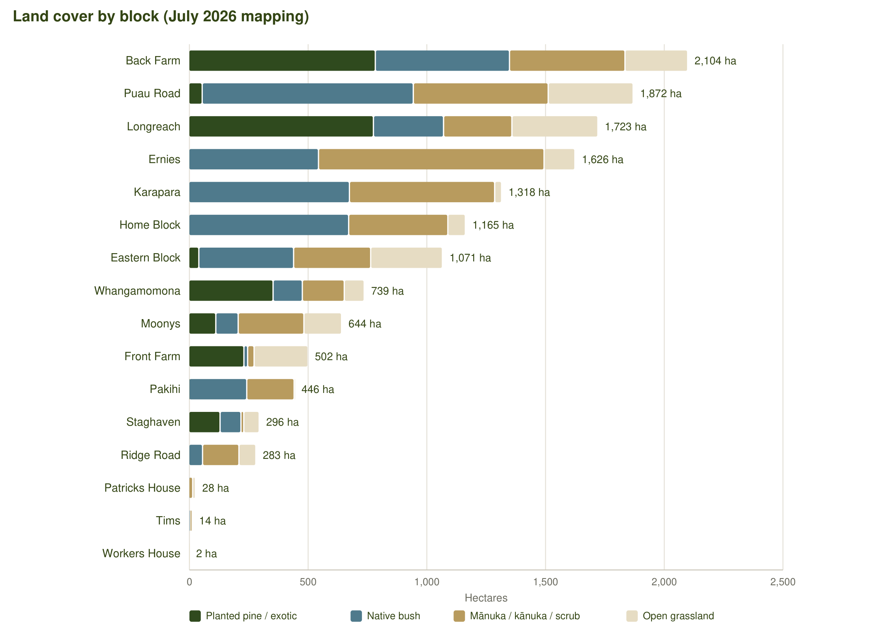
Figure 4 – Land cover by block (July 2026 mapping): radiata, native bush, mānuka/kānuka and open grassland.
- The largest mānuka blocks are Ernies (950 ha of mānuka/kānuka), Karapara (612 ha), Puau Road (568 ha), Back Farm (487 ha) and the Home Block (418 ha); Pakihi at Toatoa (199 ha of mānuka within 446 ha) is a stand-alone mānuka honey block in the eastern Bay of Plenty.
- Two carbon accounting areas of regenerating indigenous forest on Ernies (121 ha, 1991 and 1998) are registered by Makowhai Station under stock change with a unit balance of about 13,200 NZUs; further indigenous areas sit inside the permanent-forest CAA 69 on Back Farm, the Eastern Block and the Home Block.
- About 3,190 ha of regenerating scrub and grassland across the estate is indicatively post-1989 and may be eligible for ETS registration as indigenous forest, the largest areas being Ernies (688 ha), the Eastern Block (537 ha), Longreach (506 ha) and Puau Road (445 ha) – MPI to determine.
- QEII National Trust open space covenants protect native bush on parts of the Home Block (TN119/223, TNE3/650) and Back Farm (TNB4/1080, 1082, 1083); Whangamomona carries a 1991 conservation covenant over part. Sustainable Forest Management permits (Forests Act 1949) are noted on several titles.
- Under the Pukekahu Farms lease the tenant may not cut scrub or trees or apply chemicals near scrub, and the landlord keeps exclusive beekeeping and honey rights over the leased land.
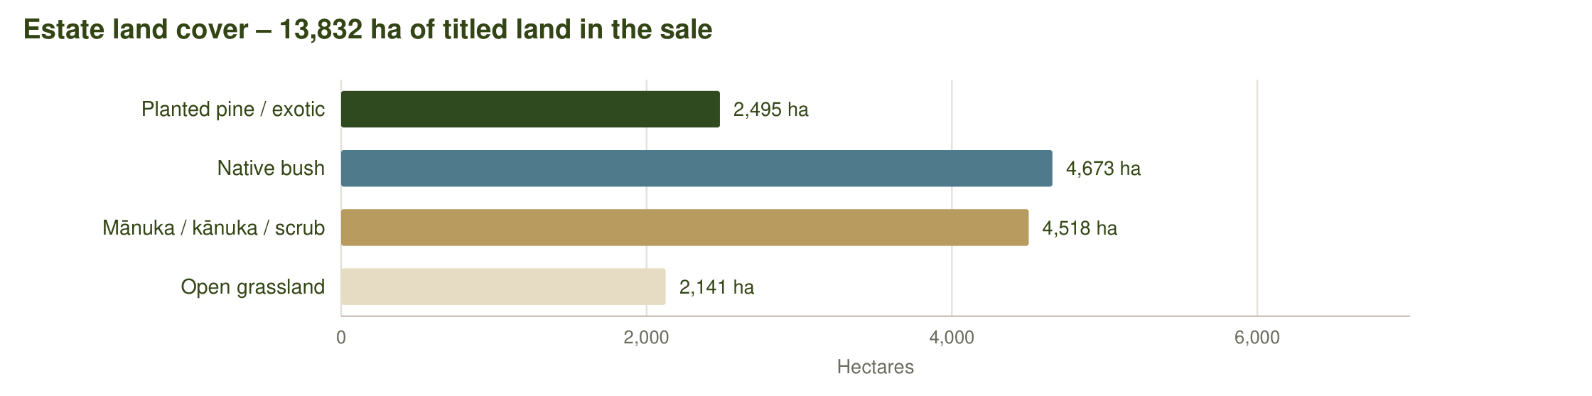
Figure 5 – Estate land cover.

5 The properties
The properties are presented by location. Each property has a key-characteristics table, a description, points to note and the items still to be confirmed, followed by a full-page map. Rating valuations and rates are from the councils' rating records (Appendix C). Buildings are from the LINZ building-outline layer and the lease; the building schedule from the forest manager and the receivers will replace these notes [TBC]. Stand records will replace the ETS-derived planting years [TBC – Stand].
- A Waitōtara Valley and Ngamatapouri – South Taranaki District: Longreach, Back Farm, Front Farm, Eastern Block, Home Block, Ernies, Karapara, Workers House, Patricks House
- B Nukumaru and the Waverley coast – South Taranaki District: Puau Road, Moonys, Ridge Road
- C Eastern Taranaki – Whangamomona, Mangaehu and Puniwhakau – Stratford District: Whangamomona, Staghaven, Tims, Soldiers Road (forestry right) (forestry right), Magons (available separately)
- D Eastern Bay of Plenty – Toatoa – Ōpōtiki District: Pakihi

5A Waitōtara Valley and Ngamatapouri – South Taranaki District
Nine properties lie in the Waitōtara Valley and its side valleys at Ngamatapouri, 30–70 km inland from Waverley on the Waitotara Valley, Taumatatahi, Kapara, Makakaho, Moewatea and Mataimoana Roads. Together they total about 9,540 ha and hold the bulk of the planted radiata, the farming land and the mānuka resource. Longreach, Back Farm, Front Farm, the Eastern Block, the Home Block, Ernies and Karapara form a near-contiguous block of hill country between the Waitōtara and Makakaho catchments.
From | Destination | km
Back Farm (Mataimoana Road) | Waverley | 34
Back Farm (Mataimoana Road) | Whanganui | 78
Back Farm (Mataimoana Road) | Hāwera | 79
Back Farm (Mataimoana Road) | Castlecliff port, Whanganui | 82
Back Farm (Mataimoana Road) | Stratford | 109
Back Farm (Mataimoana Road) | New Plymouth / Port Taranaki | 154
Longreach (Makakaho Road) | Waverley | 69
Longreach (Makakaho Road) | Whanganui | 92
Longreach (Makakaho Road) | Castlecliff port, Whanganui | 95
Longreach (Makakaho Road) | Hāwera | 113
Longreach (Makakaho Road) | Stratford | 143
Longreach (Makakaho Road) | New Plymouth / Port Taranaki | 188

5.1 Longreach
Forestry (Pinus radiata) and carbon · permanent forest · native bush and mānuka · open hill grazing
Land use | Forestry (Pinus radiata) and carbon · permanent forest · native bush and mānuka · open hill grazing
Vendor / interest | Nirvana Farm Limited (In Receivership)
Location / address | 1136 and 1022 Makakaho Road, Ngamatapouri
Total area | 1,723.14 ha (LINZ calculated 1,706.6 ha)
Land cover | Radiata / exotic 778 ha · Native bush 295 ha · Mānuka / kānuka 288 ha · Open grassland 362 ha (July 2026 mapping)
Pinus radiata – net stocked area | 777 ha planted · 691 ha adequately stocked at April 2026 · 27 ha replant + 59 ha blanking in 2026 · 777 ha adequately stocked after 2026. NSA blanked 2026: 102.77 ha with 26 QC plots (Forest360 post-planting QC sheet, 14 Oct 2026). Planting years: 2024 (777 ha); permanent-forest CAA of 1995 and 1997 radiata (84 ha); 1995–2011 radiata (23 ha) and 1997–2007 indigenous (42 ha) under stock change [TBC – stand records]
Contour and land use capability | Predominantly steep to very steep hill country. LUC 7: 1,400 ha (82%); LUC 6: 306 ha (18%) (LRIS NZLRI 2021). Open land by slope: flat (0–7°) 10 ha · rolling (8–20°) 53 ha · medium hill (21–35°) 149 ha · steep (>35°) 151 ha. Altitude 160–580 m above sea level.
ETS status | Registered: 38 CAAs, 873.2 ha, unit balance 63,819 NZUs (MPI land status reports, NFL 28 Sep 2026 / Makowhai Station Aug 2025). NFL as landowner – Stock change – indigenous: 42.3 ha, 5,272 NZUs (7 CAAs); NFL as landowner – Stock change – pine: 23.1 ha, 6,800 NZUs (7 CAAs); NFL as landowner – Permanent (PP89): 84.2 ha, 49,574 NZUs (1 CAA); NFL as landowner – Averaging – 2024: 723.7 ha, 2,173 NZUs (23 CAAs).
Indicatively ETS-eligible land | about 506 ha of post-1989 grassland and scrub (indicative, MPI to determine)
Records of title and legal description | WN24B/478 – Part Maungaporau 1 Shown on Plan B/37 Block (1605.3905 hectares); WN24B/479 – Section 5 Block III Moumahaki Survey District (16.1874 hectares); WNB4/1119 – Lot 1 Deposited Plan 24709 (2.4534 hectares); WNF2/815 – Lot 1 Deposited Plan 27378 (99.1126 hectares). Wellington Land District.
Tenure | Fee simple (freehold)
Title interests (Oct 2026 searches) | Mortgage to Vitol Asia Pte Ltd (7 June 2023) – to be discharged at settlement; Registered forestry right(s) to Longreach Carbon No 1 Limited, Longreach Carbon No 2 Limited, Longreach Carbon No 3 Limited (registered 2018–2019) [TBC – status, and whether these rights are to be surrendered before settlement] (WN24B/478); Notice(s) under s195(2) Climate Change Response Act 2002 (ETS registration) (WN24B/478, WN24B/479, WNF2/815)
Zoning | Rural Zone – Operative South Taranaki District Plan (2021)
Territorial authority | South Taranaki District
Regional council | Taranaki Regional Council
Rating valuation and rates | South Taranaki DC assessment 1241002900 – 1136 Makakaho Road, Ngamatapouri – all four titles (1,723.14 ha): land value $8,200,000, improvements $650,000, capital value $8,850,000; rates $20,799 p.a. (district $17,492 + regional $3,307)
Leases / occupation | None known [TBC]
Access | Road frontage to Makakaho Road. No tracking work required; about 35 ha of the blanking area is isolated by a bluff and needs aerial access. Internal tracks about 17.1 km and formed road 0.1 km (Topo50).
Buildings and dwellings | Six building outlines on the LINZ aerial layer, the largest about 1,600 m² (woolshed / implement shed) with a second shed of about 330 m² and smaller buildings; CBRE carried farm buildings on the block. [TBC – dwelling, condition and occupancy]

Description
Longreach is the largest Nirvana Farm Limited block and the best-performing young crop in the estate. About 777 ha of Pinus radiata was planted in 2024 across the 1,723 ha property and Stand found high survival throughout, with only 27 ha of replanting and 59 ha of blanking programmed for 2026. A pre-planting cull and constant ongoing pest control have kept pest pressure low, and only maintenance control is needed. The block also carries the estate's most valuable carbon position: an 84 ha permanent-forest accounting area of 1995 and 1997 radiata with a unit balance of about 49,600 NZUs, and a further 65 ha of older pine and regenerating indigenous forest registered under stock change. The balance of the property is native bush, mānuka/kānuka and about 362 ha of open hill country, much of it steep.

Points to note
- Approximately 506 ha of open and scrub land is indicatively ETS-eligible (post-1989 land), subject to MPI determination.

Items to confirm
- [TBC] Stand records for the 1995–2011 plantings and the intended regime (permanent or harvest).
- [TBC] Improvements on the block (CBRE carried $655,000).
- [TBC] Whether the 35 ha of bluff-isolated blanking is to be completed or excluded.

Longreach – property map
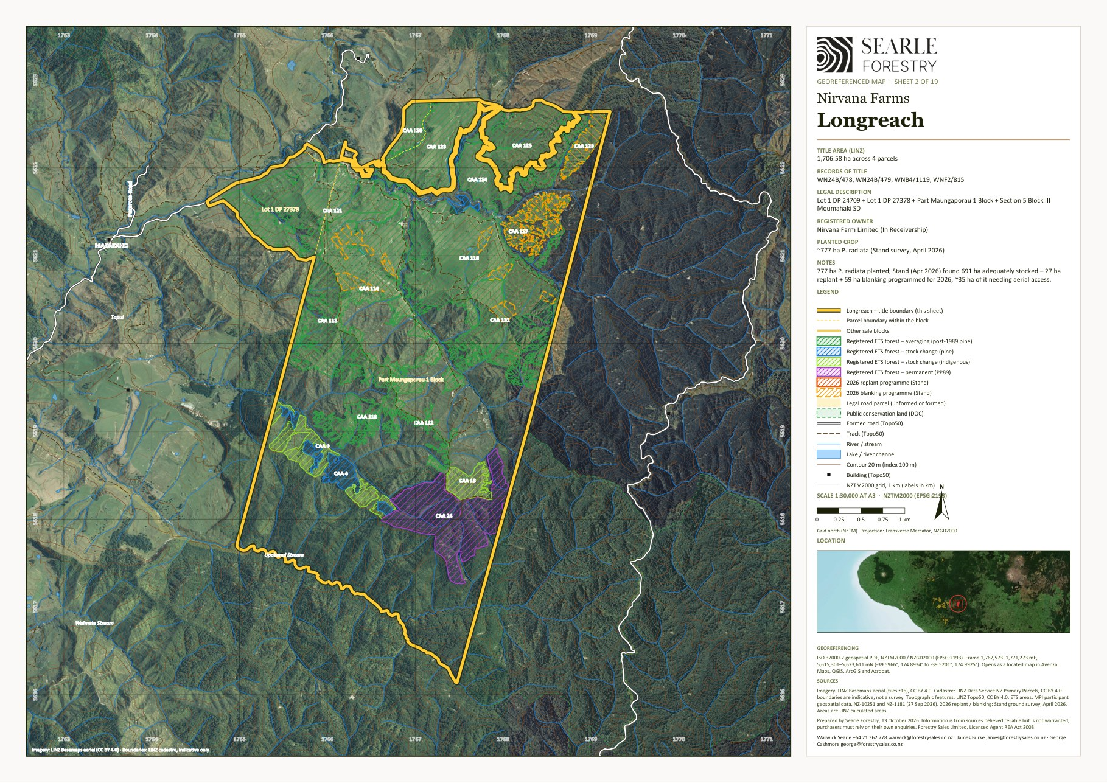
Georeferenced sheet from the Nirvana Farms map set (LINZ cadastre, LINZ aerial imagery, MPI ETS data, Stand 2026 programme). The designer may substitute a styled version; the GeoPDF sheets are supplied in the IM/maps folder and the data room.

5.2 Back Farm
Forestry (Pinus radiata) and carbon · permanent forest · native bush and mānuka · open hill grazing
Land use | Forestry (Pinus radiata) and carbon · permanent forest · native bush and mānuka · open hill grazing
Vendor / interest | Trustees of the Makowhai Trust – titles in receivership (A Grenfell and K Johnstone, McGrathNicol)
Location / address | Mataimoana Road, Waverley (187 Mataimoana Road)
Total area | 2,104.37 ha
Land cover | Radiata / exotic 786 ha · Native bush 565 ha · Mānuka / kānuka 487 ha · Open grassland 264 ha (July 2026 mapping)
Pinus radiata – net stocked area | 785 ha planted · 500 ha adequately stocked at April 2026 · 50 ha replant + 235 ha blanking in 2026 · 785 ha adequately stocked after 2026 · 3.5 ha further plantable. NSA blanked 2026: 223.65 ha with 57 QC plots (Forest360 post-planting QC sheet, 14 Oct 2026). Planting years: 2022 (188 ha) and 2023 (437 ha) under the NFL forestry right; 2022 (144 ha) by Makowhai Station; 1994 radiata (66 ha) and indigenous within permanent-forest CAA 69 [TBC – stand records]
Contour and land use capability | Predominantly steep to very steep hill country. LUC 7: 1,682 ha (80%); LUC 6: 422 ha (20%) (LRIS NZLRI 2021). Open land by slope: flat (0–7°) 19 ha · rolling (8–20°) 40 ha · medium hill (21–35°) 120 ha · steep (>35°) 85 ha. Altitude 140–560 m above sea level.
ETS status | Registered: 42 CAAs, 952.5 ha, unit balance 64,769 NZUs (MPI land status reports, NFL 28 Sep 2026 / Makowhai Station Aug 2025). Makowhai Station – Averaging – 2022: 144.1 ha, 4,371 NZUs (11 CAAs); Makowhai Station – Permanent (PP89): 183.2 ha, 52,466 NZUs (1 CAA); NFL as forestry-right holder – Averaging – 2023: 436.8 ha, 2,862 NZUs (24 CAAs); NFL as forestry-right holder – Averaging – 2022: 188.4 ha, 5,070 NZUs (6 CAAs).
Indicatively ETS-eligible land | about 281 ha of post-1989 grassland and scrub (indicative, MPI to determine)
Records of title and legal description | TNA3/681 – Section 2 and Section 4 Block IX Kapara Survey District (212.8646 hectares); TNB4/1080 – Section 1 Block IX Kapara Survey District (121.4057 hectares); TNB4/1081 – Section 4 Block V Kapara Survey District (283.2799 hectares); TNB4/1082 – Section 5 Block V Kapara Survey District (258.1894 hectares); TNB4/1083 – Section 3 Block IX Kapara Survey District (256.9754 hectares); TNE4/125 – Section 6 Block XII Opaku Survey District (142.4493 hectares); TNF3/568 – Section 6 Block V Kapara Survey District (475.1009 hectares); TNH1/1356 – Section 8 Block VI Kapara Survey District (354.0999 hectares). Taranaki Land District.
Tenure | Fee simple (freehold); registered owners are the trustees of the Makowhai Trust (H R Matthews, J Cain, M J Wallace) – sold by the receivers appointed over the titles
Title interests (Oct 2026 searches) | Mortgage to Vitol Asia Pte Ltd (7 June 2023) – to be discharged at settlement; Registered forestry right(s) to Makowhai Carbon No 7 Limited (registered 2018–2019) [TBC – status, and whether these rights are to be surrendered before settlement] (TNA3/681, TNB4/1080); Notice(s) under s195(2) Climate Change Response Act 2002 (ETS registration) (TNA3/681, TNB4/1080, TNB4/1081, TNB4/1082, TNB4/1083, TNF3/568, TNH1/1356); Forestry Right 12717687.18 to Nirvana Farm Limited (7 June 2023) over the planted areas – included in the sale; the mortgage of that forestry right to Vitol is to be discharged (TNB4/1080, TNB4/1081, TNB4/1082, TNF3/568, TNH1/1356); QEII National Trust open space covenant (2015) over part (TNB4/1080, TNB4/1082, TNB4/1083); Easements – electricity / telecommunications transmission and water supply (TNB4/1082, TNB4/1083); Sustainable Forest Management permit under s67M Forests Act 1949 (indigenous timber, 2000–2002) (TNB4/1083, TNE4/125, TNF3/568, TNH1/1356); Standard Crown mineral reservations (Petroleum, Mining, Coal Mines, Atomic Energy and Geothermal Energy Acts) (TNH1/1356)
Zoning | Rural Zone – Operative South Taranaki District Plan (2021)
Territorial authority | South Taranaki District
Regional council | Taranaki Regional Council
Rating valuation and rates | Rated mainly within one South Taranaki DC unit with Front Farm, the Eastern Block and the Home Block – South Taranaki DC assessment 1241011200 (SUIP B) – 845 Taumatatahi Road, Waitotara – Secs 4–6 Blk V, Secs 1–4 Blk IX, Secs 4, 6, 24–25, Pt Sec 9 Blk VI, Sec 1 Blk X Kapara SD, Makowhai 1A, 1B, 2 Blocks, Lots 2–3 DP 179, Lot 2 DP 413240 (3,830.27 ha): land value $14,450,000, improvements $1,190,000, capital value $15,640,000; rates $35,276 p.a. (district $29,655 + regional $5,621) Plus two stand-alone units: South Taranaki DC assessment 1241009600 – Mataimoana Road, Ngamatapouri (354.10 ha): land value $430,000, improvements $0, capital value $430,000; rates $1,882 p.a. (district $1,590 + regional $291) South Taranaki DC assessment 1245008700 – Okahutiria Road, Waverley (142.45 ha): land value $138,000, improvements $0, capital value $138,000; rates $1,259 p.a. (district $1,067 + regional $192)
Leases / occupation | None known [TBC]
Access | Road frontage to Mataimoana Road. Main track from Mataimoana Road to the woolshed needs minor maintenance; aerial lifting of seedlings and chemical needed for parts of the block. Internal tracks about 9.7 km and formed road 2.7 km (Topo50).
Buildings and dwellings | Woolshed (about 1,000 m²) and yards near the Mataimoana Road entrance with four smaller sheds; Stand note about 3.5 ha of unplanted land around the woolshed. No dwelling recorded. [TBC]

Description
The largest planted block in the estate and the core of the Makowhai Trust land. Roughly 785 ha of Pinus radiata was established across 2022 and 2023 on the easier faces of a 2,104 ha hill-country holding, with the balance in native bush and regenerating mānuka/kānuka and about 264 ha of open grassland. Stand's April 2026 ground survey found the 2023 plantings growing well and the 2022 areas the weakest, and programmed 50 ha of replanting and 235 ha of blanking for the 2026 season to bring the whole 785 ha back to a stocking above 850 stems/ha. Deer, with some goats and pigs, are present: a culling programme was carried out before planting and constant pest control continues to keep the pressure on them. An older 65 ha stand of 1994 radiata sits within the permanent-forest carbon accounting area on TNA3/681.

Points to note
- Deer, goats and pigs are present; a pre-planting culling programme and ongoing constant pest control keep the pressure on them across the 2026 worked areas.
- The 2022 plantings carry the lowest survival; the 2023 plantings are performing well.
- Planted areas are registered by Nirvana Farm Limited under its forestry right over the Makowhai Trust titles, with a further 144 ha registered by Makowhai Station as landowner.

Items to confirm
- [TBC] Completion certificate for the 2026 replant/blanking (Forest360 post-planting QC sheet of 14 October 2026 received).
- [TBC] Description of the woolshed and any other improvements (CBRE carried $450,000 of improvements).
- [TBC] Whether the 65.6 ha 1994 stand is to be harvested or retained as permanent forest.

Back Farm – property map
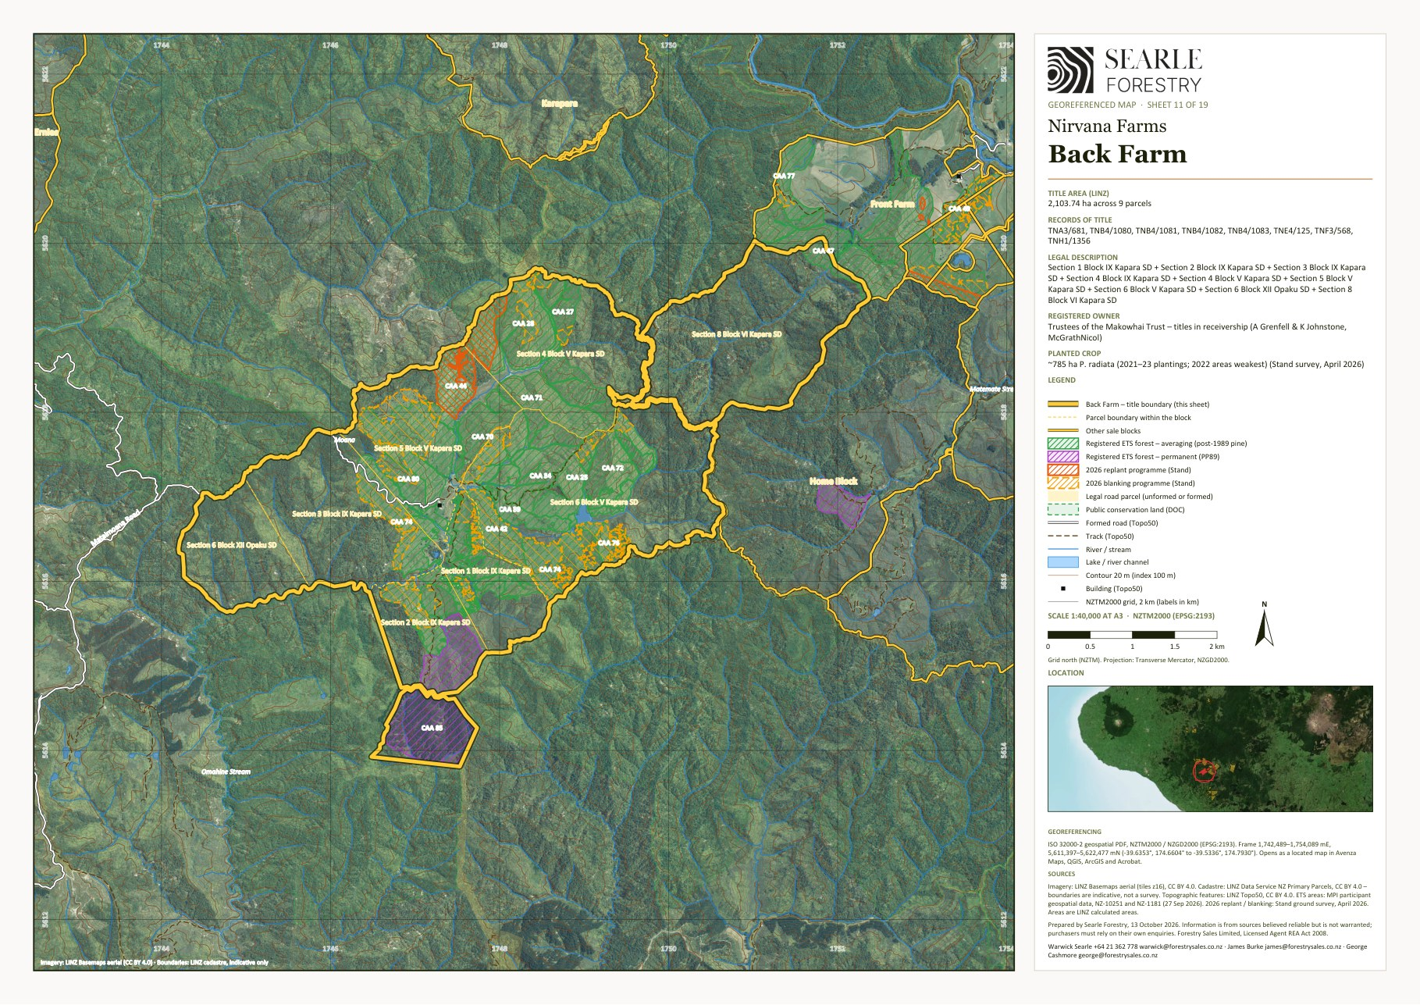
Georeferenced sheet from the Nirvana Farms map set (LINZ cadastre, LINZ aerial imagery, MPI ETS data, Stand 2026 programme). The designer may substitute a styled version; the GeoPDF sheets are supplied in the IM/maps folder and the data room.

5.3 Front Farm
Forestry (Pinus radiata) and carbon · grazing (leased to Pukekahu Farms) · farm buildings
Land use | Forestry (Pinus radiata) and carbon · grazing (leased to Pukekahu Farms) · farm buildings
Vendor / interest | Trustees of the Makowhai Trust – titles in receivership (A Grenfell and K Johnstone, McGrathNicol)
Location / address | 779–865 Taumatatahi Road, Ngamatapouri
Total area | 502.07 ha
Land cover | Radiata / exotic 232 ha · Native bush 16 ha · Mānuka / kānuka 27 ha · Open grassland 227 ha (July 2026 mapping)
Pinus radiata – net stocked area | 231 ha planted · 184 ha adequately stocked at April 2026 · 12 ha replant + 35 ha blanking in 2026 · 231 ha adequately stocked after 2026 · 140.0 ha further plantable. NSA blanked 2026: 51.56 ha with 24 QC plots (Forest360 post-planting QC sheet, 14 Oct 2026). Planting years: 2023 (231 ha) [TBC – stand records]
Contour and land use capability | Predominantly rolling to easy hill. LUC 4: 278 ha (55%); LUC 7: 185 ha (37%); LUC 6: 39 ha (8%) (LRIS NZLRI 2021). Open land by slope: flat (0–7°) 46 ha · rolling (8–20°) 86 ha · medium hill (21–35°) 72 ha · steep (>35°) 23 ha. Altitude 60–420 m above sea level.
ETS status | Registered: 6 CAAs, 235.8 ha, unit balance 1,766 NZUs (MPI land status reports, NFL 28 Sep 2026 / Makowhai Station Aug 2025). Makowhai Station – Averaging – 2023: 34.0 ha, 262 NZUs (3 CAAs); NFL as forestry-right holder – Averaging – 2023: 201.7 ha, 1,504 NZUs (3 CAAs).
Indicatively ETS-eligible land | about 234 ha of post-1989 grassland and scrub (indicative, MPI to determine)
Records of title and legal description | 451953 – Lot 2 Deposited Plan 413240 (338.5727 hectares); TNF3/564 – Section 25 Block VI Kapara Survey District (40.4686 hectares); TNF3/565 – Section 24 Block VI Kapara Survey District (45.3248 hectares); TNF3/566 – Section 6 Block VI Kapara Survey District (47.3482 hectares); TNF3/567 – Section 4 Block VI Kapara Survey District (30.3514 hectares). Taranaki Land District.
Tenure | Fee simple (freehold); registered owners are the trustees of the Makowhai Trust (H R Matthews, J Cain, M J Wallace) – sold by the receivers appointed over the titles
Title interests (Oct 2026 searches) | Mortgage to Vitol Asia Pte Ltd (7 June 2023) – to be discharged at settlement; Forestry Right 12717687.18 to Nirvana Farm Limited (7 June 2023) over the planted areas – included in the sale; the mortgage of that forestry right to Vitol is to be discharged (451953, TNF3/564, TNF3/565, TNF3/567); Notice(s) under s195(2) Climate Change Response Act 2002 (ETS registration) (451953, TNF3/564, TNF3/565, TNF3/567)
Zoning | Rural Zone – Operative South Taranaki District Plan (2021)
Territorial authority | South Taranaki District
Regional council | Taranaki Regional Council
Rating valuation and rates | Rated within one South Taranaki DC unit with Back Farm – South Taranaki DC assessment 1241011200 (SUIP B) – 845 Taumatatahi Road, Waitotara – Secs 4–6 Blk V, Secs 1–4 Blk IX, Secs 4, 6, 24–25, Pt Sec 9 Blk VI, Sec 1 Blk X Kapara SD, Makowhai 1A, 1B, 2 Blocks, Lots 2–3 DP 179, Lot 2 DP 413240 (3,830.27 ha): land value $14,450,000, improvements $1,190,000, capital value $15,640,000; rates $35,276 p.a. (district $29,655 + regional $5,621) No separate rating valuation exists for this block. [TBC – apportionment]
Leases / occupation | Title 451953 (338.6 ha) within the Pukekahu Farms grazing lease to 31 December 2029 (rent prepaid); lessee in occupation
Access | Road frontage to Taumatatahi Road. No tracking work required. Stands 1.01 and 5.01 are reached through the neighbouring Dobson farm on the northern boundary – permission to be obtained. Internal tracks about 6.5 km and formed road 1.4 km (Topo50).
Buildings and dwellings | The main farm complex – nine building outlines including a woolshed / covered yards of about 900 m², a dwelling (about 230–290 m²) and farm sheds; occupied by the lessee (Pukekahu Farms), who maintains the dwellings under the lease. [TBC – number of dwellings, bedrooms, condition]

Description
The most developed farm in the estate: 502 ha on Taumatatahi Road with the highest proportion of easy contour, about 231 ha of 2023 Pinus radiata and some 227 ha of open pasture, 140 ha of which Stand identified as suitable for new planting. Survival is good overall (184 ha adequately stocked) with stand 1.03 needing 12 ha of replanting and 35 ha of blanking, largely from pest damage. The farm (title 451953, 338.6 ha) is within the Pukekahu Farms grazing lease to 31 December 2029 and is occupied by the lessee; CBRE's improvement value of $855,000 indicates the main farm buildings and a dwelling.

Points to note
- About 140 ha of open ground is plantable (ETS eligibility would depend on the registration ballot).
- Goats had ring-barked trees in the north of stand 1.01; constant pest control continues to keep the pressure on them. Aerial lifting budget of $3,300 is sufficient.

Items to confirm
- [TBC] Dwelling(s), woolshed, yards and other improvements, and who occupies them.
- [TBC] Fencing between the leased pasture and the planted stands.

Front Farm – property map
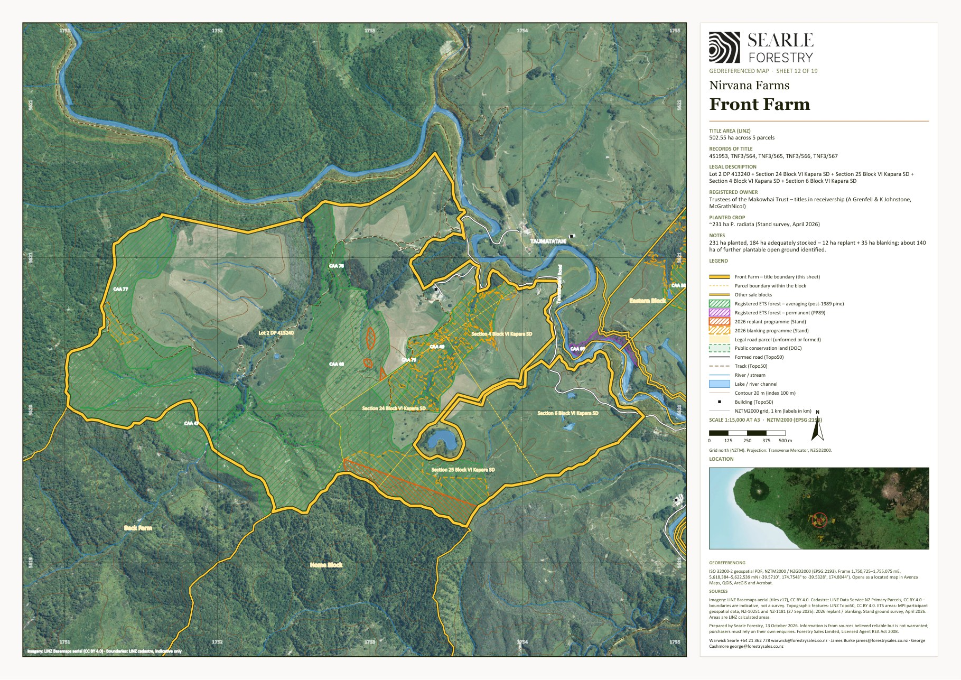
Georeferenced sheet from the Nirvana Farms map set (LINZ cadastre, LINZ aerial imagery, MPI ETS data, Stand 2026 programme). The designer may substitute a styled version; the GeoPDF sheets are supplied in the IM/maps folder and the data room.

5.4 Eastern Block
Forestry (Pinus radiata) and carbon · native bush and mānuka · grazing (leased to Pukekahu Farms)
Land use | Forestry (Pinus radiata) and carbon · native bush and mānuka · grazing (leased to Pukekahu Farms)
Vendor / interest | Trustees of the Makowhai Trust – titles in receivership (A Grenfell and K Johnstone, McGrathNicol)
Location / address | 776–845 Kapara Road, Ngamatapouri (Makowhai 1A, 1B and 2 Blocks)
Total area | 1,071.47 ha
Land cover | Radiata / exotic 42 ha · Native bush 399 ha · Mānuka / kānuka 325 ha · Open grassland 302 ha (July 2026 mapping)
Pinus radiata – net stocked area | 138 ha planted · 0 ha adequately stocked at April 2026 · 18 ha replant + 20 ha blanking in 2026 · 38 ha adequately stocked after 2026 · 70.0 ha further plantable. NSA blanked 2026: 36.01 ha with 17 QC plots (Forest360 post-planting QC sheet, 14 Oct 2026). Planting years: 2023 (25 ha) and 2024 (86 ha) registered; about 138 ha planted 2023–24 including the failed stand 1.03 [TBC – stand records]
Contour and land use capability | Predominantly steep to very steep hill country. LUC 7: 868 ha (81%); LUC 6: 160 ha (15%); LUC 4: 43 ha (4%) (LRIS NZLRI 2021). Open land by slope: flat (0–7°) 18 ha · rolling (8–20°) 64 ha · medium hill (21–35°) 140 ha · steep (>35°) 80 ha. Altitude 40–500 m above sea level.
ETS status | Registered: 15 CAAs, 111.2 ha, unit balance 259 NZUs (MPI land status reports, NFL 28 Sep 2026 / Makowhai Station Aug 2025). NFL as forestry-right holder – Averaging – 2023: 25.3 ha (4 CAAs); NFL as forestry-right holder – Averaging – 2024: 86.0 ha, 259 NZUs (11 CAAs).
Indicatively ETS-eligible land | about 537 ha of post-1989 grassland and scrub (indicative, MPI to determine)
Records of title and legal description | TNB4/1024 – Makowhai 2 Block (6.3232 hectares); TNE3/648 – Makowhai 1A Block (28.0371 hectares); TNE3/649 – Lot 2-3 Deposited Plan 179 and Makowhai 1B Block (1037.1081 hectares). Taranaki Land District.
Tenure | Fee simple (freehold); registered owners are the trustees of the Makowhai Trust (H R Matthews, J Cain, M J Wallace) – sold by the receivers appointed over the titles
Title interests (Oct 2026 searches) | Mortgage to Vitol Asia Pte Ltd (7 June 2023) – to be discharged at settlement; Forestry Right 12717687.18 to Nirvana Farm Limited (7 June 2023) over the planted areas – included in the sale; the mortgage of that forestry right to Vitol is to be discharged (TNE3/649); Registered forestry right(s) to Makowhai Carbon No 4 Limited, Makowhai Carbon No 5 Limited, Makowhai Carbon No 6 Limited, Makowhai Carbon No 7 Limited (registered 2018–2019) [TBC – status, and whether these rights are to be surrendered before settlement] (TNE3/649); Sustainable Forest Management permit under s67M Forests Act 1949 (indigenous timber, 2000–2002) (TNE3/649); Notice(s) under s195(2) Climate Change Response Act 2002 (ETS registration) (TNE3/649)
Zoning | Rural Zone – Operative South Taranaki District Plan (2021)
Territorial authority | South Taranaki District
Regional council | Taranaki Regional Council
Rating valuation and rates | Rated within one South Taranaki DC unit with Back Farm – South Taranaki DC assessment 1241011200 (SUIP B) – 845 Taumatatahi Road, Waitotara – Secs 4–6 Blk V, Secs 1–4 Blk IX, Secs 4, 6, 24–25, Pt Sec 9 Blk VI, Sec 1 Blk X Kapara SD, Makowhai 1A, 1B, 2 Blocks, Lots 2–3 DP 179, Lot 2 DP 413240 (3,830.27 ha): land value $14,450,000, improvements $1,190,000, capital value $15,640,000; rates $35,276 p.a. (district $29,655 + regional $5,621) No separate rating valuation exists for this block. [TBC – apportionment]
Leases / occupation | Title TNE3/649 (1,037 ha) within the Pukekahu Farms grazing lease to 31 December 2029 (rent prepaid); leased dwelling
Access | Previously worked through the neighbouring Larson property; the track network through the Matthews/Wallace title is suitable but has a culvert near the end of its life. Access permission needs to be re-secured. Internal tracks about 4.1 km (Topo50).
Buildings and dwellings | One of the two dwellings maintained by the tenant under the Pukekahu Farms lease is on the leased land here or on Front Farm; no building outlines are mapped on the LINZ aerial layer within the titles. [TBC – location and description of the leased dwelling]

Description
A 1,071 ha hill-country block adjoining Front Farm and the Home Block. About 138 ha was planted in 2023–24, but stand 1.03 has failed to pest damage in heavy scrub and Stand have excluded it from the 2026 programme because of the difficulty of reaching the area and the helicopter-lifting cost; the culling programme carried out before planting and constant ongoing pest control continue on the rest of the block. Stand 1.01 is to be replanted (18 ha) and blanked (20 ha), giving about 38 ha of adequately stocked crop after the 2026 season. The property is predominantly native bush and mānuka/kānuka with roughly 300 ha of open grassland, of which about 70 ha has been identified as plantable new ground. Most of the block (title TNE3/649, 1,037 ha) is within the Pukekahu Farms grazing lease to 31 December 2029 and carries one of the leased dwellings.

Points to note
- Stand 1.03 (about 100 ha) is not being remediated; a purchaser may choose to re-establish it under the ongoing pest-control programme.
- The Eastern Block lease was granted without the financier's formal consent and could be cleared if required (receivers' advice).
- About 537 ha of open and scrub land is indicatively ETS-eligible.

Items to confirm
- [TBC] Status of the failed stand 1.03 in the ETS (CAA area and any liability on removal from the register).
- [TBC] Improvements (CBRE carried $755,000 – dwelling and farm buildings) and the leased dwelling.
- [TBC] Access arrangement over the Larson property.

Eastern Block – property map
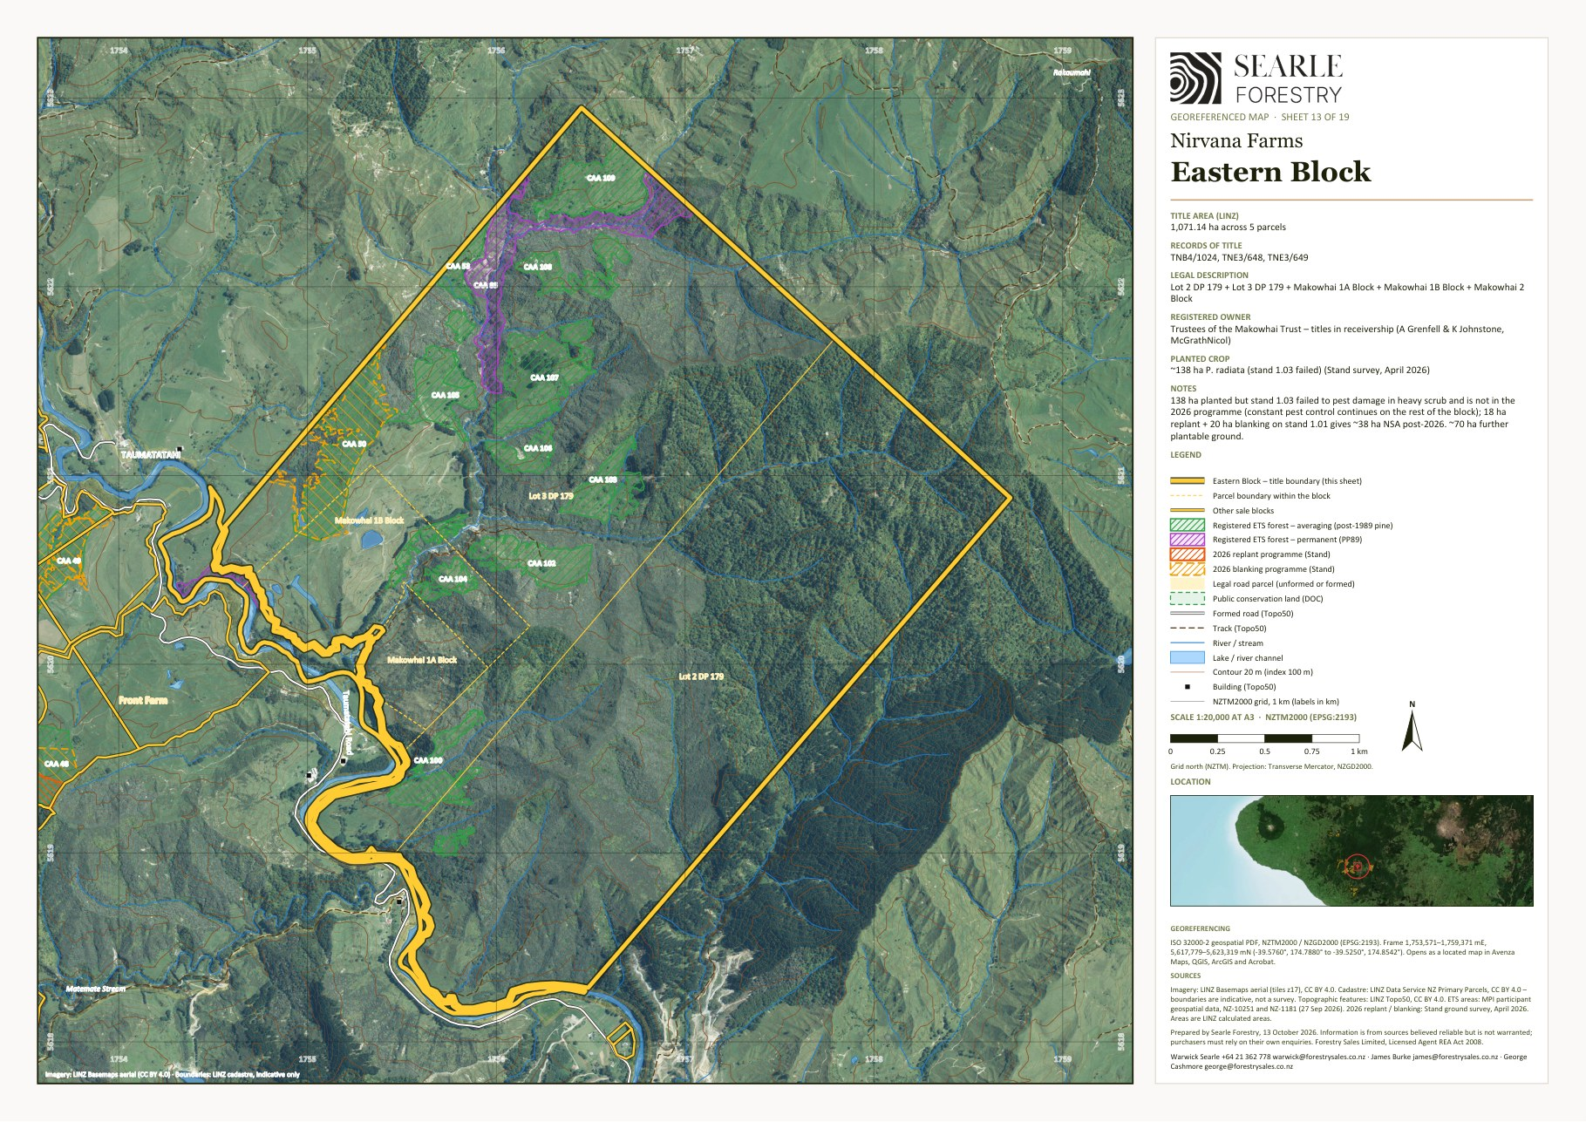
Georeferenced sheet from the Nirvana Farms map set (LINZ cadastre, LINZ aerial imagery, MPI ETS data, Stand 2026 programme). The designer may substitute a styled version; the GeoPDF sheets are supplied in the IM/maps folder and the data room.

5.5 Home Block
Native bush and mānuka (honey) · carbon (indigenous) · open hill grazing
Land use | Native bush and mānuka (honey) · carbon (indigenous) · open hill grazing
Vendor / interest | Trustees of the Makowhai Trust – titles in receivership (A Grenfell and K Johnstone, McGrathNicol)
Location / address | 776–845 Kapara Road, Ngamatapouri
Total area | 1,165.17 ha (LINZ calculated 1,168.6 ha)
Land cover | Native bush 673 ha · Mānuka / kānuka 418 ha · Open grassland 74 ha (July 2026 mapping)
Pinus radiata – net stocked area | No radiata crop
Contour and land use capability | Predominantly steep to very steep hill country. LUC 7: 1,054 ha (90%); LUC 6: 115 ha (10%) (LRIS NZLRI 2021). Open land by slope: flat (0–7°) 5 ha · rolling (8–20°) 16 ha · medium hill (21–35°) 34 ha · steep (>35°) 19 ha. Altitude 100–500 m above sea level.
ETS status | No carbon accounting areas registered on the block
Indicatively ETS-eligible land | about 260 ha of post-1989 grassland and scrub (indicative, MPI to determine)
Records of title and legal description | TN119/223 – Part Section 9 Block VI Kapara Survey District (687.6368 hectares); TNE3/650 – Section 1 Block X Kapara Survey District (477.5290 hectares). Taranaki Land District.
Tenure | Fee simple (freehold); registered owners are the trustees of the Makowhai Trust (H R Matthews, J Cain, M J Wallace) – sold by the receivers appointed over the titles
Title interests (Oct 2026 searches) | Mortgage to Vitol Asia Pte Ltd (7 June 2023) – to be discharged at settlement; Registered forestry right(s) to Makowhai Carbon No 1 Limited, Makowhai Carbon No 2 Limited, Makowhai Carbon No 3 Limited, Makowhai Carbon No 6 Limited, Makowhai Carbon No 7 Limited (registered 2018–2019) [TBC – status, and whether these rights are to be surrendered before settlement] (TN119/223); QEII National Trust open space covenant (2015) over part; Sustainable Forest Management permit under s67M Forests Act 1949 (indigenous timber, 2000–2002); Notice(s) under s195(2) Climate Change Response Act 2002 (ETS registration); Registered forestry right(s) to Makowhai Carbon No 1 Limited, Makowhai Carbon No 2 Limited, Makowhai Carbon No 3 Limited (registered 2018–2019) [TBC – status, and whether these rights are to be surrendered before settlement] (TNE3/650)
Zoning | Rural Zone – Operative South Taranaki District Plan (2021)
Territorial authority | South Taranaki District
Regional council | Taranaki Regional Council
Rating valuation and rates | Rated within one South Taranaki DC unit with Back Farm – South Taranaki DC assessment 1241011200 (SUIP B) – 845 Taumatatahi Road, Waitotara – Secs 4–6 Blk V, Secs 1–4 Blk IX, Secs 4, 6, 24–25, Pt Sec 9 Blk VI, Sec 1 Blk X Kapara SD, Makowhai 1A, 1B, 2 Blocks, Lots 2–3 DP 179, Lot 2 DP 413240 (3,830.27 ha): land value $14,450,000, improvements $1,190,000, capital value $15,640,000; rates $35,276 p.a. (district $29,655 + regional $5,621) No separate rating valuation exists for this block. [TBC – apportionment]
Leases / occupation | None known [TBC]
Access | Kapara Road frontage [TBC]. Internal tracks about 12.2 km (Topo50).
Buildings and dwellings | One small building outline (about 50 m²); no dwelling recorded. The former owner's residence is understood to be outside the sale titles. [TBC]

Description
Two titles of 1,165 ha between Front Farm and the Eastern Block: 673 ha of native bush, 418 ha of mānuka/kānuka and about 74 ha of open ground. About 260 ha of the scrub and grassland is indicatively post-1989 and potentially ETS-eligible. CBRE carried $275,000 of improvements. The private residence occupied by the former owner is understood not to be on the land being sold.

Points to note
- No Pinus radiata on the block.

Items to confirm
- [TBC] Improvements and occupancy; confirm the former owner's residence is outside the sale titles.

Home Block – property map
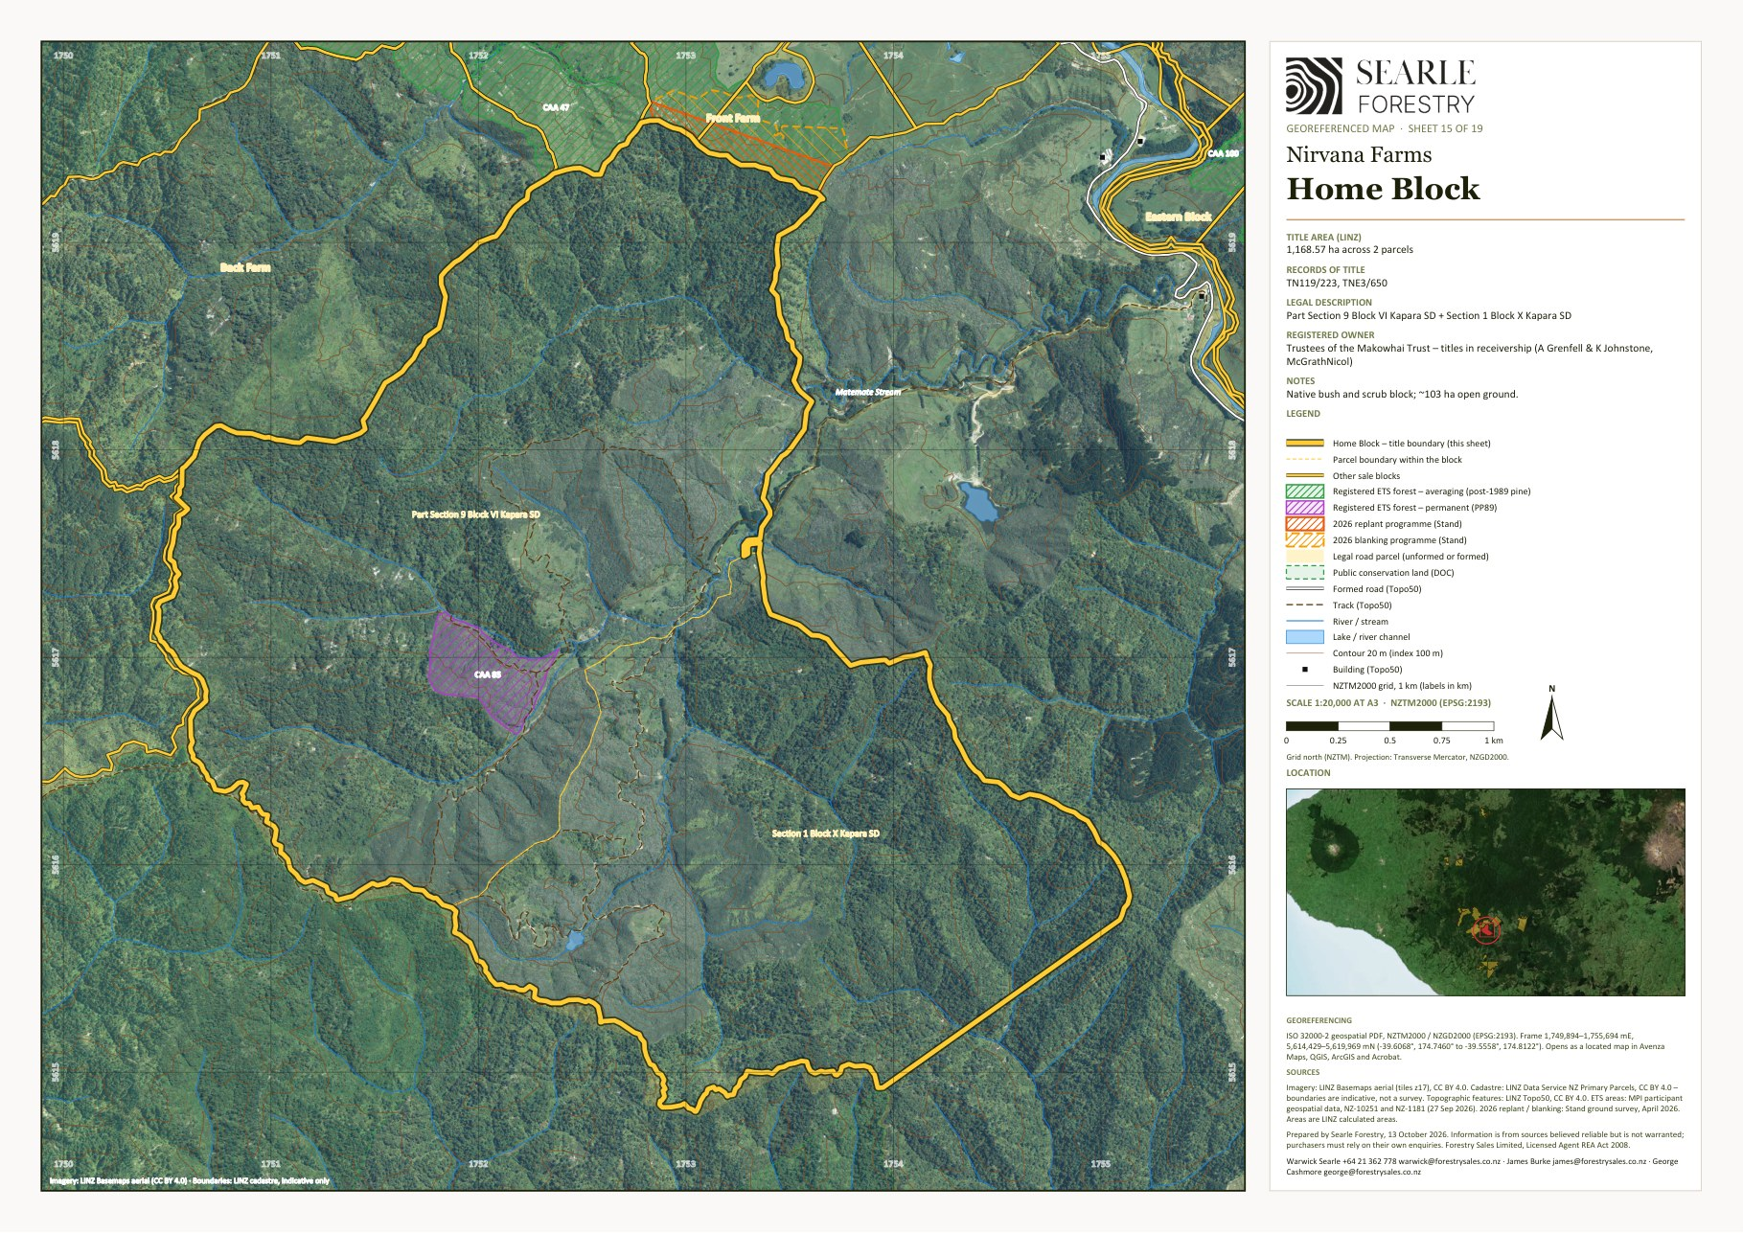
Georeferenced sheet from the Nirvana Farms map set (LINZ cadastre, LINZ aerial imagery, MPI ETS data, Stand 2026 programme). The designer may substitute a styled version; the GeoPDF sheets are supplied in the IM/maps folder and the data room.

5.6 Ernies
Mānuka and native bush (honey) · carbon (indigenous) · open hill grazing
Land use | Mānuka and native bush (honey) · carbon (indigenous) · open hill grazing
Vendor / interest | Trustees of the Makowhai Trust – titles in receivership (A Grenfell and K Johnstone, McGrathNicol)
Location / address | Sections 2–20 Moewatea Road, Ngamatapouri
Total area | 1,626.37 ha (LINZ calculated 1,624.4 ha)
Land cover | Native bush 546 ha · Mānuka / kānuka 950 ha · Open grassland 130 ha (July 2026 mapping)
Pinus radiata – net stocked area | No radiata crop
Contour and land use capability | Predominantly steep to very steep hill country. LUC 7: 1,515 ha (93%); LUC 6: 110 ha (7%) (LRIS NZLRI 2021). Open land by slope: flat (0–7°) 20 ha · rolling (8–20°) 46 ha · medium hill (21–35°) 48 ha · steep (>35°) 17 ha. Altitude 60–460 m above sea level.
ETS status | Registered: 2 CAAs, 120.9 ha, unit balance 13,159 NZUs (MPI land status reports, NFL 28 Sep 2026 / Makowhai Station Aug 2025). Makowhai Station – Stock change – indigenous: 120.9 ha, 13,159 NZUs (2 CAAs).
Indicatively ETS-eligible land | about 688 ha of post-1989 grassland and scrub (indicative, MPI to determine)
Records of title and legal description | 421910 – Lot 2 Deposited Plan 406242 and Section 12 Block VIII Opaku Survey District (352.8488 hectares); TN175/43 – Section 2 Block IV Opaku Survey District (239.2704 hectares); TN175/44 – Subdivision 1 Section 3 Block IV Opaku Survey District and Subdivision 1 Section 10 Block IV Opaku Survey District (216.0010 hectares); TNH4/190 – Section 16-18 Block IV Opaku Survey District (138.1466 hectares); TNJ2/204 – Section 19-20 Block IV Opaku Survey District and Section 15 Block VIII Opaku Survey District (172.1916 hectares); TNJ2/714 – Section 5, Section 12 and Section 14 Block IV Opaku Survey District (507.9107 hectares). Taranaki Land District.
Tenure | Fee simple (freehold); registered owners are the trustees of the Makowhai Trust (H R Matthews, J Cain, M J Wallace) – sold by the receivers appointed over the titles
Title interests (Oct 2026 searches) | Mortgage to Vitol Asia Pte Ltd (7 June 2023) – to be discharged at settlement; Registered forestry right(s) to Angiwhai Carbon No 1 Limited, Angiwhai Carbon No 2 Limited, Angiwhai Carbon No 3 Limited (registered 2018–2019) [TBC – status, and whether these rights are to be surrendered before settlement] (421910, TNJ2/204); Notice(s) under s195(2) Climate Change Response Act 2002 (ETS registration); Registered forestry right(s) to Angiwhai Carbon No 3 Limited, Angiwhai Carbon No 4 Limited, Angiwhai Carbon No 5 Limited (registered 2018–2019) [TBC – status, and whether these rights are to be surrendered before settlement] (TN175/43); Registered forestry right(s) to Angiwhai Carbon No 6 Limited (registered 2018–2019) [TBC – status, and whether these rights are to be surrendered before settlement] (TN175/44); Sustainable Forest Management permit under s67M Forests Act 1949 (indigenous timber, 2000–2002) (TN175/44, TNH4/190, TNJ2/204, TNJ2/714); Registered forestry right(s) to Angiwhai Carbon No 2 Limited, Angiwhai Carbon No 3 Limited, Angiwhai Carbon No 4 Limited (registered 2018–2019) [TBC – status, and whether these rights are to be surrendered before settlement] (TNH4/190); Registered forestry right(s) to Angiwhai Carbon No 4 Limited, Angiwhai Carbon No 5 Limited (registered 2018–2019) [TBC – status, and whether these rights are to be surrendered before settlement] (TNJ2/714)
Zoning | Rural Zone – Operative South Taranaki District Plan (2021)
Territorial authority | South Taranaki District
Regional council | Taranaki Regional Council
Rating valuation and rates | South Taranaki DC assessment 1245009700 – Moeawatea Road – Opaku Block IV sections and Lot 2 DP 406242 [TBC – legal description truncated in the database] (1,626.37 ha): land value $6,000,000, improvements $75,000, capital value $6,075,000; rates $15,848 p.a. (district $13,342 + regional $2,506)
Leases / occupation | None known [TBC]
Access | Moewatea Road frontage [TBC]. Internal tracks about 4.3 km and formed road 0.6 km (Topo50).
Buildings and dwellings | Four building outlines (about 130, 110, 45 and 17 m²) – sheds and a possible cottage on Moewatea Road; CBRE carried farm improvements on the block. [TBC – description and occupancy]

Description
A 1,626 ha mānuka/kānuka and native bush block west of the Home Block, historically run for honey production. About 950 ha is regenerating mānuka/kānuka and 546 ha mature native forest, with 130 ha of open ground. Two carbon accounting areas of regenerating indigenous forest (121 ha) are registered by Makowhai Station with a unit balance of about 13,200 NZUs, and roughly 690 ha of the scrub and grassland is indicatively post-1989 and therefore potentially ETS-eligible – the largest eligible area of any block. CBRE carried $500,000 of improvements.

Points to note
- No Pinus radiata on the block.
- The largest indicatively ETS-eligible area in the estate (about 688 ha, MPI to determine).

Items to confirm
- [TBC] Improvements and any dwelling/occupancy.
- [TBC] Legal and physical access.

Ernies – property map
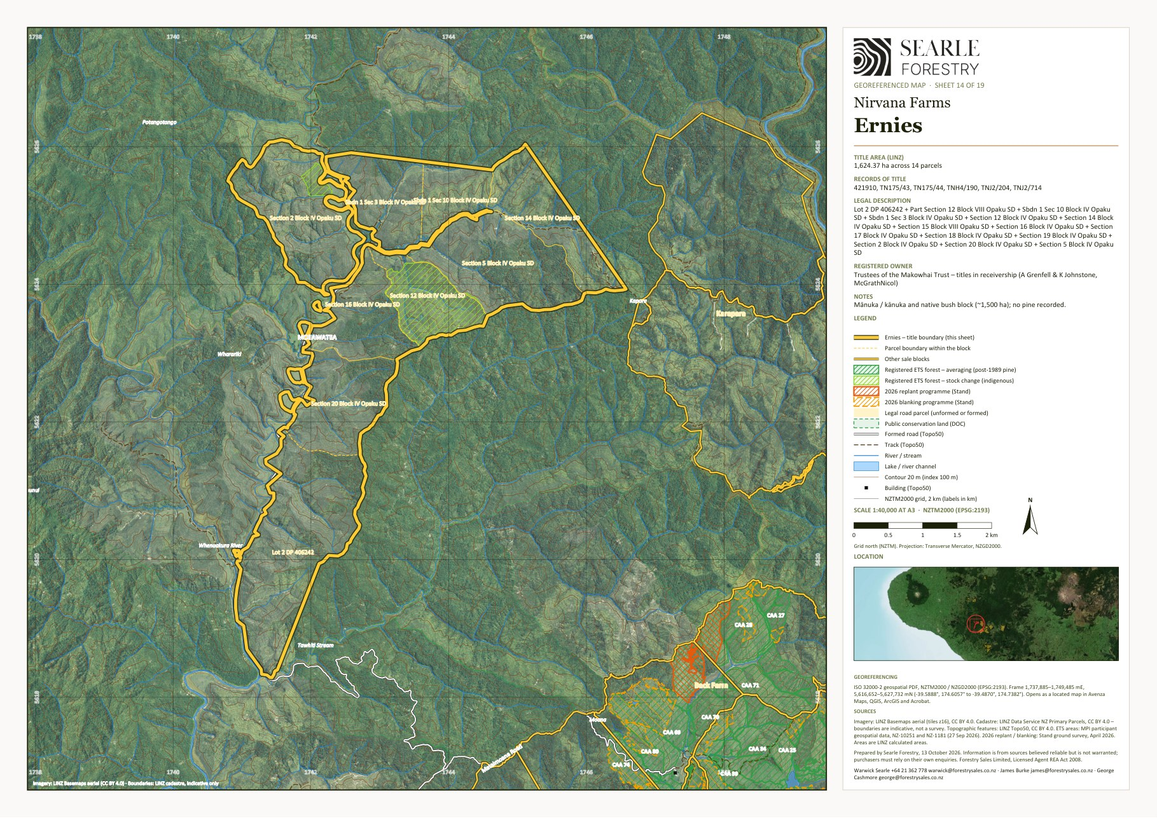
Georeferenced sheet from the Nirvana Farms map set (LINZ cadastre, LINZ aerial imagery, MPI ETS data, Stand 2026 programme). The designer may substitute a styled version; the GeoPDF sheets are supplied in the IM/maps folder and the data room.

5.7 Karapara
Native bush and mānuka (honey, conservation)
Land use | Native bush and mānuka (honey, conservation)
Vendor / interest | Trustees of the Makowhai Trust – titles in receivership (A Grenfell and K Johnstone, McGrathNicol)
Location / address | 1, 3 and 4A Waitotara Valley Road
Total area | 1,317.71 ha (LINZ calculated 1,310.7 ha)
Land cover | Native bush 677 ha · Mānuka / kānuka 612 ha · Open grassland 29 ha (July 2026 mapping)
Pinus radiata – net stocked area | No radiata crop
Contour and land use capability | Predominantly steep to very steep hill country. LUC 7: 1,163 ha (89%); LUC 6: 148 ha (11%) (LRIS NZLRI 2021). Open land by slope: flat (0–7°) 2 ha · rolling (8–20°) 6 ha · medium hill (21–35°) 14 ha · steep (>35°) 7 ha. Altitude 80–460 m above sea level.
ETS status | No carbon accounting areas registered on the block
Indicatively ETS-eligible land | about 3 ha of post-1989 grassland and scrub (indicative, MPI to determine)
Records of title and legal description | TN227/30 – Section 1 Block I Kapara Survey District (765.3162 hectares); TN227/31 – Section 3 Block I Kapara Survey District (546.3256 hectares); TN227/32 – Section 4A Block I Kapara Survey District (6.0703 hectares). Taranaki Land District.
Tenure | Fee simple (freehold); registered owners are the trustees of the Makowhai Trust (H R Matthews, J Cain, M J Wallace) – sold by the receivers appointed over the titles
Title interests (Oct 2026 searches) | Mortgage to Vitol Asia Pte Ltd (7 June 2023) – to be discharged at settlement; Sustainable Forest Management permit under s67M Forests Act 1949 (indigenous timber, 2000–2002) (TN227/31)
Zoning | Rural Zone – Operative South Taranaki District Plan (2021)
Territorial authority | South Taranaki District
Regional council | Taranaki Regional Council
Rating valuation and rates | South Taranaki DC assessment 1241007600 – 187 Mataimoana Road, Waverley (council address) – Secs 1, 3, 4A Blk I Kapara SD (1,317.71 ha): land value $3,300,000, improvements $82,000, capital value $3,382,000; rates $8,176 p.a. (district $6,878 + regional $1,298)
Leases / occupation | None known [TBC]
Access | Waitotara Valley Road frontage [TBC]. Internal tracks about 10.5 km (Topo50).
Buildings and dwellings | No building outlines mapped within the titles; CBRE carried improvements (likely yards, fencing and tracks). [TBC]

Description
A 1,318 ha block that is almost entirely native bush (677 ha) and regenerating mānuka/kānuka (612 ha), with under 30 ha of open ground. It is a honey and conservation block rather than a development property, and almost none of it is indicatively ETS-eligible as post-1989 land. CBRE carried $400,000 of improvements.

Points to note
- No Pinus radiata on the block.

Items to confirm
- [TBC] Improvements and occupancy.
- [TBC] Legal access.

Karapara – property map
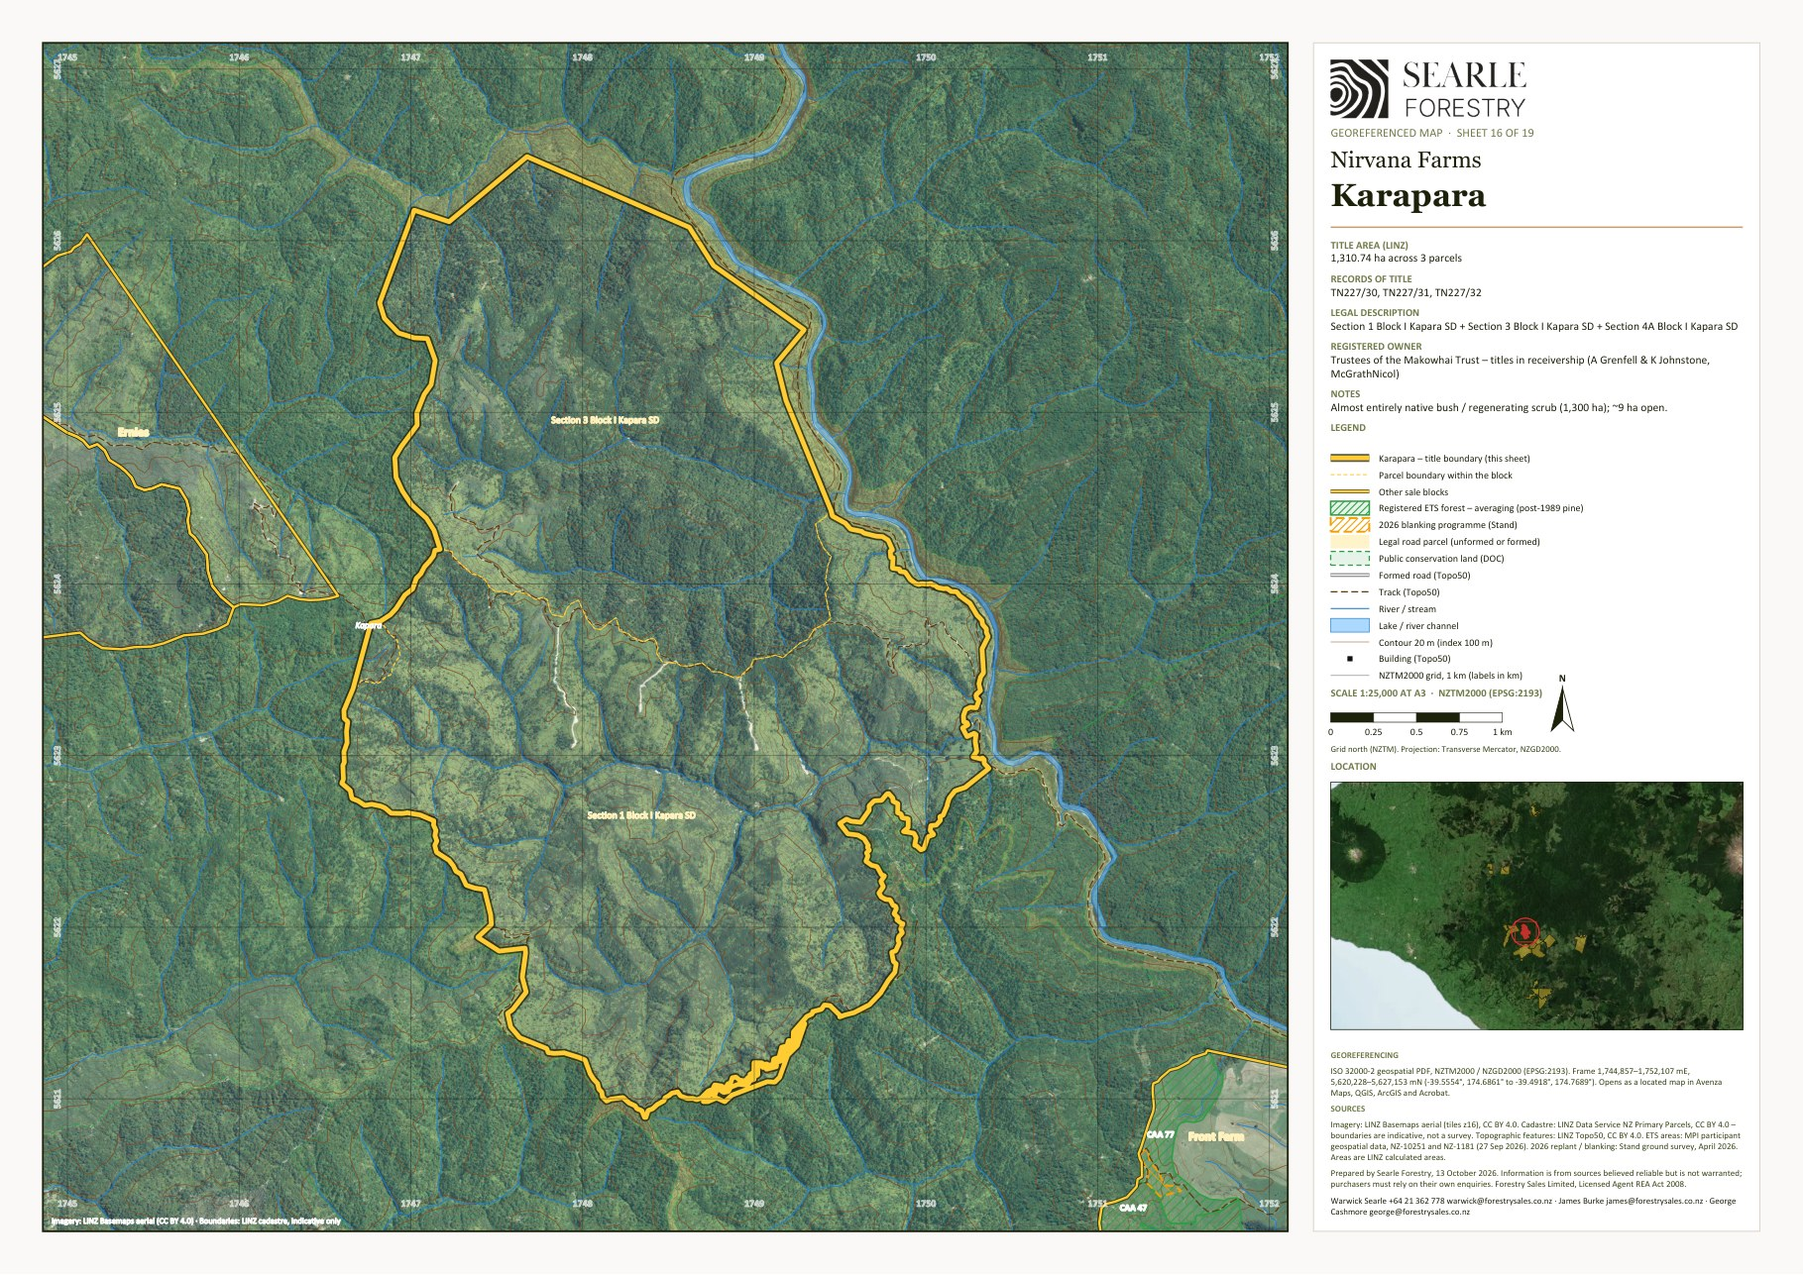
Georeferenced sheet from the Nirvana Farms map set (LINZ cadastre, LINZ aerial imagery, MPI ETS data, Stand 2026 programme). The designer may substitute a styled version; the GeoPDF sheets are supplied in the IM/maps folder and the data room.

5.8 Workers House
Dwelling
Land use | Dwelling
Vendor / interest | Nirvana Farm Limited (In Receivership)
Location / address | 228 Taumatatahi Road, Ngamatapouri
Total area | 1.71 ha
Land cover | Open grassland 2 ha (July 2026 mapping)
Pinus radiata – net stocked area | No radiata crop
Contour and land use capability | Predominantly flat to undulating. LUC 3: 2 ha (100%) (LRIS NZLRI 2021). Open land by slope: flat (0–7°) 2 ha · rolling (8–20°) 0 ha · medium hill (21–35°) 0 ha · steep (>35°) 0 ha. Altitude 40–40 m above sea level.
ETS status | No carbon accounting areas registered on the block
Indicatively ETS-eligible land | about 2 ha of post-1989 grassland and scrub (indicative, MPI to determine)
Records of title and legal description | TNE3/610 – Section 26 Block VI Kapara Survey District (6121 square metres); TNE3/611 – Section 21 Block VI Kapara Survey District (1.1002 hectares). Taranaki Land District.
Tenure | Fee simple (freehold)
Title interests (Oct 2026 searches) | Mortgage to Vitol Asia Pte Ltd (7 June 2023) – to be discharged at settlement; Electricity agreement (1966)
Zoning | Rural Zone – Operative South Taranaki District Plan (2021)
Territorial authority | South Taranaki District
Regional council | Taranaki Regional Council
Rating valuation and rates | South Taranaki DC assessment 1241010500 – 216 Waitotara Valley Road (council address) (1.10 ha): land value $100,000, improvements $335,000, capital value $435,000; rates $1,893 p.a. (district $1,599 + regional $293) South Taranaki DC assessment 1241010501 – Waitotara Valley Road (0.61 ha): land value $95,000, improvements $1,000, capital value $96,000; rates $205 p.a. (district $172 + regional $33)
Leases / occupation | None known [TBC]
Access | Road frontage to Taumatatahi Road.
Buildings and dwellings | Workers' dwelling at 228 Taumatatahi Road – a single building outline of about 300 m² on 1.7 ha with power and a 1966 electricity agreement on the title. [TBC – bedrooms, condition and occupancy]

Description
Two small sections (1.7 ha) on Taumatatahi Road with a workers' dwelling (CBRE improvements $150,000).

Items to confirm
- [TBC] Dwelling description, condition and occupancy.

Workers House – property map
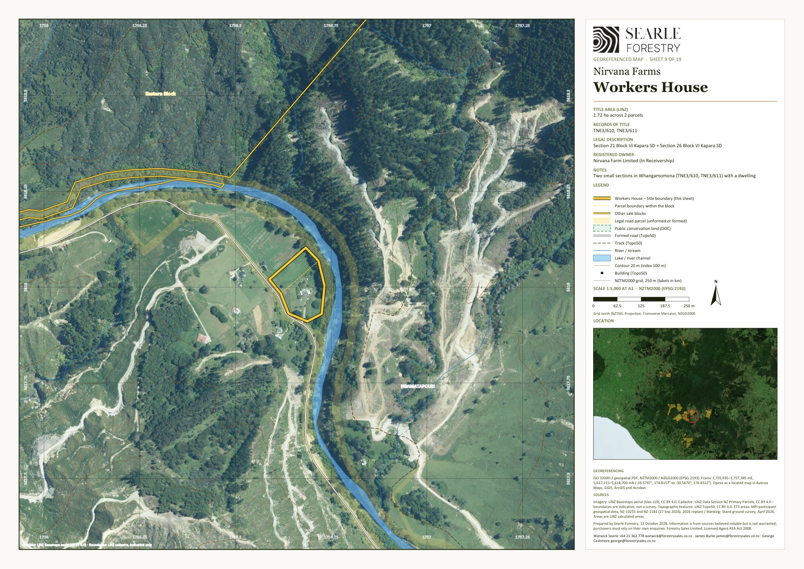
Georeferenced sheet from the Nirvana Farms map set (LINZ cadastre, LINZ aerial imagery, MPI ETS data, Stand 2026 programme). The designer may substitute a styled version; the GeoPDF sheets are supplied in the IM/maps folder and the data room.

5.9 Patricks House
Dwelling and small grazing block
Land use | Dwelling and small grazing block
Vendor / interest | Nirvana Farm Limited (In Receivership)
Location / address | 2606 Waitotara Valley Road, Waitōtara
Total area | 27.66 ha
Land cover | Native bush 0 ha · Mānuka / kānuka 17 ha · Open grassland 11 ha (July 2026 mapping)
Pinus radiata – net stocked area | No radiata crop
Contour and land use capability | Predominantly steep to very steep hill country. LUC 7: 21 ha (75%); LUC 3: 7 ha (25%) (LRIS NZLRI 2021). Open land by slope: flat (0–7°) 7 ha · rolling (8–20°) 2 ha · medium hill (21–35°) 2 ha · steep (>35°) 0 ha. Altitude 40–180 m above sea level.
ETS status | No carbon accounting areas registered on the block
Indicatively ETS-eligible land | about 28 ha of post-1989 grassland and scrub (indicative, MPI to determine)
Records of title and legal description | 690021 – Lot 1 Deposited Plan 484884 and Lot 4 Deposited Plan 85385 (27.2445 hectares); WN53B/169 – Lot 1 Deposited Plan 85385 (2079 square metres); WN53B/170 – Lot 2 Deposited Plan 85385 (2083 square metres). Wellington Land District.
Tenure | Fee simple (freehold)
Title interests (Oct 2026 searches) | Mortgage to Vitol Asia Pte Ltd (7 June 2023) – to be discharged at settlement; Easements – electricity / telecommunications transmission and water supply; Standard Crown mineral reservations (Petroleum, Mining, Coal Mines, Atomic Energy and Geothermal Energy Acts); Consent notice / amalgamation condition under s241 Resource Management Act 1991
Zoning | Rural Zone – Operative South Taranaki District Plan (2021)
Territorial authority | South Taranaki District
Regional council | Taranaki Regional Council
Rating valuation and rates | South Taranaki DC assessment 1241017301 – Waitotara Valley Road – Lots 1, 2, 4 DP 85385, Lot 1 DP 484884 (27.66 ha): land value $275,000, improvements $110,000, capital value $385,000; rates $1,786 p.a. (district $1,510 + regional $276)
Leases / occupation | None known [TBC]
Access | Road frontage to Waitotara Valley Road.
Buildings and dwellings | House at 2606 Waitotara Valley Road (about 210 m²) with an outbuilding (about 50 m²); water-supply and power easements registered. A tenant is believed to occupy one of the estate dwellings. [TBC – description, condition and tenancy]

Description
A 27.7 ha dwelling block on the Waitotara Valley Road with about 11 ha of easy to rolling pasture and 16 ha of scrub. CBRE carried $300,000 of improvements, being the house and outbuildings.

Items to confirm
- [TBC] Dwelling description, condition and occupancy (a tenant, 'Rex', is believed to occupy one of the estate dwellings).

Patricks House – property map
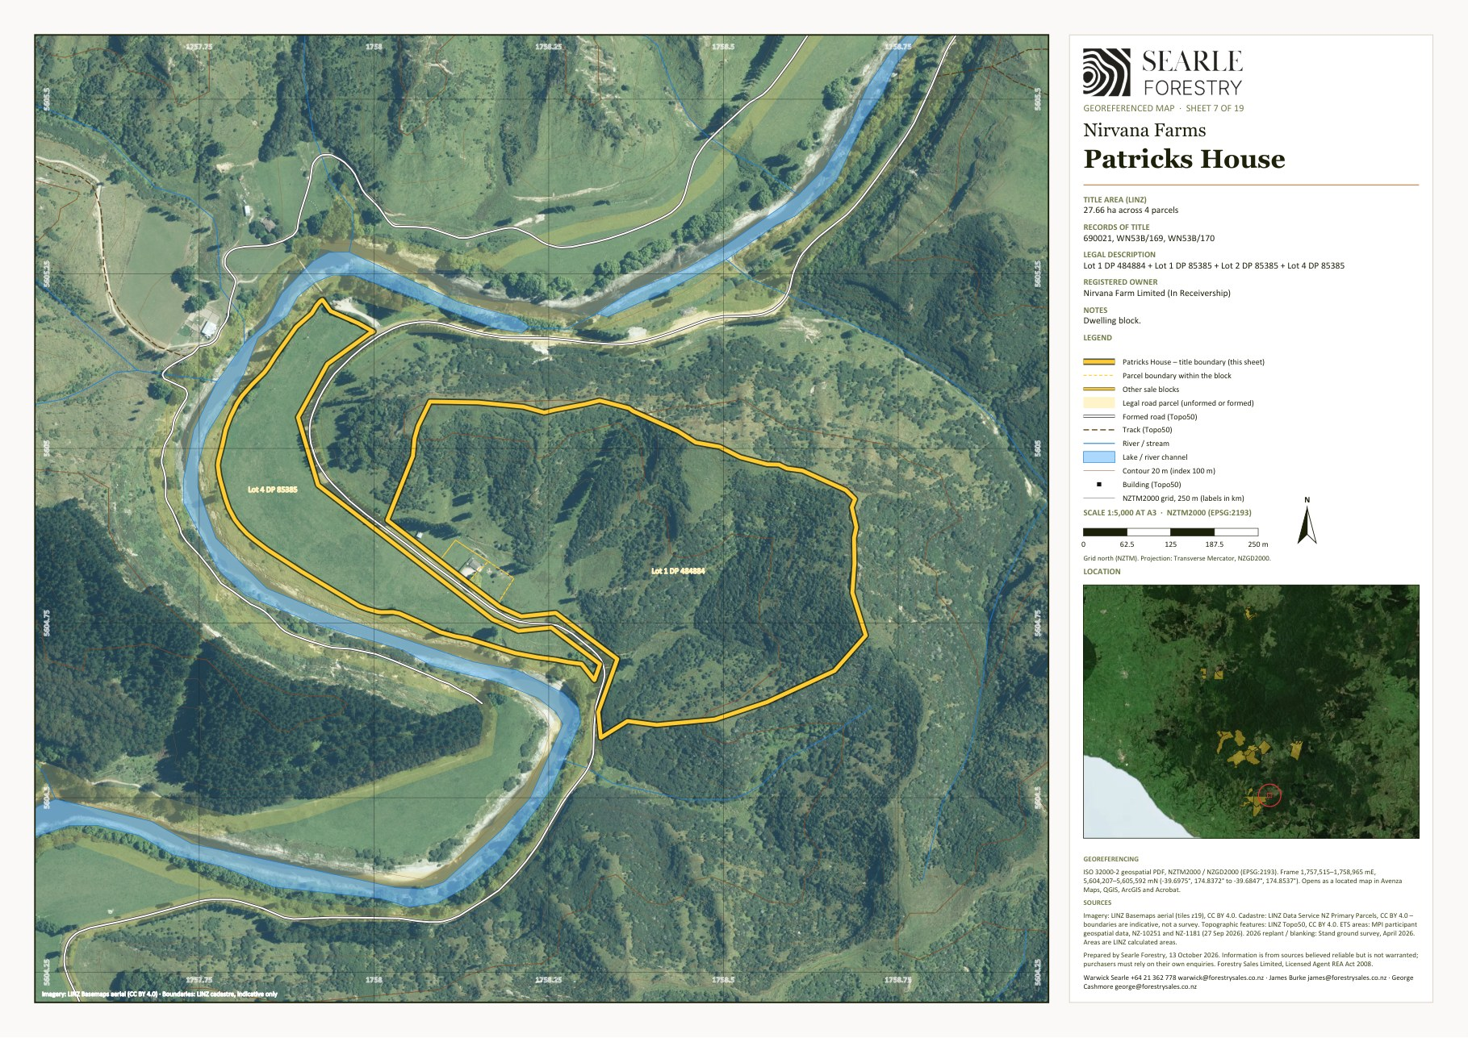
Georeferenced sheet from the Nirvana Farms map set (LINZ cadastre, LINZ aerial imagery, MPI ETS data, Stand 2026 programme). The designer may substitute a styled version; the GeoPDF sheets are supplied in the IM/maps folder and the data room.

5B Nukumaru and the Waverley coast – South Taranaki District
Three properties sit on the coastal hill country at Nukumaru between Waverley and Waitōtara, off Puau, Lakes, Waikare and Ridge Roads, totalling about 2,798 ha. Puau Road is the largest and includes the two Crown renewable leases; Moonys and Ridge Road adjoin it.
From | Destination | km
Puau Road / Moonys / Ridge Road | Waverley | 31
Puau Road / Moonys / Ridge Road | Whanganui | 54
Puau Road / Moonys / Ridge Road | Castlecliff port, Whanganui | 57
Puau Road / Moonys / Ridge Road | Hāwera | 75
Puau Road / Moonys / Ridge Road | Stratford | 105
Puau Road / Moonys / Ridge Road | New Plymouth / Port Taranaki | 150

5.10 Puau Road
Native bush and mānuka (honey) · forestry (Pinus radiata) · grazing (part leased to Pukekahu Farms) · Crown leasehold
Land use | Native bush and mānuka (honey) · forestry (Pinus radiata) · grazing (part leased to Pukekahu Farms) · Crown leasehold
Vendor / interest | Nirvana Farm Limited (In Receivership)
Location / address | Puau Road / Waitotara Valley Road, Nukumaru
Total area | 1,871.68 ha (LINZ calculated 1,868.7 ha)
Land cover | Radiata / exotic 56 ha · Native bush 889 ha · Mānuka / kānuka 568 ha · Open grassland 358 ha (July 2026 mapping)
Pinus radiata – net stocked area | 52 ha planted · 26 ha adequately stocked at April 2026 · 17 ha replant + 8 ha blanking in 2026 · 52 ha adequately stocked after 2026. NSA blanked 2026: 21.37 ha with 10 QC plots (Forest360 post-planting QC sheet, 14 Oct 2026). Planting years: 2024 (52 ha) [TBC – stand records]
Contour and land use capability | Predominantly steep to very steep hill country. LUC 7: 1,766 ha (95%); LUC 6: 60 ha (3%); LUC 3: 43 ha (2%) (LRIS NZLRI 2021). Open land by slope: flat (0–7°) 45 ha · rolling (8–20°) 45 ha · medium hill (21–35°) 154 ha · steep (>35°) 114 ha. Altitude 20–340 m above sea level.
ETS status | Registered: 5 CAAs, 46.1 ha, unit balance 139 NZUs (MPI land status reports, NFL 28 Sep 2026 / Makowhai Station Aug 2025). NFL as landowner – Averaging – 2024: 46.1 ha, 139 NZUs (5 CAAs).
Indicatively ETS-eligible land | about 445 ha of post-1989 grassland and scrub (indicative, MPI to determine)
Records of title and legal description | 948076 – Section 1B Block I Nukumaru Survey District (720.3404 hectares); 948077 – Section 1 Block I Nukumaru Survey District (884.2381 hectares); WN115/77 – Section 4 Block I Nukumaru Survey District (259.4035 hectares); WN24A/444 – Puau 1 Block (7.7016 hectares). Wellington Land District.
Tenure | Fee simple (freehold) on 2 titles; Crown renewable leases under s82 Land Act 1948 on 948076 and 948077 (33 years from 1 July 2020)
Title interests (Oct 2026 searches) | Mortgage to Vitol Asia Pte Ltd (7 June 2023) – to be discharged at settlement; Notice(s) under s195(2) Climate Change Response Act 2002 (ETS registration) (WN115/77)
Zoning | Rural Zone – Operative South Taranaki District Plan (2021)
Territorial authority | South Taranaki District
Regional council | Taranaki Regional Council
Rating valuation and rates | Rated within one South Taranaki DC unit with Moonys – South Taranaki DC assessment 1240020501 – Waikare Road, Waitotara – Secs 1B, 1, 4 Blk I Nukumaru SD, Puau 1 Block, Secs 13, 19, Pt 12 Blk V Omahine SD, Sec 15, Pt 19 Blk IV Wairoa SD (2,515.30 ha): land value $6,900,000, improvements $300,000, capital value $7,200,000; rates $16,316 p.a. (district $13,717 + regional $2,599)
Leases / occupation | Crown lease 948077 (884 ha) within the Pukekahu Farms grazing lease to 31 December 2029 (rent prepaid)
Access | Worked through the neighbouring Wood Country Limited property – permission required. A small amount of tracking ($2,500) is needed to reopen the main ridge track. Internal tracks about 6.9 km (Topo50).
Buildings and dwellings | One small shed (about 25 m²); no dwelling. [TBC]

Description
At 1,872 ha Puau Road is the second-largest block but the least developed: about 1,460 ha is native bush and mānuka/kānuka, with 358 ha of open hill country and a 52 ha stand of 2024 radiata on the two freehold titles. Two of the four titles (948076 and 948077, 1,605 ha) are Crown renewable leases under section 82 of the Land Act 1948 for 33 years from 1 July 2020, and 948077 (884 ha) is also within the Pukekahu Farms grazing lease to 31 December 2029. The northern end of stand 1.01 failed to pest damage and is to be replanted (17 ha) with 8 ha of blanking; heavy gorse in the south needs a release spray. About 445 ha of open and scrub land is indicatively ETS-eligible.

Points to note
- Crown lease reassignment is expected to be straightforward (no pine on the leased titles).
- Goats are present at altitude; a pre-planting cull and constant ongoing pest control support the 2026 work.

Items to confirm
- [TBC] Crown lease rent, review dates and consent requirements for assignment.
- [TBC] Boundary of the Pukekahu Farms lease on 948077 (aerial plan in the lease).

Puau Road – property map
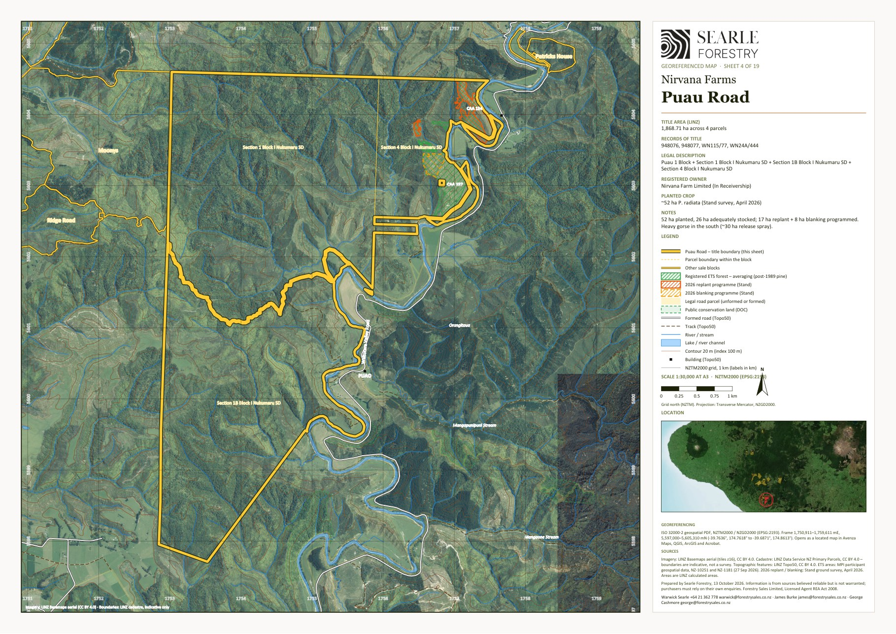
Georeferenced sheet from the Nirvana Farms map set (LINZ cadastre, LINZ aerial imagery, MPI ETS data, Stand 2026 programme). The designer may substitute a styled version; the GeoPDF sheets are supplied in the IM/maps folder and the data room.

5.11 Moonys
Mānuka, native bush and open hill grazing · older exotic cover
Land use | Mānuka, native bush and open hill grazing · older exotic cover
Vendor / interest | Nirvana Farm Limited (In Receivership)
Location / address | 12–19 Waikare Road and Lakes Road, Nukumaru
Total area | 643.62 ha (LINZ calculated 645.1 ha)
Land cover | Radiata / exotic 114 ha · Native bush 94 ha · Mānuka / kānuka 277 ha · Open grassland 159 ha (July 2026 mapping)
Pinus radiata – net stocked area | No radiata crop
Contour and land use capability | Predominantly steep to very steep hill country. LUC 7: 366 ha (57%); LUC 6: 271 ha (42%) (LRIS NZLRI 2021). Open land by slope: flat (0–7°) 25 ha · rolling (8–20°) 27 ha · medium hill (21–35°) 69 ha · steep (>35°) 38 ha. Altitude 60–300 m above sea level.
ETS status | No carbon accounting areas registered on the block
Indicatively ETS-eligible land | about 36 ha of post-1989 grassland and scrub (indicative, MPI to determine)
Records of title and legal description | WN110/44 – Section 19 Block V Omahine Survey District (80.9371 hectares); WN181/222 – Section 15 and Part Section 19 Block IV Wairoa Survey District (432.0449 hectares); WN23A/665 – Part Section 12 Block V Omahine Survey District (46.4594 hectares); WN476/64 – Section 13 Block V Omahine Survey District (84.1746 hectares). Wellington Land District.
Tenure | Fee simple (freehold)
Title interests (Oct 2026 searches) | Mortgage to Vitol Asia Pte Ltd (7 June 2023) – to be discharged at settlement; Notice(s) under s195(2) Climate Change Response Act 2002 (ETS registration); Standard Crown mineral reservations (Petroleum, Mining, Coal Mines, Atomic Energy and Geothermal Energy Acts) (WN23A/665)
Zoning | Rural Zone – Operative South Taranaki District Plan (2021)
Territorial authority | South Taranaki District
Regional council | Taranaki Regional Council
Rating valuation and rates | Rated within one South Taranaki DC unit with Puau Road – South Taranaki DC assessment 1240020501 – Waikare Road, Waitotara – Secs 1B, 1, 4 Blk I Nukumaru SD, Puau 1 Block, Secs 13, 19, Pt 12 Blk V Omahine SD, Sec 15, Pt 19 Blk IV Wairoa SD (2,515.30 ha): land value $6,900,000, improvements $300,000, capital value $7,200,000; rates $16,316 p.a. (district $13,717 + regional $2,599) No separate rating valuation exists for Moonys.
Leases / occupation | None known [TBC]
Access | Waikare Road / Lakes Road frontage [TBC]. Internal tracks about 0.2 km and formed road 1.1 km (Topo50).
Buildings and dwellings | Three small buildings (about 125, 70 and 20 m²) – sheds / hut; no dwelling recorded. [TBC]

Description
A 644 ha block of mixed scrub, native and open hill country near the Waverley coast, adjoining Ridge Road and Puau Road. The appraisal mapping shows about 277 ha of mānuka/kānuka, 94 ha of native bush, 159 ha of open grassland and about 114 ha of exotic forest cover. No radiata has been established under the current programme and there is no ETS registration on the block, so the mapped exotic cover needs to be checked on the ground.

Points to note
- Not in Stand's planting programme; no ETS CAAs.

Items to confirm
- [TBC] Nature and age of the ~114 ha mapped as exotic forest cover (older plantation, wilding pine or scrub).
- [TBC] Improvements (CBRE $100,000) and occupancy.

Moonys – property map
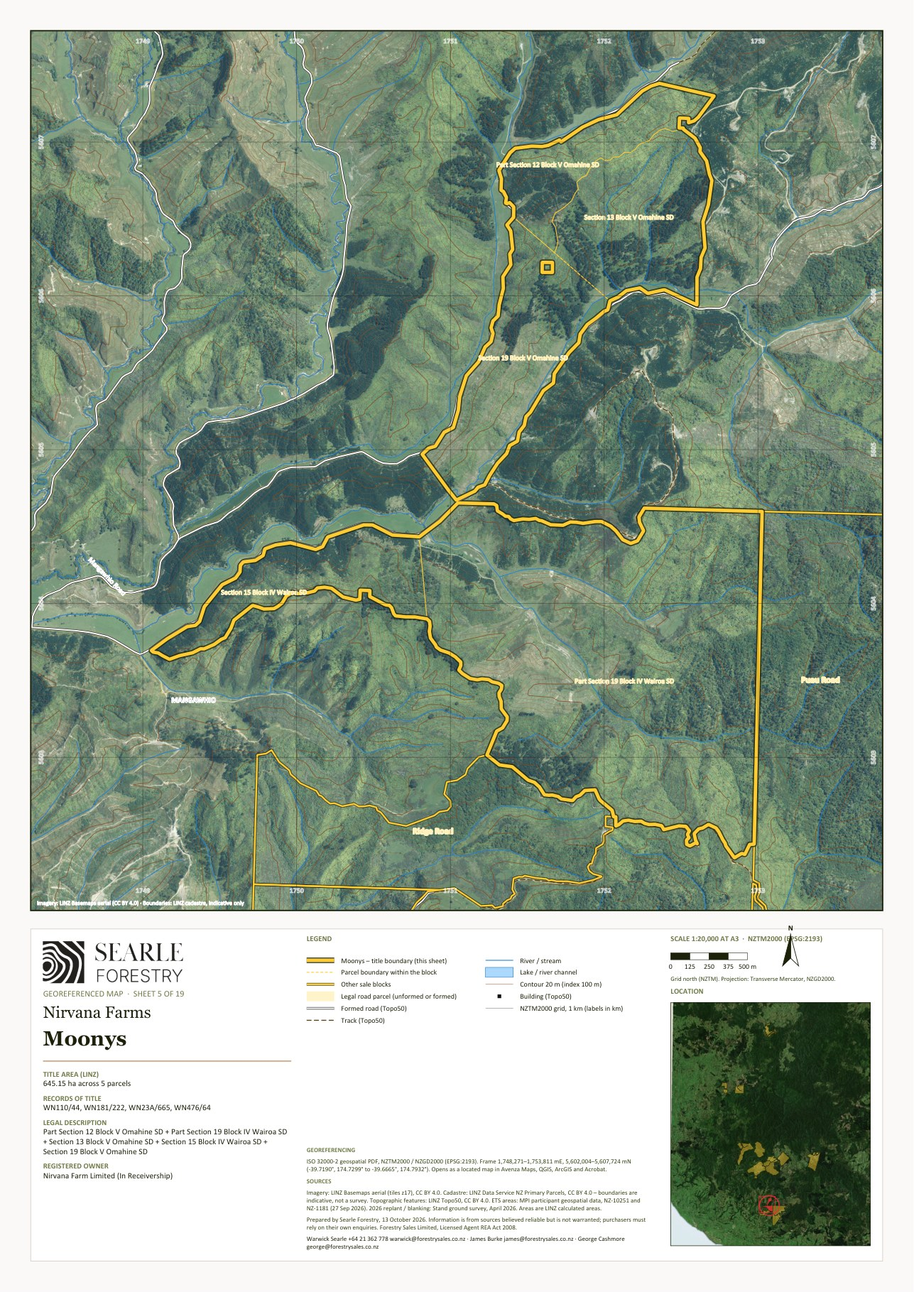
Georeferenced sheet from the Nirvana Farms map set (LINZ cadastre, LINZ aerial imagery, MPI ETS data, Stand 2026 programme). The designer may substitute a styled version; the GeoPDF sheets are supplied in the IM/maps folder and the data room.

5.12 Ridge Road
Mānuka scrub and open grazing
Land use | Mānuka scrub and open grazing
Vendor / interest | Nirvana Farm Limited (In Receivership)
Location / address | 1464 Ridge Road, Nukumaru
Total area | 282.59 ha
Land cover | Native bush 58 ha · Mānuka / kānuka 153 ha · Open grassland 71 ha (July 2026 mapping)
Pinus radiata – net stocked area | No radiata crop
Contour and land use capability | Predominantly steep to very steep hill country. LUC 7: 240 ha (85%); LUC 3: 43 ha (15%) (LRIS NZLRI 2021). Open land by slope: flat (0–7°) 22 ha · rolling (8–20°) 23 ha · medium hill (21–35°) 20 ha · steep (>35°) 6 ha. Altitude 20–320 m above sea level.
ETS status | No carbon accounting areas registered on the block
Indicatively ETS-eligible land | about 66 ha of post-1989 grassland and scrub (indicative, MPI to determine)
Records of title and legal description | 753569 – Lot 2-3 Deposited Plan 500597 (89.7128 hectares); WN526/225 – Part Section 6 Block IV Wairoa Survey District and Defined On Survey Office Plan 14533 (6.9201 hectares); WN8C/173 – Lot 1-2 Deposited Plan 1512 (185.9531 hectares). Wellington Land District.
Tenure | Fee simple (freehold)
Title interests (Oct 2026 searches) | Mortgage to Vitol Asia Pte Ltd (7 June 2023) – to be discharged at settlement; Consent notice / amalgamation condition under s241 Resource Management Act 1991 (753569)
Zoning | Rural Zone – Operative South Taranaki District Plan (2021)
Territorial authority | South Taranaki District
Regional council | Taranaki Regional Council
Rating valuation and rates | South Taranaki DC assessment 1240019700 – 1464 Ridge Road, Waitotara – Pt Sec 6 Blk IV Wairoa SD, Lots 1–2 DP 1512, Lots 2–3 DP 500597 (282.59 ha): land value $1,190,000, improvements $90,000, capital value $1,280,000; rates $3,694 p.a. (district $3,113 + regional $581)
Leases / occupation | None known [TBC]
Access | Road frontage to Ridge Road. Internal tracks about 0.2 km and formed road 0.0 km (Topo50).
Buildings and dwellings | Five small buildings off Ridge Road, the largest about 180 m² – sheds; no dwelling recorded. [TBC]

Description
A 283 ha block of regenerating scrub (153 ha) and native (58 ha) with about 71 ha of open ground, much of it flat to rolling. About 66 ha is indicatively ETS-eligible.

Points to note
- No Pinus radiata on the block.

Items to confirm
- [TBC] Improvements (CBRE $35,000).

Ridge Road – property map
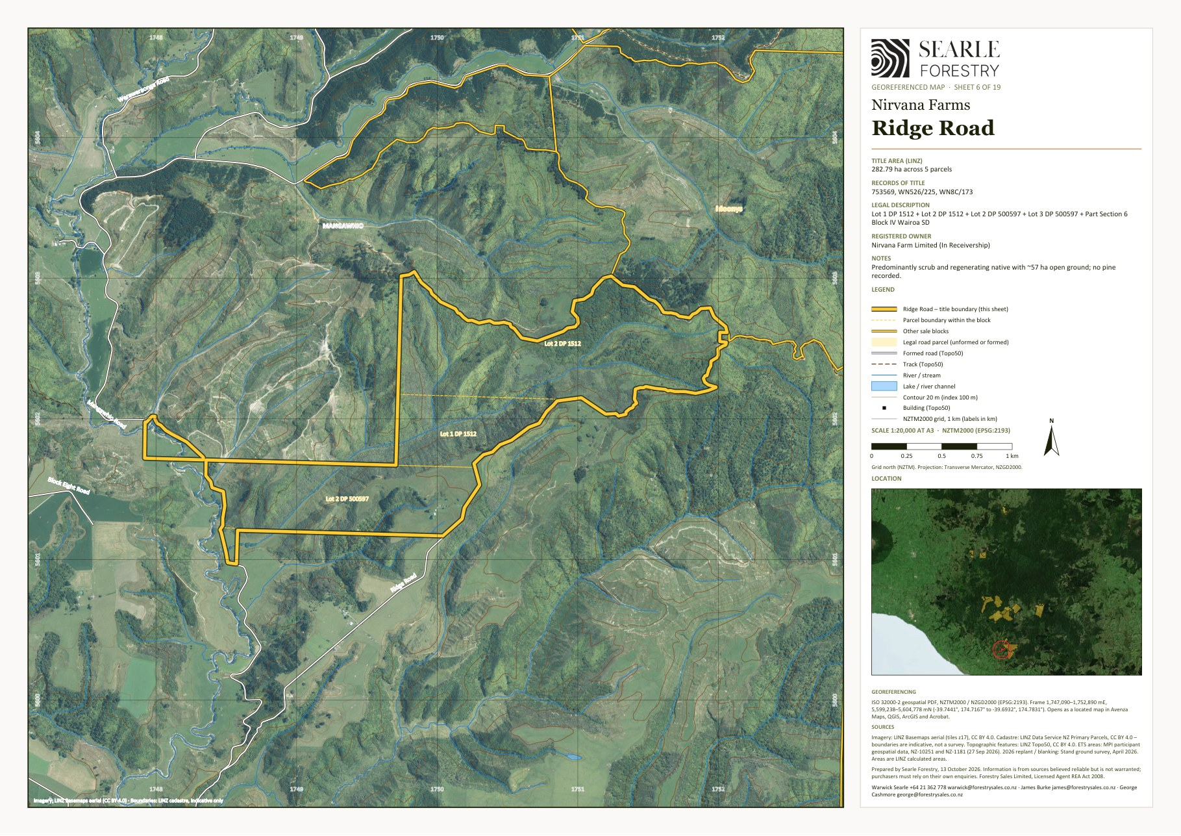
Georeferenced sheet from the Nirvana Farms map set (LINZ cadastre, LINZ aerial imagery, MPI ETS data, Stand 2026 programme). The designer may substitute a styled version; the GeoPDF sheets are supplied in the IM/maps folder and the data room.

5C Eastern Taranaki – Whangamomona, Mangaehu and Puniwhakau – Stratford District
The eastern Taranaki properties are spread along the Forgotten World Highway and the Mangaehu and Puniwhakau Roads east of Stratford: Whangamomona (739 ha), Staghaven (296 ha) and Tims (14 ha), with the Soldiers Road forestry right at Tuwharenikau Road. Magons (777 ha, Puniwhakau Road), owned by a third party, is available separately and is described here because it adjoins this country.
From | Destination | km
Whangamomona | Stratford | 68
Whangamomona | Hāwera | 98
Whangamomona | New Plymouth | 106
Whangamomona | Port Taranaki | 112
Whangamomona | Whanganui | 186
Staghaven / Tims (Mangaehu Road) | Stratford | 41
Staghaven / Tims (Mangaehu Road) | Hāwera | 71
Staghaven / Tims (Mangaehu Road) | New Plymouth | 79
Staghaven / Tims (Mangaehu Road) | Port Taranaki | 84
Staghaven / Tims (Mangaehu Road) | Whanganui | 159

5.13 Whangamomona
Forestry (Pinus radiata) and carbon · native bush and mānuka
Land use | Forestry (Pinus radiata) and carbon · native bush and mānuka
Vendor / interest | Nirvana Farm Limited (In Receivership)
Location / address | 45–105 Whangamomona Road, Whangamōmona
Total area | 738.94 ha
Land cover | Radiata / exotic 355 ha · Native bush 123 ha · Mānuka / kānuka 177 ha · Open grassland 84 ha (July 2026 mapping)
Pinus radiata – net stocked area | 355 ha planted · 139 ha adequately stocked at April 2026 · 194 ha replant + 22 ha blanking in 2026 · 355 ha adequately stocked after 2026 · 5.5 ha further plantable. NSA blanked 2026: 177.86 ha with 52 QC plots (Forest360 post-planting QC sheet, 14 Oct 2026). Planting years: 2024 (355 ha) [TBC – stand records]
Contour and land use capability | Predominantly steep to very steep hill country. LUC 7: 524 ha (71%); LUC 6: 214 ha (29%) (LRIS NZLRI 2021). Open land by slope: flat (0–7°) 4 ha · rolling (8–20°) 15 ha · medium hill (21–35°) 38 ha · steep (>35°) 28 ha. Altitude 140–400 m above sea level.
ETS status | Registered: 17 CAAs, 308.6 ha, unit balance 928 NZUs (MPI land status reports, NFL 28 Sep 2026 / Makowhai Station Aug 2025). NFL as landowner – Averaging – 2024: 308.6 ha, 928 NZUs (17 CAAs).
Indicatively ETS-eligible land | about 78 ha of post-1989 grassland and scrub (indicative, MPI to determine)
Records of title and legal description | TNK4/628 – Lot 1-2 Deposited Plan 19775, Section 1 Survey Office Plan 4558, Section 31 Block IV Town of Whangamomona, Lot 1-2 Deposited Plan 6674, Section 29 Block I Mahoe Survey District, Defined On Survey Office Plan 4792, Section 1-2 Survey Office Plan 13206, Section 1-10 Survey Office Plan 13278, Part Section 1 Survey Office Plan 13279 and Section 1 Survey Office Plan 13296 (738.9428 hectares). Taranaki Land District.
Tenure | Fee simple (freehold)
Title interests (Oct 2026 searches) | Registered forestry right(s) to Whanga Carbon Limited (registered 2018–2019) [TBC – status, and whether these rights are to be surrendered before settlement]; Conservation covenant under s77 Reserves Act 1977 (1991) over part; Notice of access rights under s83 Crown Minerals Act 1991 (2010); Section 27B State-Owned Enterprises Act 1986 memorial (Treaty resumption provision); Standard Crown mineral reservations (Petroleum, Mining, Coal Mines, Atomic Energy and Geothermal Energy Acts)
Zoning | Rural Zone – Stratford District Plan 2014
Territorial authority | Stratford District
Regional council | Taranaki Regional Council
Rating valuation and rates | Stratford DC assessment 1199138200 – Whangamomona Road RD 26 – composite unit for TNK4/628 [TBC – database shows the first parcel only] (738.94 ha): land value $3,910,000, improvements $350,000, capital value $4,260,000; rates $33,341 p.a.
Leases / occupation | None known [TBC]
Access | Road frontage to Whangamomona Road (SH43 Forgotten World Highway). About $8,500 of maintenance tracking needed to restore access to parts of the block; aerial lifting into stand 2. Internal tracks about 4.6 km (Topo50).
Buildings and dwellings | Seven building outlines around the Whangamomona Road frontage, the largest about 625 m² (the old woolshed noted by Stand) with two buildings of about 160 m² that may be dwellings or cottages. [TBC – description, condition and occupancy; the block includes the 46 and 105 Whangamomona Road addresses]

Description
A single 739 ha title in 21 parcels wrapping around the Whangamomona township on the Forgotten World Highway. About 355 ha of radiata was planted in 2024, of which only 139 ha was adequately stocked at April 2026: stands 2.01 and 2.02 failed to heavy pest pressure before the culling programme and are programmed for 194 ha of replanting, with 22 ha of blanking elsewhere. Dothistroma needle blight is affecting about 150 ha of compartments 1.01 and 1.02 and treatment (about $15,000) was recommended. Stand note the replanted stands remain at high risk and that the 5.5 ha of unplanted ground behind the hotel and under the old power lines should be planted in priority. The remainder of the block is native bush and mānuka/kānuka with about 84 ha of open hill.

Points to note
- Constant pest control continues to keep the pressure on deer, goats and pigs on the replanted stands.
- The block includes the 46 and 105 Whangamomona Road addresses.

Items to confirm
- [TBC] Improvements (CBRE carried $250,000 – old woolshed and any dwelling) and occupancy.
- [TBC] Whether the 2026 replanting of stands 2.01/2.02 has been completed.

Whangamomona – property map
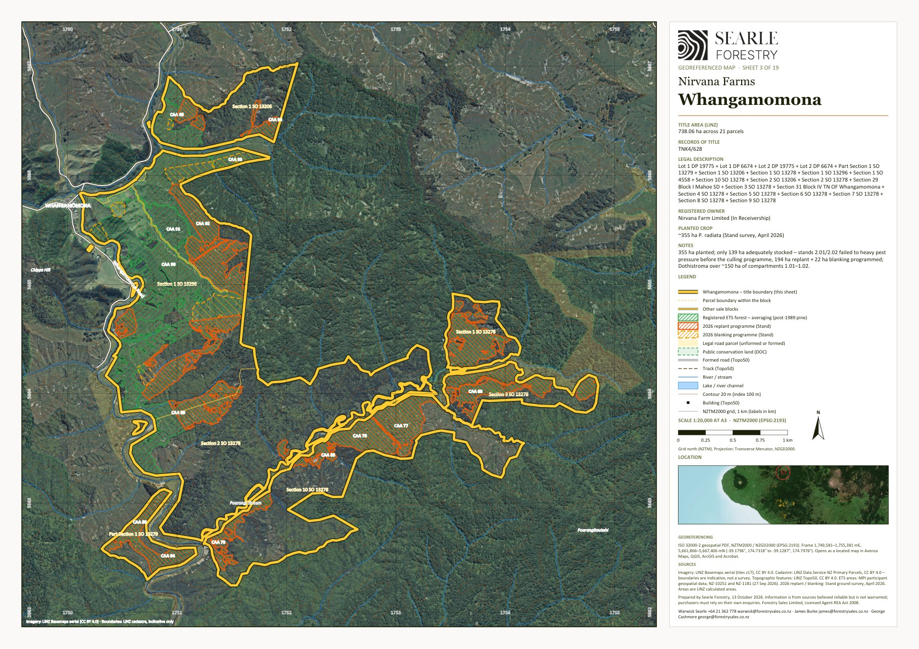
Georeferenced sheet from the Nirvana Farms map set (LINZ cadastre, LINZ aerial imagery, MPI ETS data, Stand 2026 programme). The designer may substitute a styled version; the GeoPDF sheets are supplied in the IM/maps folder and the data room.

5.14 Staghaven
Forestry (Pinus radiata) and carbon · native bush · rolling pasture
Land use | Forestry (Pinus radiata) and carbon · native bush · rolling pasture
Vendor / interest | Nirvana Farm Limited (In Receivership)
Location / address | 694 Mangaehu Road, Puniwhakau
Total area | 295.55 ha (LINZ calculated 296.6 ha)
Land cover | Radiata / exotic 132 ha · Native bush 88 ha · Mānuka / kānuka 12 ha · Open grassland 65 ha (July 2026 mapping)
Pinus radiata – net stocked area | 83 ha planted · 83 ha adequately stocked at April 2026 · 0 ha replant + 0 ha blanking in 2026 · 83 ha adequately stocked after 2026. Planting years: 2024 (83 ha); 2011 radiata (22 ha) under stock change; older exotic about 27 ha [TBC – stand records]
Contour and land use capability | Predominantly steep to very steep hill country. LUC 7: 171 ha (58%); LUC 6: 80 ha (27%); LUC 4: 46 ha (15%) (LRIS NZLRI 2021). Open land by slope: flat (0–7°) 0 ha · rolling (8–20°) 20 ha · medium hill (21–35°) 45 ha · steep (>35°) 0 ha. Altitude 140–440 m above sea level.
ETS status | Registered: 8 CAAs, 82.5 ha, unit balance 4,654 NZUs (MPI land status reports, NFL 28 Sep 2026 / Makowhai Station Aug 2025). NFL as landowner – Stock change – pine: 21.6 ha, 4,472 NZUs (5 CAAs); NFL as landowner – Averaging – 2024: 60.9 ha, 182 NZUs (3 CAAs).
Indicatively ETS-eligible land | about 26 ha of post-1989 grassland and scrub (indicative, MPI to determine)
Records of title and legal description | TNH4/186 – Section 2-3 and Section 5 Block III Omoana Survey District (242.8113 hectares); TN118/45 – Subdivision 1 Section 1 Block III Omona Survey District (44.7178 hectares); TNH4/183 – Section 11 Block III Omoana Survey District (8.0229 hectares). Taranaki Land District.
Tenure | Fee simple (freehold)
Title interests (Oct 2026 searches) | Mortgage to Vitol Asia Pte Ltd (7 June 2023) – to be discharged at settlement; Registered forestry right(s) to Staghaven Carbon Limited (registered 2018–2019) [TBC – status, and whether these rights are to be surrendered before settlement] (TNH4/186); Sustainable Forest Management permit under s67M Forests Act 1949 (indigenous timber, 2000–2002) (TNH4/186); Notice(s) under s195(2) Climate Change Response Act 2002 (ETS registration) (TN118/45, TNH4/183)
Zoning | Rural Zone – Stratford District Plan 2014
Territorial authority | Stratford District
Regional council | Taranaki Regional Council
Rating valuation and rates | Stratford DC assessment 1204110201 (SUIP A) – Mangaehu Road RD 22 – Sub 1 Sec 1, Secs 2, 3, 5, 11 Blk III Omoana SD (a 43 ha SUIP B in the same assessment is not in the sale titles [TBC]) (295.55 ha): land value $1,300,000, improvements $190,000, capital value $1,490,000; rates $5,760 p.a. (district $5,071 + regional $689)
Leases / occupation | None known [TBC]
Access | Road frontage to Mangaehu Road.
Buildings and dwellings | One small building (about 20 m²); the Staghaven homestead sits on TNH4/170, which has been sold separately and is not included. [TBC]

Description
Three titles totalling 296 ha on Mangaehu Road east of Stratford. About 83 ha of radiata was planted in 2024 on top of some 49 ha of older exotic forest including 2011 stands registered in the ETS; Stand found near-100% survival and no remediation is required. The balance is native bush and about 65 ha of rolling to medium-hill pasture. The fourth Staghaven title (TNH4/170, 156 ha at 694 Mangaehu Road), which carries the homestead, was transferred to FR Waipuna Limited – the owner of Magons – and is not included in the receivership sale; it is available separately through Searle Forestry by negotiation with that owner.

Points to note
- The best-stocked young crop in the estate – no 2026 work required.
- Financier security remains over these titles and will be released at settlement.
- The homestead title TNH4/170 (FR Waipuna Limited) is available separately – see the Magons entry.

Items to confirm
- [TBC] Stand records for the older exotic areas (about 49 ha) and their regime.
- [TBC] Access and any easements following the separate sale of TNH4/170.

Staghaven – property map
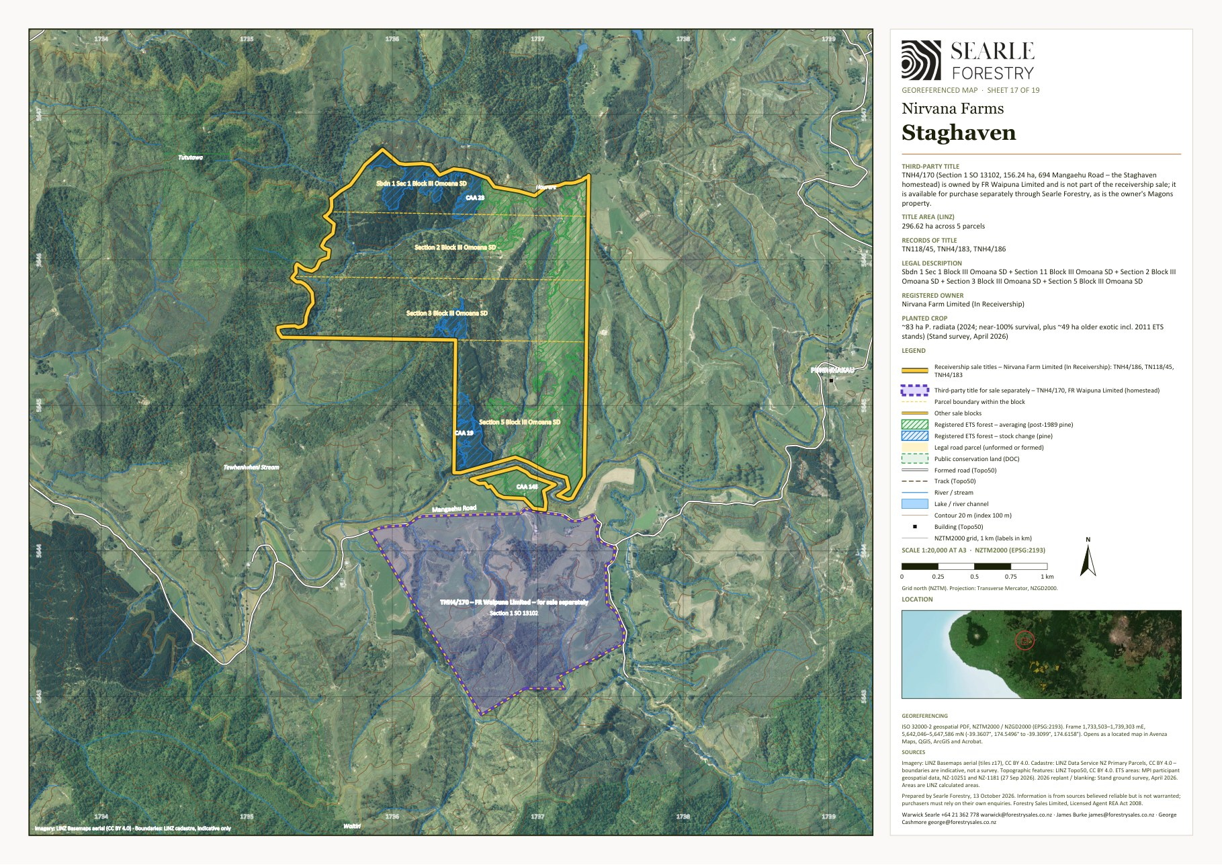
Georeferenced sheet from the Nirvana Farms map set (LINZ cadastre, LINZ aerial imagery, MPI ETS data, Stand 2026 programme). The designer may substitute a styled version; the GeoPDF sheets are supplied in the IM/maps folder and the data room.

5.15 Tims
Native bush and scrub
Land use | Native bush and scrub
Vendor / interest | Nirvana Farm Limited (In Receivership)
Location / address | 1210 Upper Mangaehu Road
Total area | 14.32 ha
Land cover | Native bush 5 ha · Mānuka / kānuka 9 ha (July 2026 mapping)
Pinus radiata – net stocked area | No radiata crop
Contour and land use capability | Predominantly steep to very steep hill country. LUC 7: 14 ha (100%) (LRIS NZLRI 2021). Altitude 240–400 m above sea level.
ETS status | No carbon accounting areas registered on the block
Indicatively ETS-eligible land | Negligible
Records of title and legal description | 646771 – Lot 1 Deposited Plan 473178 (14.3204 hectares). Taranaki Land District.
Tenure | Fee simple (freehold)
Title interests (Oct 2026 searches) | Mortgage to Vitol Asia Pte Ltd (7 June 2023) – to be discharged at settlement; Sustainable Forest Management permit under s67M Forests Act 1949 (indigenous timber, 2000–2002)
Zoning | Rural Zone – Stratford District Plan 2014
Territorial authority | Stratford District
Regional council | Taranaki Regional Council
Rating valuation and rates | Stratford DC assessment 1204114400 – Upper Mangaehu Road RD 22 – Lot 1 DP 473178 (14.32 ha): land value $67,000, improvements $0, capital value $67,000; rates $1,371 p.a. (district $1,202 + regional $169)
Leases / occupation | None known [TBC]
Access | Road frontage to Upper Mangaehu Road.
Buildings and dwellings | No buildings.

Description
A 14 ha block of native and scrub on Upper Mangaehu Road, near Staghaven.

Tims – property map
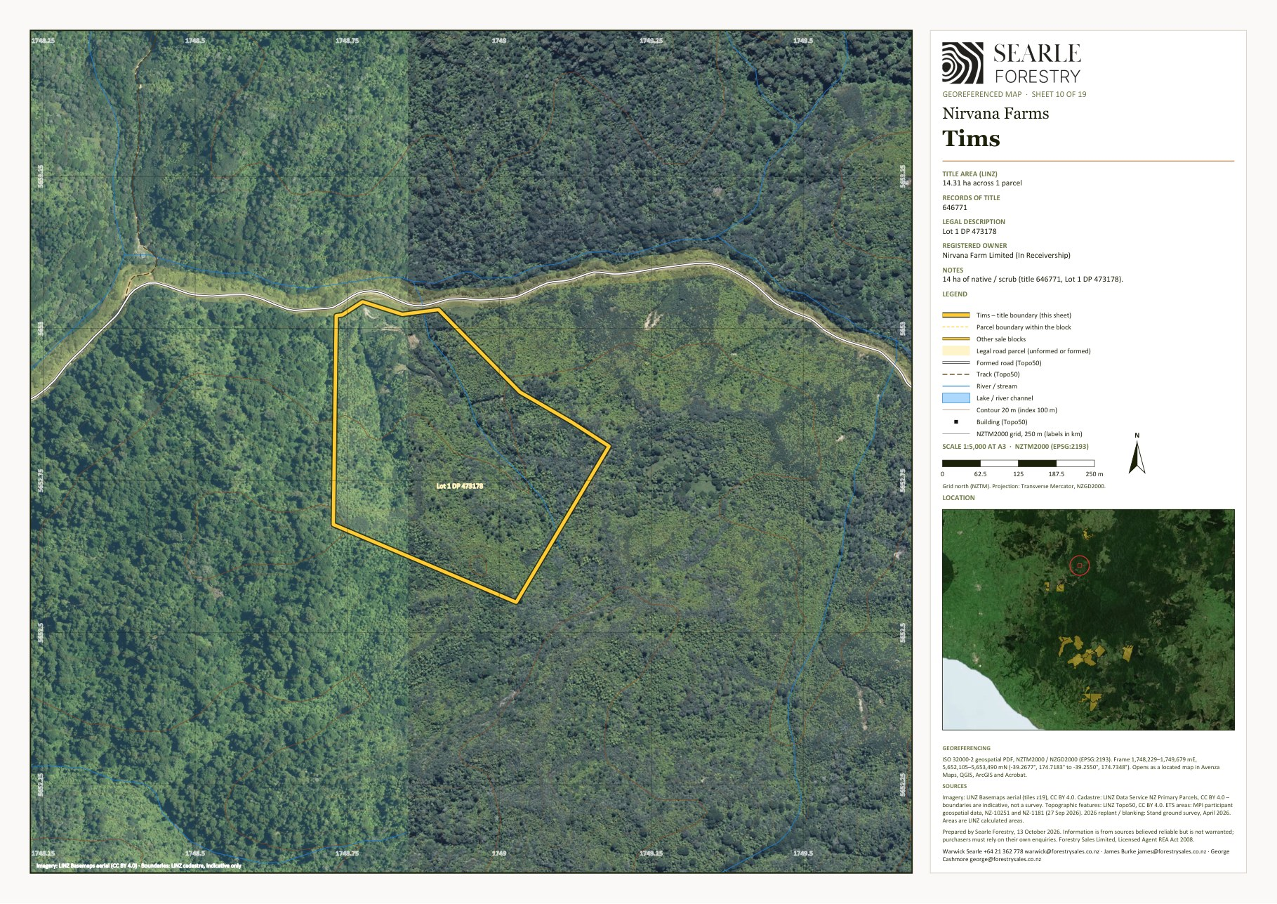
Georeferenced sheet from the Nirvana Farms map set (LINZ cadastre, LINZ aerial imagery, MPI ETS data, Stand 2026 programme). The designer may substitute a styled version; the GeoPDF sheets are supplied in the IM/maps folder and the data room.

5.16 Soldiers Road (forestry right) – forestry right
Forestry right only – Pinus radiata and carbon
Land use | Forestry right only – Pinus radiata and carbon
Vendor / interest | Forestry Right 12717687.19 held by Nirvana Farm Limited (In Receivership) – land owned by Land & Bee's Limited (not included)
Location / address | 202 Tuwharenikau Road (Tawhiwhi Settlement)
Total area | 362.19 ha – forestry right over the whole title; land not included
Land cover | Radiata / exotic 176 ha · Native bush 1 ha · Mānuka / kānuka 131 ha · Open grassland 53 ha (July 2026 mapping)
Pinus radiata – net stocked area | 176 ha planted · 50 ha adequately stocked at April 2026 · 88 ha replant + 38 ha blanking in 2026 · 176 ha adequately stocked after 2026. Planting years: 2023 (176 ha) [TBC – stand records]
Contour and land use capability | Hill country at about 300–500 m; open land by slope: flat 5 ha · rolling 14 ha · medium hill 21 ha · steep 13 ha (July 2026 mapping). [TBC – LUC]
ETS status | Four NFL CAAs (9.6 ha, 59 NZUs) registered over RT 153235 at 28 Sep 2026 – the forestry right describes a 160 ha carbon accounting area; registration of the balance of the 176 ha [TBC]
Indicatively ETS-eligible land | about 114 ha of post-1989 grassland and scrub (indicative, MPI to determine)
Records of title and legal description | RT 153235 – Section 5S and Subdivision 2 Section 6S Tawhiwhi Settlement (362.19 ha), Taranaki Land District – Land & Bee's Limited. Taranaki Land District.
Tenure | Registered forestry right (Forestry Rights Registration Act 1983) over the whole title – the freehold land is not included
Title interests (Oct 2026 searches) | [TBC – forestry right instrument and any mortgage of it]
Zoning | Rural Zone – Stratford District Plan 2014
Territorial authority | Stratford District
Regional council | Taranaki Regional Council
Rating valuation and rates | Not applicable – the land (RT 153235) is rated to Land & Bee's Limited.
Leases / occupation | Forestry right only; no leases
Access | One internal track through the centre of the block; much of the planted area is reachable only by air, so pest control is carried out by aerial shooting. Aerial lifting budget $8,800 plus $3,300 for chemical.
Buildings and dwellings | Not applicable – forestry right only.

Description
Offered as a registered forestry right only. Forestry Right 12717687.19 was granted by Land & Bee's Limited to Nirvana Farm Limited over the whole of title 153235 (362 ha) and covers about 176 ha of radiata planted in 2023. Stand found a large part of the crop had failed to pest damage – only 50 ha was adequately stocked – and programmed 88 ha of replanting and 38 ha of blanking for 2026, noting that the scattered fingers of planting among scrub need the regular aerial shooting that forms part of the ongoing pest-control programme. The land itself is retained by Land & Bee's Limited.

Points to note
- Only the forestry right is for sale; the freehold land is not included.
- The CBRE report records the 176 ha as ETS-registered with carbon pre-sold to year 14.

Items to confirm
- [TBC] Copy of the forestry right (term, rent, harvest and carbon provisions, access rights).
- [TBC] Current ETS registration of the full planted area and the unit balance.
- [TBC] Status of the 2026 replanting.
Internal note – not for the IM: Soldiers Road: no map sheet yet – the forestry-right area over RT 153235 will be added to the map set once the registered plan is on file.

5.17 Magons – available separately
Forestry (Pinus radiata) and carbon · hill grazing – available separately
Land use | Forestry (Pinus radiata) and carbon · hill grazing – available separately
Vendor / interest | FR Waipuna Limited (registered owner) – not part of the receivership sale; available through Searle Forestry by separate negotiation
Location / address | 172 Puniwhakau Road, Puniwhakau (east of Stratford)
Total area | 776.96 ha
Land cover | Not mapped – CBRE (Oct 2024) land classes: 86 ha easy / undulating (LUC I–III), 270 ha medium hill (LUC IV–V), 421 ha steep hill (LUC VI–VIII) [TBC]
Pinus radiata – net stocked area | About 311 ha of ETS-registered Pinus radiata (CBRE, Oct 2024) [TBC – planting years, net stocked area and CAA detail from the owner]
Contour and land use capability | CBRE (Oct 2024) land classes: 86 ha easy / undulating (LUC I–III), 270 ha medium hill (LUC IV–V), 421 ha steep hill (LUC VI–VIII) [TBC – altitude and LUC mapping]
ETS status | Carbon units to year 14 recorded by CBRE as pre-sold [TBC – NZU position and forward-sale status with the owner]
Indicatively ETS-eligible land | [TBC]
Records of title and legal description | TNB1/802 – Section 35 Block III Omoana Survey District (1.9905 ha); TNG1/745 – Sections 21 and 27 Block IV Omoana Survey District (87.0074 ha); TNG1/730 – Section 20 Block IV Omoana Survey District (80.9371 ha); TNG1/733 – Section 22 Block IV Omoana Survey District (80.9371 ha); TNG1/734 – Section 23 Block IV Omoana Survey District (80.9371 ha); TNE3/1365 – Sections 24–26 Block IV Omoana Survey District (283.2799 ha); TNL1/652 – Sections 20–21 Block III Omoana Survey District (161.8742 ha). Taranaki Land District.
Tenure | Fee simple (freehold) [TBC – title searches]
Title interests (Oct 2026 searches) | [TBC – title searches]
Zoning | Rural Zone – Stratford District Plan 2014
Territorial authority | Stratford District
Regional council | Taranaki Regional Council
Rating valuation and rates | Stratford DC assessment 1204109700 – Puniwhakau Road RD 22 – Secs 20–27 and 35 Blks III/IV Omoana SD [TBC – database shows the first parcel only] (776.96 ha): land value $3,340,000, improvements $470,000, capital value $3,810,000; rates $31,472 p.a. (district $29,937 + regional $1,535)
Leases / occupation | [TBC – owner]
Access | Road frontage to Puniwhakau Road [TBC].
Buildings and dwellings | About ten building outlines on the LINZ aerial layer around 172 Puniwhakau Road including a shed of about 570 m² and a building of about 250 m²; CBRE carried a dwelling and farm buildings. [TBC – owner's schedule]

Description
Magons is a 777 ha hill-country forestry property at 172 Puniwhakau Road, about 35 km east of Stratford, in the same Puniwhakau and Mangaehu Road country as Staghaven and Tims. It is owned by FR Waipuna Limited and does not form part of the receivership sale, but the owner has made it available for purchase through Searle Forestry alongside the Nirvana Farms estate. The same owner holds the fourth Staghaven title, TNH4/170 (156 ha at 694 Mangaehu Road, carrying the Staghaven homestead), which is also available separately. CBRE's October 2024 report recorded about 311 ha of ETS-registered Pinus radiata on Magons' easier and medium-hill country, with the balance in steep hill. A purchaser of the eastern Taranaki blocks could therefore assemble a holding of more than 1,200 ha across Magons, the two Staghaven holdings and Tims. Full property details, stand records and the carbon position will be provided on request [TBC – owner's information].

Points to note
- Not part of the receivership sale – offered by FR Waipuna Limited through Searle Forestry by separate negotiation, together with Staghaven title TNH4/170.
- Planted area, age classes and ETS registration are from CBRE (Oct 2024) and are to be verified with the owner.

Items to confirm
- [TBC] Owner's authority and terms of sale for Magons and TNH4/170; title searches, interests and any security.
- [TBC] Stand records, net stocked area, ETS CAAs and NZU position; status of the carbon forward sale.
- [TBC] Description of the Staghaven homestead and improvements on TNH4/170; access between TNH4/170 and the sale titles.

Staghaven homestead title TNH4/170 – available separately from the same owner
Owner / basis | FR Waipuna Limited – not part of the receivership sale; separate negotiation through Searle Forestry
Location / address | 694 Mangaehu Road, Puniwhakau
Total area | 156.24 ha
Record of title and legal description | TNH4/170 – Section 1 Survey Office Plan 13102 (156.2373 ha). Taranaki Land District.
Tenure | Fee simple (freehold) [TBC – title search and interests]
Zoning | Rural Zone – Stratford District Plan 2014
Territorial authority | Stratford District
Regional council | Taranaki Regional Council
Rating valuation and rates | Stratford DC assessment 1204110202 – 694 Mangaehu Road RD 22 – Section 1 SO 13102 (156.24 ha): land value $1,450,000, improvements $610,000, capital value $2,060,000; rates $17,551 p.a. (district $16,655 + regional $897)
Buildings and dwellings | The Staghaven homestead and farm buildings [TBC – owner's description]

The fourth Staghaven title, carrying the Staghaven homestead and farm buildings, was transferred to FR Waipuna Limited (the owner of Magons) before the receivership and is not part of the sale. It is available for purchase through Searle Forestry by separate negotiation with that owner, with or without Magons. [TBC – description of the homestead, land cover, any ETS registration and the owner's terms]

Magons – property map
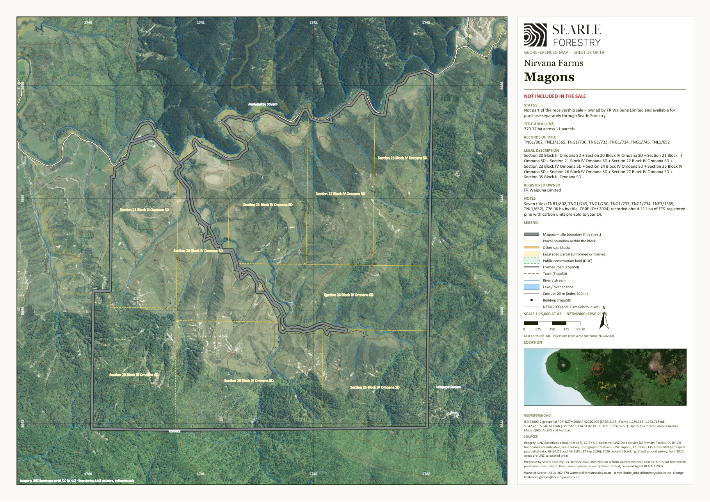
Georeferenced sheet from the Nirvana Farms map set (LINZ cadastre, LINZ aerial imagery, MPI ETS data, Stand 2026 programme). The designer may substitute a styled version; the GeoPDF sheets are supplied in the IM/maps folder and the data room.

Staghaven homestead title TNH4/170 (FR Waipuna Limited) – shown with the receivership Staghaven titles – property map
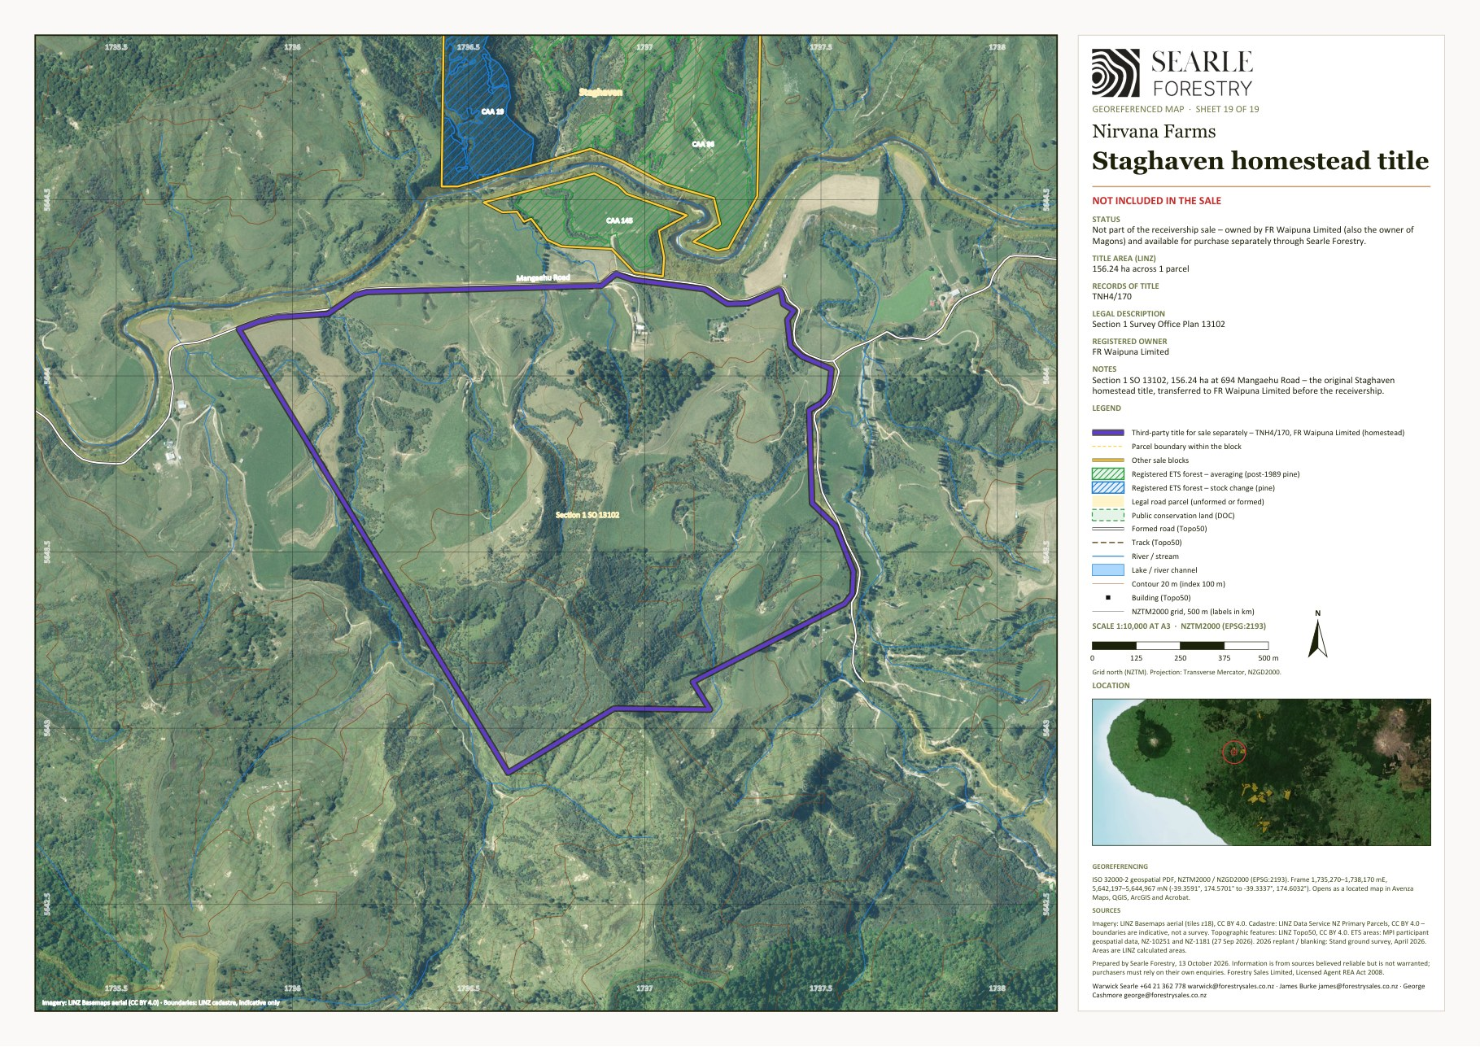
Georeferenced sheet from the Nirvana Farms map set (LINZ cadastre, LINZ aerial imagery, MPI ETS data, Stand 2026 programme). The designer may substitute a styled version; the GeoPDF sheets are supplied in the IM/maps folder and the data room.

5D Eastern Bay of Plenty – Toatoa – Ōpōtiki District
Pakihi is the one outlying property: 446 ha of mānuka and native bush on Pakihi Road at Toatoa, about 21 km inland from Ōpōtiki in the eastern Bay of Plenty.
From | Destination | km
Pakihi (Toatoa) | Ōpōtiki | 21
Pakihi (Toatoa) | Whakatāne | 65
Pakihi (Toatoa) | Gisborne | 158

5.18 Pakihi
Mānuka and native bush (honey)
Land use | Mānuka and native bush (honey)
Vendor / interest | Nirvana Farm Limited (In Receivership)
Location / address | Pakihi Road, Toatoa (573 / 1016 Pakihi Road)
Total area | 445.60 ha (LINZ calculated 447.3 ha)
Land cover | Radiata / exotic 0 ha · Native bush 244 ha · Mānuka / kānuka 199 ha · Open grassland 2 ha (July 2026 mapping)
Pinus radiata – net stocked area | No radiata crop
Contour and land use capability | Predominantly steep to very steep hill country. LUC 7: 444 ha (99%) (LRIS NZLRI 2021). Open land by slope: flat (0–7°) 0 ha · rolling (8–20°) 1 ha · medium hill (21–35°) 1 ha · steep (>35°) 0 ha. Altitude 80–600 m above sea level.
ETS status | No carbon accounting areas registered on the block
Indicatively ETS-eligible land | about 1 ha of post-1989 grassland and scrub (indicative, MPI to determine)
Records of title and legal description | GS5C/1448 – Section 20 and Section 22 Block XIII Waiaua Survey District (57.4906 hectares); GS6C/1378 – Lot 1 Deposited Plan 8364 (191.6400 hectares); GS6C/1379 – Lot 2 Deposited Plan 8364 (191.6200 hectares); GS6C/1380 – Section 23 Block XIII Waiaua Survey District (4.8461 hectares). Gisborne Land District.
Tenure | Fee simple (freehold)
Title interests (Oct 2026 searches) | Mortgage to Vitol Asia Pte Ltd (7 June 2023) – to be discharged at settlement; Subject to s59 Land Act 1948 (Crown mineral reservation)
Zoning | Rural Zone – Operative Ōpōtiki District Plan 2021
Territorial authority | Ōpōtiki District
Regional council | Bay of Plenty Regional Council
Rating valuation and rates | Ōpōtiki DC assessment 0763023200 – Pakihi Road, Pakihi – Secs 20, 22, 23 Blk XIII Waiaua SD, Lots 1–2 DP 8364 (valued 1 Jun 2025; improvements $70,000 per council) (445.28 ha): land value $890,000, improvements $70,000, capital value $960,000; rates $3,790 p.a. (Ōpōtiki DC 2026/27 levy incl. GST; Bay of Plenty Regional Council rates billed separately [TBC])
Leases / occupation | None known [TBC]
Access | Road frontage to Pakihi Road. Internal tracks about 2.6 km (Topo50).
Buildings and dwellings | Four small buildings (about 115, 55, 18 and 17 m²) – hut / sheds; no dwelling recorded. [TBC]

Description
The one outlying block: 446 ha of mānuka and native bush on Pakihi Road inland from Ōpōtiki, about 21 km from the town. The appraisal mapping records 244 ha of native bush and 199 ha of mānuka/kānuka; CBRE's land classes (15 ha easy, 362 ha medium hill, 68 ha steep) describe it as a mānuka honey block. It is geographically separate from the Taranaki–Whanganui estate and could suit a separate purchaser.

Points to note
- No Pinus radiata on the block; almost none of the land is indicatively post-1989.

Items to confirm
- [TBC] Land cover – the LCDB-based classification shows the block as open grassland, the 2023/24 imagery as bush and scrub.
- [TBC] Improvements (CBRE $100,000) and occupancy.

Pakihi – property map
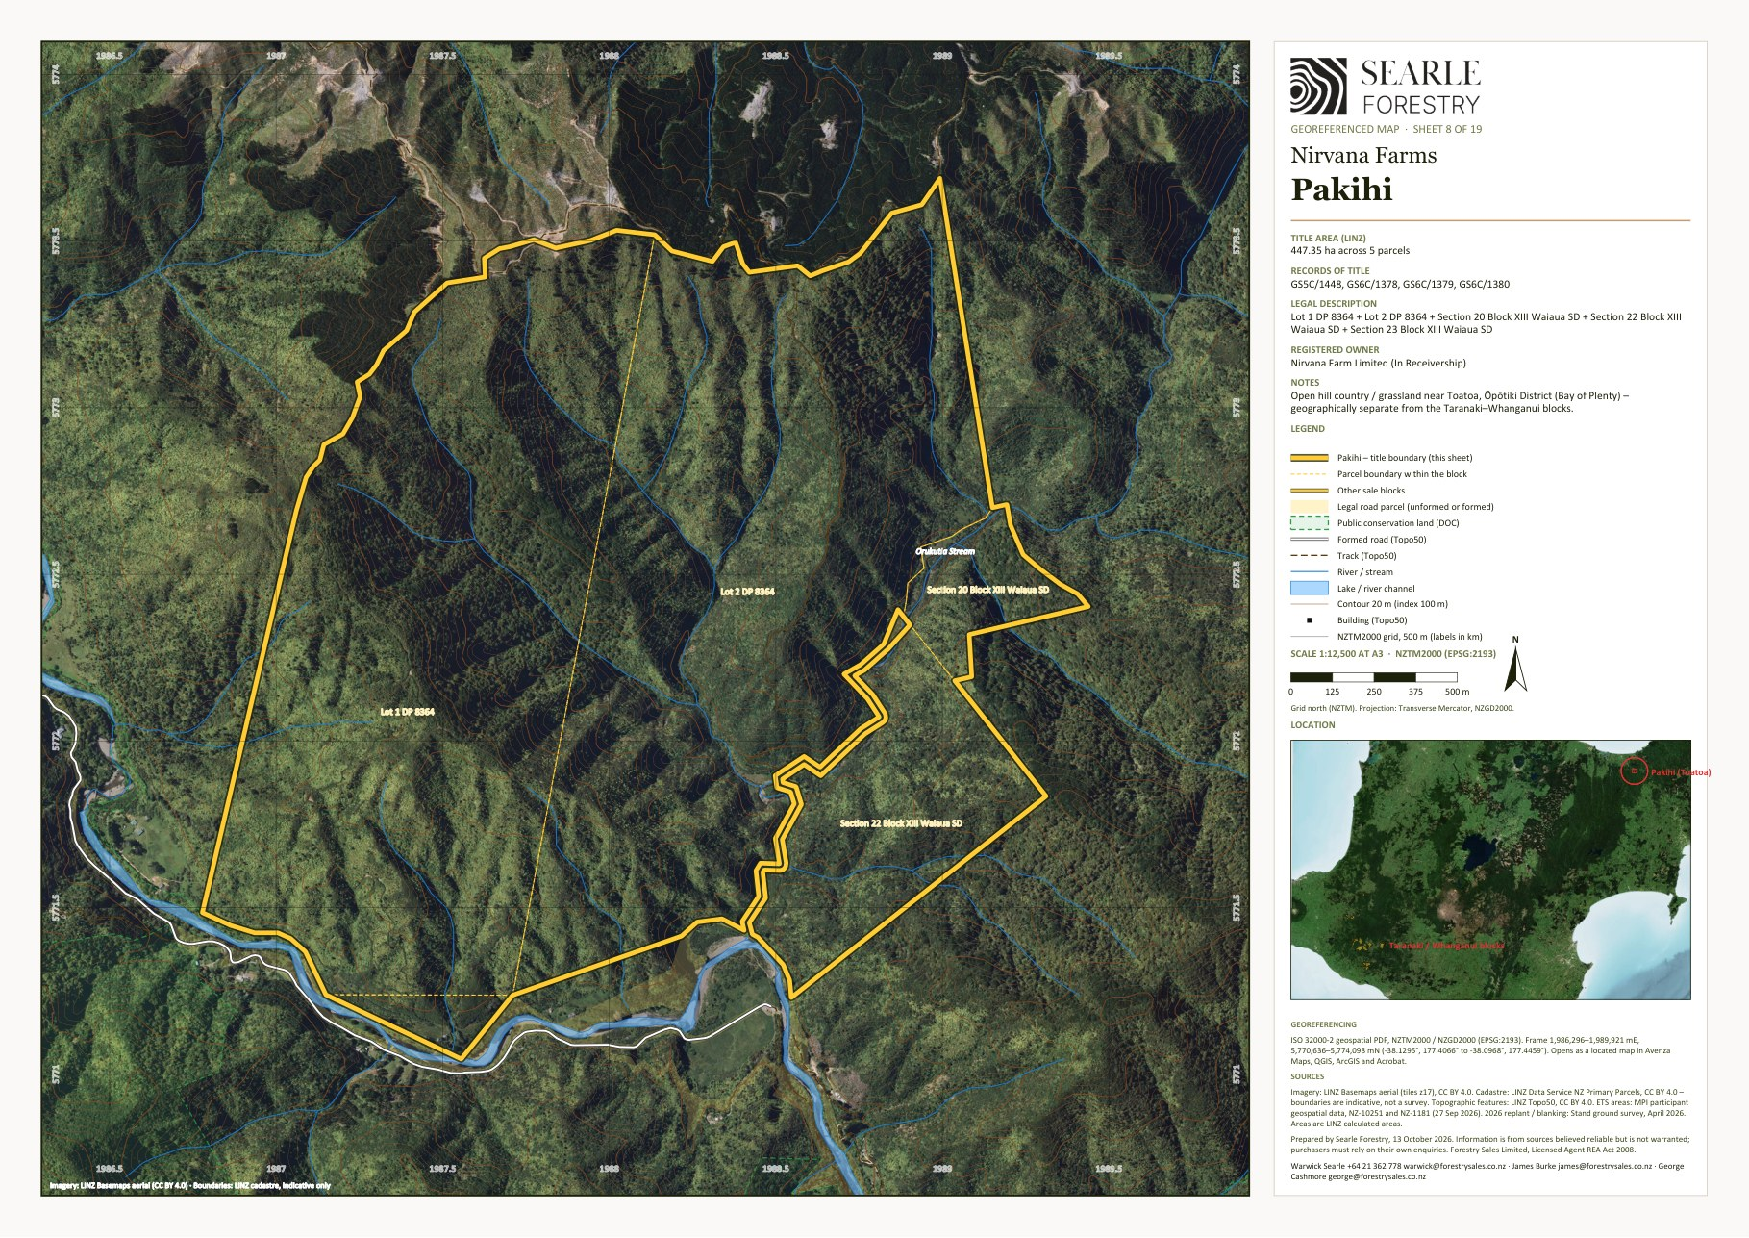
Georeferenced sheet from the Nirvana Farms map set (LINZ cadastre, LINZ aerial imagery, MPI ETS data, Stand 2026 programme). The designer may substitute a styled version; the GeoPDF sheets are supplied in the IM/maps folder and the data room.

Appendix A Schedule of titles and legal descriptions
From the LINZ guaranteed title searches of October 2026. Areas are hectares; estate is fee simple unless stated.
Property | Vendor | Record of title | Legal description | Area (ha)
Longreach | NFL | WN24B/478 | Part Maungaporau 1 Shown on Plan B/37 Block | 1,605.3905
Longreach | NFL | WN24B/479 | Section 5 Block III Moumahaki Survey District | 16.1874
Longreach | NFL | WNB4/1119 | Lot 1 Deposited Plan 24709 | 2.4534
Longreach | NFL | WNF2/815 | Lot 1 Deposited Plan 27378 | 99.1126
Back Farm | Makowhai Trust | TNA3/681 | Section 2 and Section 4 Block IX Kapara Survey District | 212.8646
Back Farm | Makowhai Trust | TNB4/1080 | Section 1 Block IX Kapara Survey District | 121.4057
Back Farm | Makowhai Trust | TNB4/1081 | Section 4 Block V Kapara Survey District | 283.2799
Back Farm | Makowhai Trust | TNB4/1082 | Section 5 Block V Kapara Survey District | 258.1894
Back Farm | Makowhai Trust | TNB4/1083 | Section 3 Block IX Kapara Survey District | 256.9754
Back Farm | Makowhai Trust | TNE4/125 | Section 6 Block XII Opaku Survey District | 142.4493
Back Farm | Makowhai Trust | TNF3/568 | Section 6 Block V Kapara Survey District | 475.1009
Back Farm | Makowhai Trust | TNH1/1356 | Section 8 Block VI Kapara Survey District | 354.0999
Front Farm | Makowhai Trust | 451953 | Lot 2 Deposited Plan 413240 | 338.5727
Front Farm | Makowhai Trust | TNF3/564 | Section 25 Block VI Kapara Survey District | 40.4686
Front Farm | Makowhai Trust | TNF3/565 | Section 24 Block VI Kapara Survey District | 45.3248
Front Farm | Makowhai Trust | TNF3/566 | Section 6 Block VI Kapara Survey District | 47.3482
Front Farm | Makowhai Trust | TNF3/567 | Section 4 Block VI Kapara Survey District | 30.3514
Eastern Block | Makowhai Trust | TNB4/1024 | Makowhai 2 Block | 6.3232
Eastern Block | Makowhai Trust | TNE3/648 | Makowhai 1A Block | 28.0371
Eastern Block | Makowhai Trust | TNE3/649 | Lot 2-3 Deposited Plan 179 and Makowhai 1B Block | 1,037.1081
Home Block | Makowhai Trust | TN119/223 | Part Section 9 Block VI Kapara Survey District | 687.6368
Home Block | Makowhai Trust | TNE3/650 | Section 1 Block X Kapara Survey District | 477.5290
Ernies | Makowhai Trust | 421910 | Lot 2 Deposited Plan 406242 and Section 12 Block VIII Opaku Survey District | 352.8488
Ernies | Makowhai Trust | TN175/43 | Section 2 Block IV Opaku Survey District | 239.2704
Ernies | Makowhai Trust | TN175/44 | Subdivision 1 Section 3 Block IV Opaku Survey District and Subdivision 1 Section 10 Block IV Opaku Survey District | 216.0010
Ernies | Makowhai Trust | TNH4/190 | Section 16-18 Block IV Opaku Survey District | 138.1466
Ernies | Makowhai Trust | TNJ2/204 | Section 19-20 Block IV Opaku Survey District and Section 15 Block VIII Opaku Survey District | 172.1916
Ernies | Makowhai Trust | TNJ2/714 | Section 5, Section 12 and Section 14 Block IV Opaku Survey District | 507.9107
Karapara | Makowhai Trust | TN227/30 | Section 1 Block I Kapara Survey District | 765.3162
Karapara | Makowhai Trust | TN227/31 | Section 3 Block I Kapara Survey District | 546.3256
Karapara | Makowhai Trust | TN227/32 | Section 4A Block I Kapara Survey District | 6.0703
Workers House | NFL | TNE3/610 | Section 26 Block VI Kapara Survey District | 0.6121
Workers House | NFL | TNE3/611 | Section 21 Block VI Kapara Survey District | 1.1002
Patricks House | NFL | 690021 | Lot 1 Deposited Plan 484884 and Lot 4 Deposited Plan 85385 | 27.2445
Patricks House | NFL | WN53B/169 | Lot 1 Deposited Plan 85385 | 0.2079
Patricks House | NFL | WN53B/170 | Lot 2 Deposited Plan 85385 | 0.2083
Puau Road | NFL | 948076 (Crown lease) | Section 1B Block I Nukumaru Survey District | 720.3404
Puau Road | NFL | 948077 (Crown lease) | Section 1 Block I Nukumaru Survey District | 884.2381
Puau Road | NFL | WN115/77 | Section 4 Block I Nukumaru Survey District | 259.4035
Puau Road | NFL | WN24A/444 | Puau 1 Block | 7.7016
Moonys | NFL | WN110/44 | Section 19 Block V Omahine Survey District | 80.9371
Moonys | NFL | WN181/222 | Section 15 and Part Section 19 Block IV Wairoa Survey District | 432.0449
Moonys | NFL | WN23A/665 | Part Section 12 Block V Omahine Survey District | 46.4594
Moonys | NFL | WN476/64 | Section 13 Block V Omahine Survey District | 84.1746
Ridge Road | NFL | 753569 | Lot 2-3 Deposited Plan 500597 | 89.7128
Ridge Road | NFL | WN526/225 | Part Section 6 Block IV Wairoa Survey District and Defined On Survey Office Plan 14533 | 6.9201
Ridge Road | NFL | WN8C/173 | Lot 1-2 Deposited Plan 1512 | 185.9531
Whangamomona | NFL | TNK4/628 | Lot 1-2 Deposited Plan 19775, Section 1 Survey Office Plan 4558, Section 31 Block IV Town of Whangamomona, Lot 1-2 Deposited Plan 6674, Section 29 Block I Mahoe Survey District, Defined On Survey Office Plan 4792, Section 1-2 Survey Office Plan 13206, Section 1-10 Survey Office Plan 13278, Part Section 1 Survey Office Plan 13279 and Section 1 Survey Office Plan 13296 | 738.9428
Staghaven | NFL | TNH4/186 | Section 2-3 and Section 5 Block III Omoana Survey District | 242.8113
Staghaven | NFL | TN118/45 | Subdivision 1 Section 1 Block III Omona Survey District | 44.7178
Staghaven | NFL | TNH4/183 | Section 11 Block III Omoana Survey District | 8.0229
Tims | NFL | 646771 | Lot 1 Deposited Plan 473178 | 14.3204
Pakihi | NFL | GS5C/1448 | Section 20 and Section 22 Block XIII Waiaua Survey District | 57.4906
Pakihi | NFL | GS6C/1378 | Lot 1 Deposited Plan 8364 | 191.6400
Pakihi | NFL | GS6C/1379 | Lot 2 Deposited Plan 8364 | 191.6200
Pakihi | NFL | GS6C/1380 | Section 23 Block XIII Waiaua Survey District | 4.8461
Total |  | 56 titles |  | 13,831.9606
Soldiers Road | NFL forestry right | 153235 (Land & Bee's Ltd) | Section 5S and Subdivision 2 Section 6S Tawhiwhi Settlement | (362.1936)
Magons (separate) | FR Waipuna Ltd | TNB1/802 | Section 35 Block III Omoana Survey District | 1.9905
Magons (separate) | FR Waipuna Ltd | TNG1/745 | Sections 21 and 27 Block IV Omoana Survey District | 87.0074
Magons (separate) | FR Waipuna Ltd | TNG1/730 | Section 20 Block IV Omoana Survey District | 80.9371
Magons (separate) | FR Waipuna Ltd | TNG1/733 | Section 22 Block IV Omoana Survey District | 80.9371
Magons (separate) | FR Waipuna Ltd | TNG1/734 | Section 23 Block IV Omoana Survey District | 80.9371
Magons (separate) | FR Waipuna Ltd | TNE3/1365 | Sections 24–26 Block IV Omoana Survey District | 283.2799
Magons (separate) | FR Waipuna Ltd | TNL1/652 | Sections 20–21 Block III Omoana Survey District | 161.8742
Staghaven homestead (separate) | FR Waipuna Ltd | TNH4/170 | Section 1 Survey Office Plan 13102 | 156.2373

Appendix B Items to confirm before release
- Stand: GIS stand data and forest descriptions (species, planting year and net stocked area by stand) being collated – expected late October 2026 – to replace the ETS-derived planting years; a Forest360 Blanking NSA 2026 sheet for Soldiers Road and Stand's QC plot summary spreadsheet (referred to by the receivers on 15 October but not yet in the data room); the final copy of the NZ Forestry Limited quality-control review (draft received 15 October 2026) and confirmation it can be placed in the data room – plot-level stocking results are not reproduced in the IM.
- NZU holding account balances for NFL and Makowhai Station, NZGT trustee documentation, and the agreed wording on the forward sale of units to the financier.
- Status of the 2018–19 forestry rights to the Longreach, Angiwhai, Makowhai, Staghaven and Whanga Carbon companies, and whether they are surrendered before settlement.
- Copies of Forestry Rights 12717687.18 and 12717687.19 – term, rent, carbon and harvest provisions; registered CAA area under the Soldiers Road right.
- Crown lease rent, review and assignment requirements for 948076 and 948077.
- Rates: confirm the council figures in Appendix C against the current invoices; apportion the combined Waitōtara Valley unit (1241011200) and the Puau Road / Moonys unit (1240020501) if blocks are sold separately; check the rating unit at 395 Taumatatahi Road (assessment 1241011201, 446 ha) that is not in the title schedule; zoning of Section 31 Block IV Town of Whangamomona.
- FR Waipuna Limited: confirm the basis on which Magons and Staghaven title TNH4/170 are offered alongside the receivership sale, and the wording the owner approves for the IM.
- Schedule of dwellings and farm buildings by block with construction, condition and occupancy (replacing the LINZ building-outline notes); confirmation that the former owner's residence is outside the sale titles.
- Honey: historical hive numbers, apiary sites and production by block; any existing apiary agreements.
- Magons: owner's authority and terms, title searches, stand records, ETS and NZU position, rating details.
- Legal access and easements; practical access through the Dobson, Larson and Wood Country properties; fencing condition.
- Climate (NIWA rainfall, sunshine and temperature) for the location pages; Moonys exotic cover; Pakihi land cover on the ground.
- Marketing position on the Pukekahu Farms lease; EOI closing date and time; data-room link; brand for the layout.

Appendix C Rating valuations and rates
Source: Taranaki Regional Council property-rating layer (South Taranaki and Stratford rating information, data edited 27 July 2026; rates understood to be 2026/27) and the Ōpōtiki District Council property and rating search. South Taranaki values are from the revaluation effective 1 September 2024 and Stratford's from 1 August 2023; improvements values are capital value less land value. [TBC – confirm against the current rates invoices before release.]
Rating unit | Council / assessment | Area (ha) | Land value | Improvements | Capital value | Rates p.a.
Back Farm (part), Front Farm, Eastern Block and Home Block – one rating unit | South Taranaki DC 1241011200 (SUIP B) | 3,830.27 | $14,450,000 | $1,190,000 | $15,640,000 | $35,276
Back Farm – Section 8 Block VI Kapara SD (TNH1/1356) | South Taranaki DC 1241009600 | 354.10 | $430,000 | $0 | $430,000 | $1,882
Back Farm – Section 6 Block XII Opaku SD (TNE4/125) | South Taranaki DC 1245008700 | 142.45 | $138,000 | $0 | $138,000 | $1,259
Longreach | South Taranaki DC 1241002900 | 1,723.14 | $8,200,000 | $650,000 | $8,850,000 | $20,799
Ernies | South Taranaki DC 1245009700 | 1,626.37 | $6,000,000 | $75,000 | $6,075,000 | $15,848
Karapara | South Taranaki DC 1241007600 | 1,317.71 | $3,300,000 | $82,000 | $3,382,000 | $8,176
Patricks House | South Taranaki DC 1241017301 | 27.66 | $275,000 | $110,000 | $385,000 | $1,786
Workers House – Section 21 (TNE3/611) | South Taranaki DC 1241010500 | 1.10 | $100,000 | $335,000 | $435,000 | $1,893
Workers House – Section 26 (TNE3/610) | South Taranaki DC 1241010501 | 0.61 | $95,000 | $1,000 | $96,000 | $205
Puau Road and Moonys – one rating unit | South Taranaki DC 1240020501 | 2,515.30 | $6,900,000 | $300,000 | $7,200,000 | $16,316
Ridge Road | South Taranaki DC 1240019700 | 282.59 | $1,190,000 | $90,000 | $1,280,000 | $3,694
Whangamomona | Stratford DC 1199138200 | 738.94 | $3,910,000 | $350,000 | $4,260,000 | $33,341
Staghaven | Stratford DC 1204110201 (SUIP A) | 295.55 | $1,300,000 | $190,000 | $1,490,000 | $5,760
Tims | Stratford DC 1204114400 | 14.32 | $67,000 | $0 | $67,000 | $1,371
Pakihi | Ōpōtiki DC 0763023200 | 445.28 | $890,000 | $70,000 | $960,000 | $3,790
Magons (separate sale – FR Waipuna Limited) | Stratford DC 1204109700 | 776.96 | $3,340,000 | $470,000 | $3,810,000 | $31,472
Staghaven homestead title TNH4/170 (separate sale – FR Waipuna Limited) | Stratford DC 1204110202 | 156.24 | $1,450,000 | $610,000 | $2,060,000 | $17,551
Total – sale titles (excluding the FR Waipuna holdings) |  | 13,315.39 | $47,245,000 | $3,443,000 | $50,688,000 | $151,395

Internal note – not for the IM: One rating unit carries an estate street address but a legal description outside the title schedule: South Taranaki 1241011201 (395 Taumatatahi Road – Pt Sec 10, Secs 7 and 14 Blk VI Kapara SD, 446 ha, CV $3.0m) – check with the receivers whether a title is missing from the schedule or this is a neighbour. The council also attaches '187 Mataimoana Road' to Karapara rather than Back Farm, and '216 Waitotara Valley Road' to the Workers House. Check before the IM quotes addresses.

Appendix D Sources
- Searle Forestry appraisal, July 2026, and Staghaven addendum, September 2026 – land-cover and slope mapping by block (values not reproduced).
- Stand, Nirvana Farm Limited Ground Survey, 23 April 2026 – planted areas, survival, 2026 programme, access and pest notes.
- NZ Forestry Limited (Cameron Eyre, RMNZIF), Planting/Blanking Report for Nirvana Farms Limited, October 2026 (draft) – independent quality-control plots on the seven blocks worked in 2026.
- Forest360 Ltd, Nirvana Farm Limited – Blanking NSA 2026 post-planting quality-control sheets for Back Farm, Eastern Block, Front Farm, Longreach, Puau Road and Whangamomona, 14 October 2026 – net stocked area blanked in 2026 and QC plot locations by block (data room, folder 1); Stand's final work-area mark-ups of 24–27 September 2026.
- MPI land status reports – Nirvana Farm Limited (28 September 2026) and Makowhai Station (August 2025); CAA geospatial data (27 September 2026); section 194A notices.
- LINZ guaranteed title searches, October 2026 – legal descriptions, areas, registered owners and interests; LINZ Data Service cadastre and 8 m DEM; LRIS NZLRI Land Use Capability (2021).
- CBRE, Market Valuation TAR-282069, 14 October 2024 – addresses, land classes, Magons description and the carbon forward sale (values not reproduced).
- Agency agreements, Nirvana Farm Limited (In Receivership) and Makowhai Trust land (Receivers), 14 and 21 September 2026 – title schedules and scope.
- Vitol – Nirvana Farm prepayment facility security summary; Deed of Lease of Farmland – Pukekahu Farms Limited (2025); Crown renewable leases 948076 and 948077.
- Nirvana Farms georeferenced map set (Searle Forestry, 9 October 2026) – property sheets.

